Vista Initial Set Up of LOVIBOND® RY and AOCS RY
We have LOVIBOND® RY and AOCS RY implemented in Essentials 1.01.0021 and above. Please check our latest Vista Essentials at https://support.hunterlab.com/hc/en-us/articles/213682966-Vista-Software-download-Update-Vista-Essentials-software-Revision-21
Following is an example using 20 mm flat sample cell and reporting LOVIBOND®RY at 133.35 mm (5.25'').
1. From the Workspace Menu, select color scales.
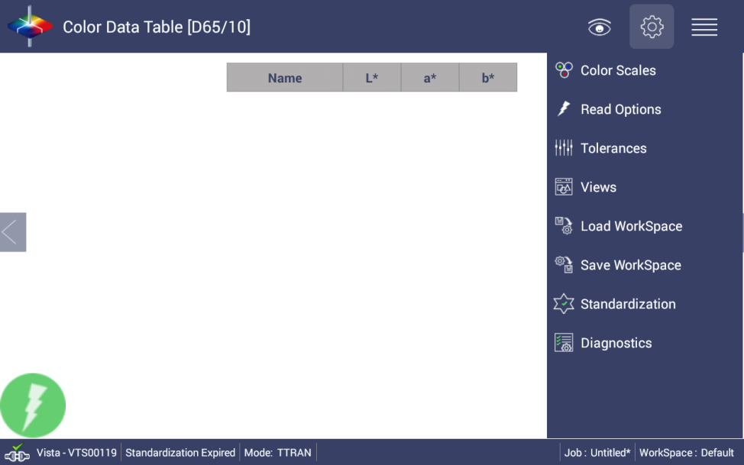
a. Set Color Scale to CIE L*a*b* and Illuminant/Observer to C/2.
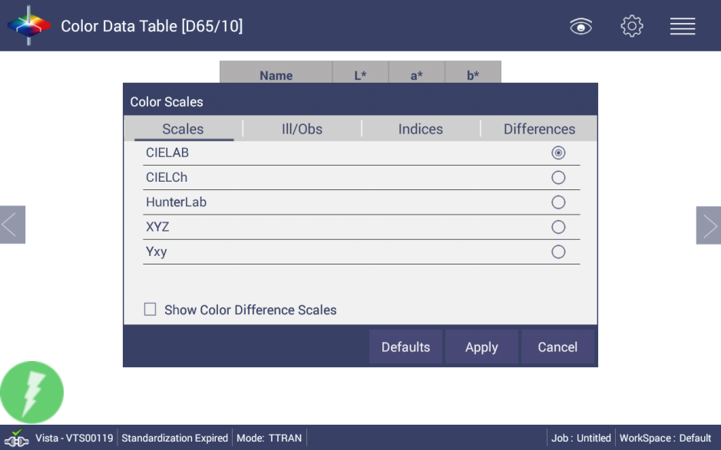
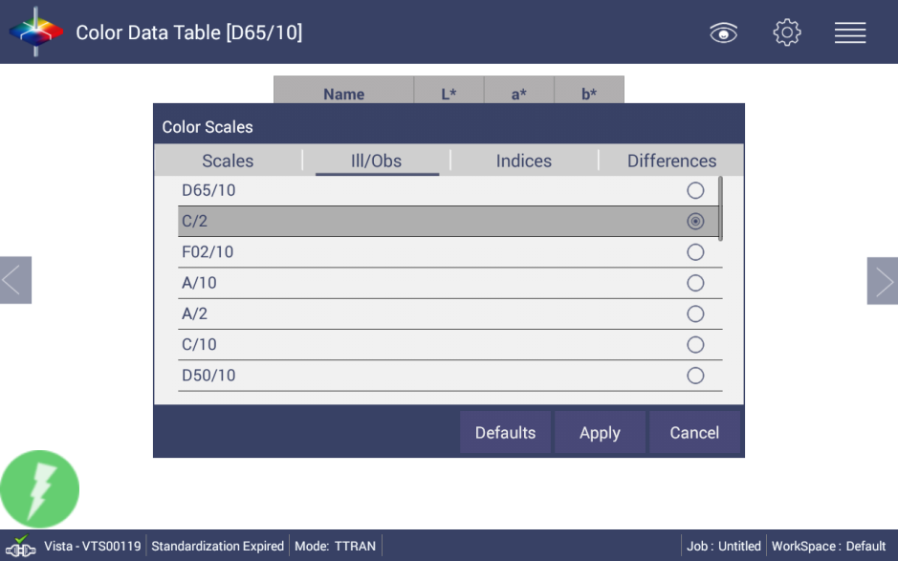
b. From the Indices Tab, select the LOVIBOND® Lov-Y[C/2] and Lov-R[C/2]. (If you want to use AOCS RY, please select AOCS-R[C/2] and AOCS-Y[C/2] instead of LOVIBOND®.)
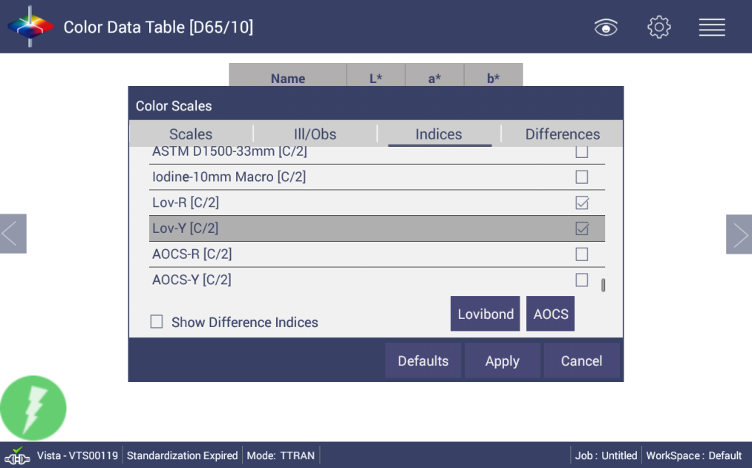
c. Click the "Lovibond" button. (Click "AOCS" button if AOCS RY is applied)
Select the Cell Path Length (mm) that will be used
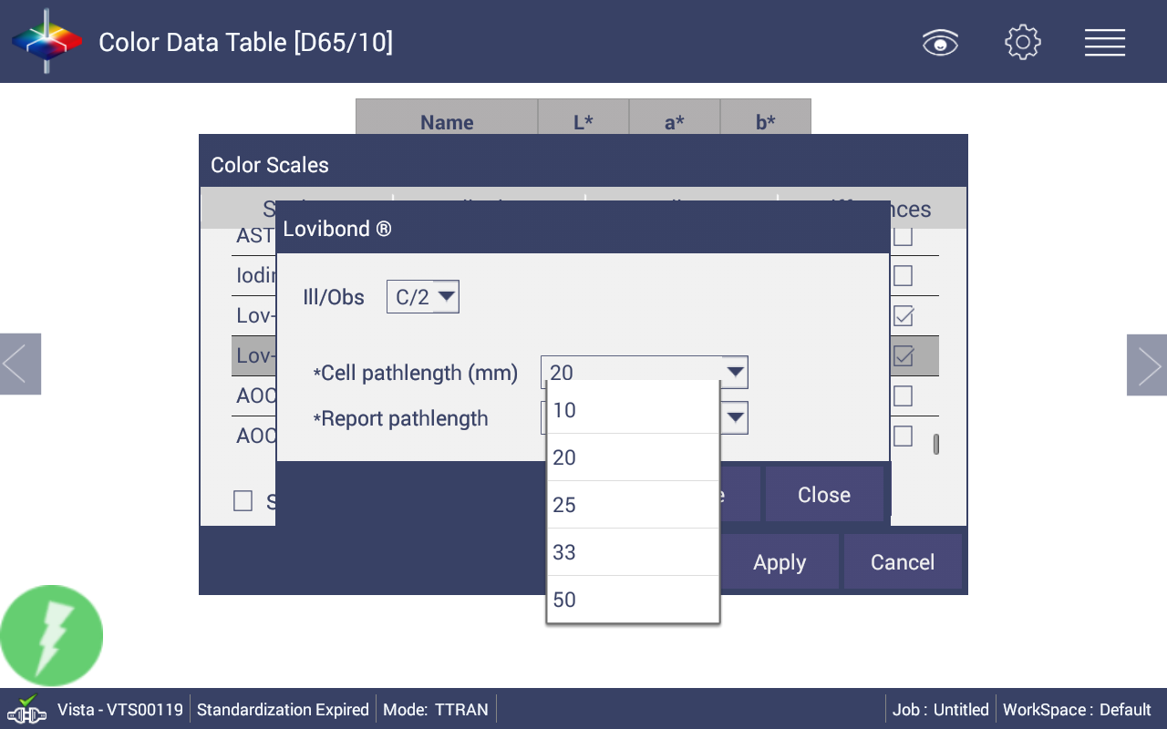
Select the Report Path Length for the output desired. As a suggestion, use 1 inch for very dark samples and 5.25 inch for light samples.
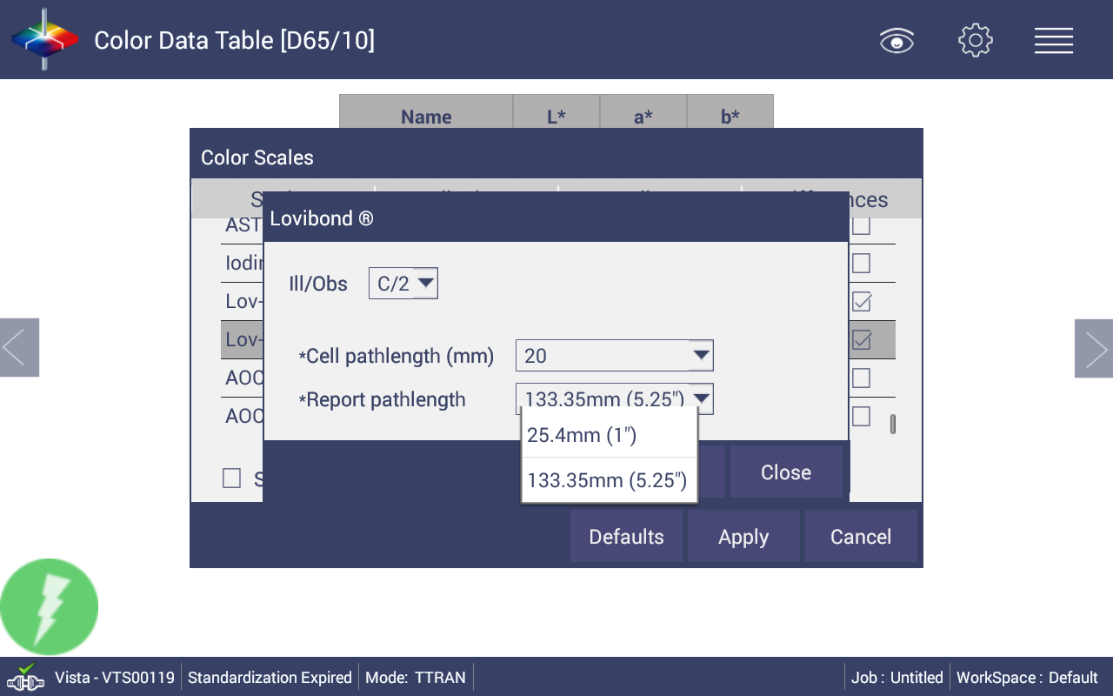
d. If you want to save the above setup for future use, click "Save Workspace" from Workspace menu
When prompted to Save, select NO to create a new Workspace Name
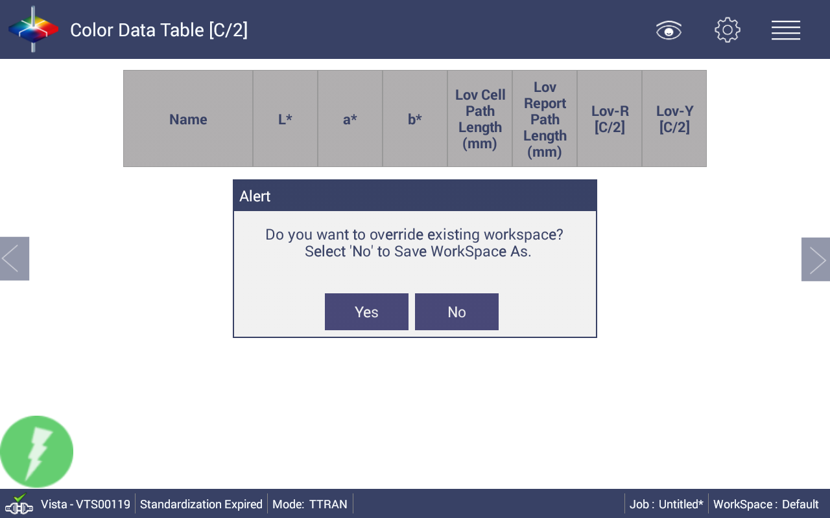
Enter the name of the Workspace. As a suggestion, "Lovibond"& cell pathlength
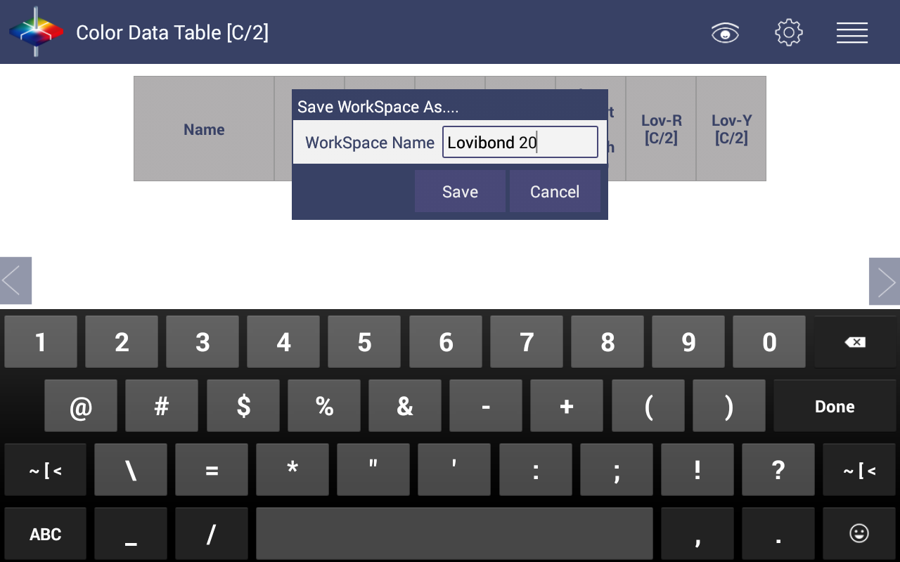
2. Standardize using the sample cell filled with Distilled Water

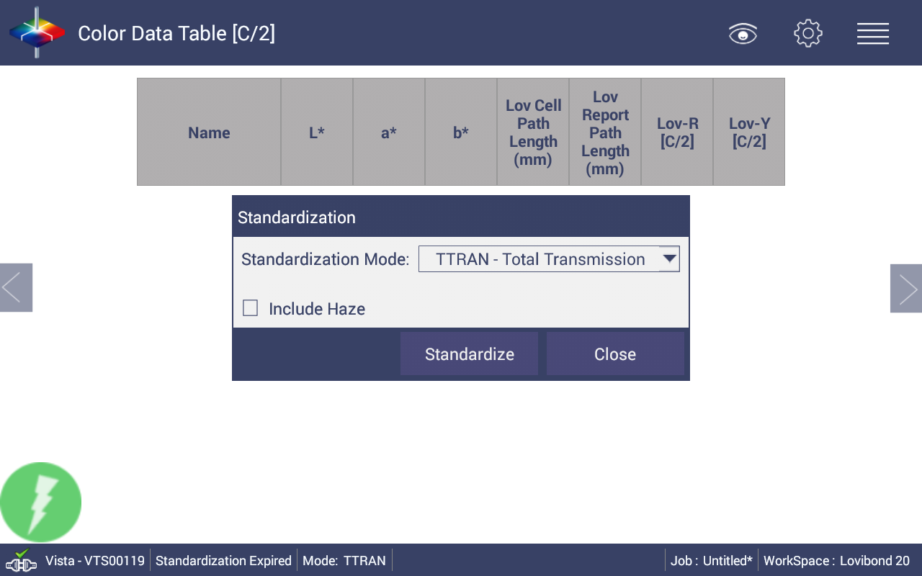
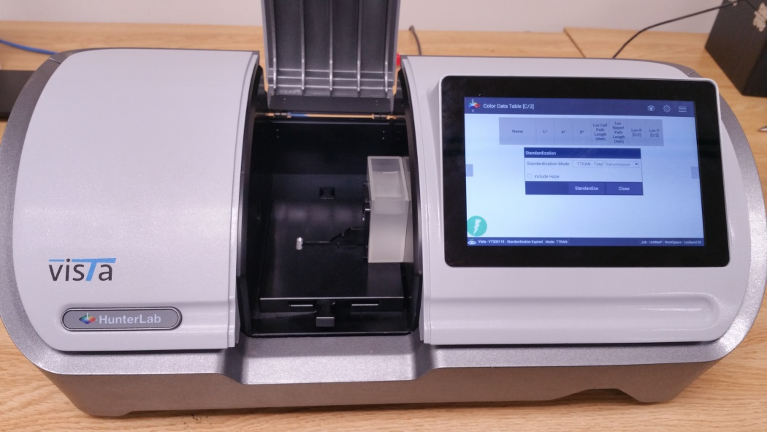
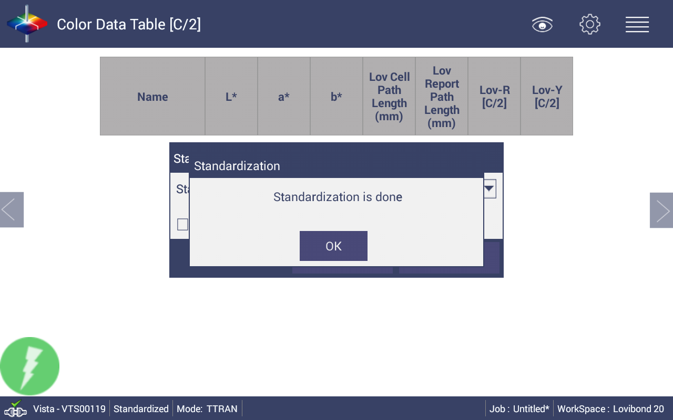
a. After standardization, read the water to ensure it is close to 0 for LOVIBOND® values
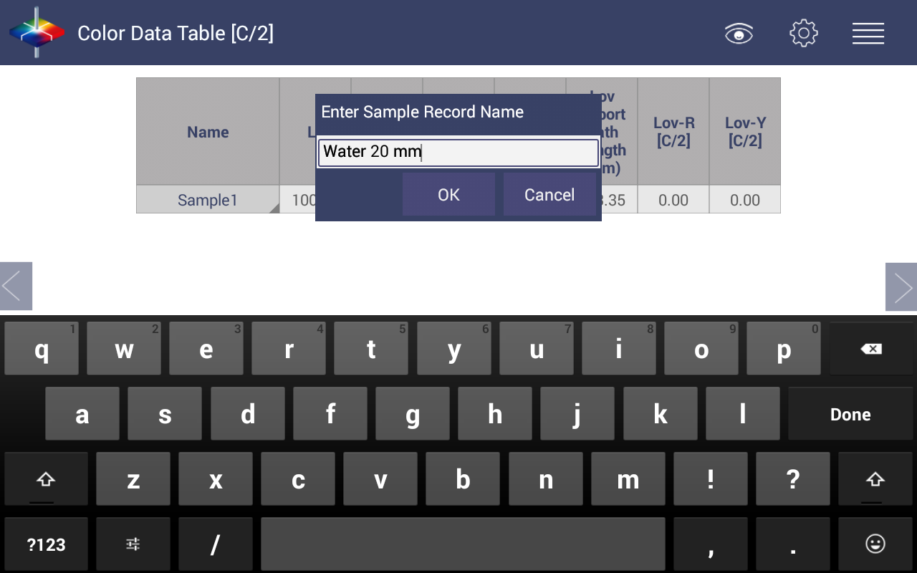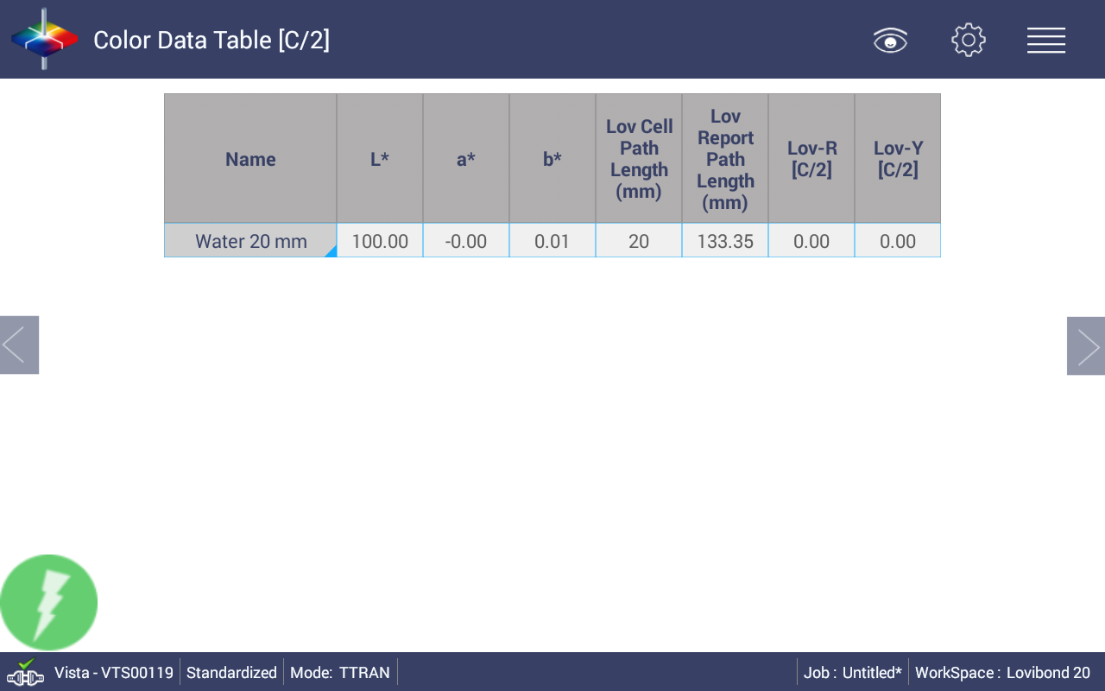
Note: Standardization with distilled water is required when changing cell path lengths or if the standardization interval has expired.

3. Empty cell, dry, and fill with desired sample to measure
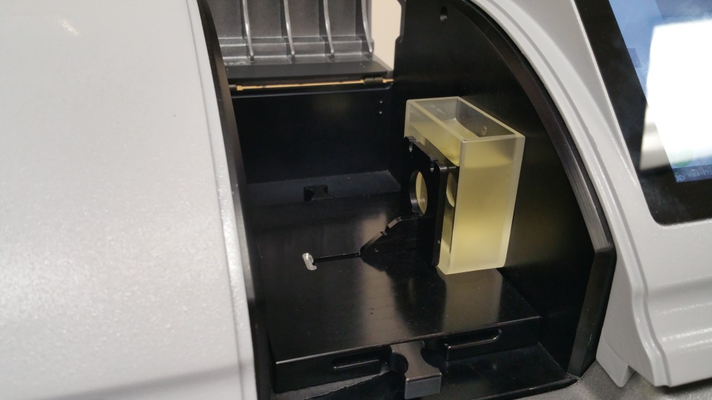
4. Read sample and fill in the desired sample name. You may wish to include the cell path length that was used as part of the name. As a suggestion, name sample with cell pathlength, like "20mm sample1". Since you can always change the Lovibond cell/report pathlength value through LOVIBOND® configuration, it is necessary to know what true cell pathlength was used to measure this sample.
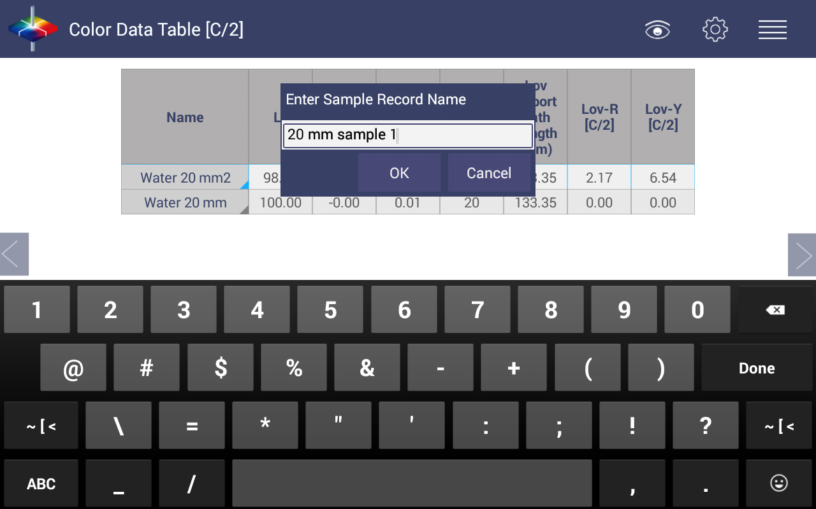
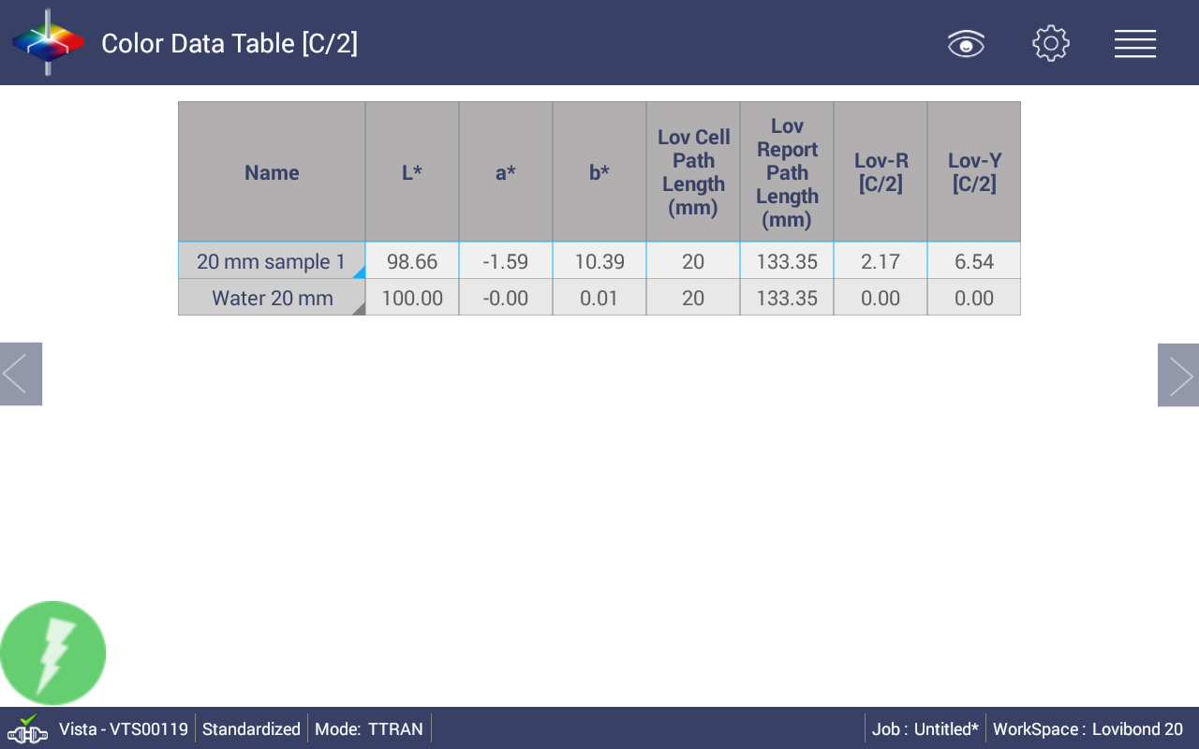

Note: If you want to use a different pathlength cell to measure samples. Please open a new job, and repeat all the above steps. If you do not open a new job, directly apply the new LOVIBOND® cell pathlength, all the existing samples LOVIBOND® RY will be recalculated to this new configuration.
“LOVIBOND” is a registered trademark of The Tintometer Ltd, UK.

