MSEZ New Lamp Replacement Instructions

Purpose:
The MSEZ and CFEZ Lamps D02-1013-925 (M3L4) have been improved and require new installation procedures. The new lamp has a copper shield installed on the back of the lamp which uses one of the mounting screws to hold it on.

Tools:
Phillips screws driver

Parts:
New Lamp with Heat Shield mounted on the back.

Installation:
- Remove batteries from the MSEZ.
- Allow the instrument to sit a while allowing the lamp capacitors to discharge.
- Remove six screws and open the MSEZ cover. Note: Two of the screws are under the tamper labels.

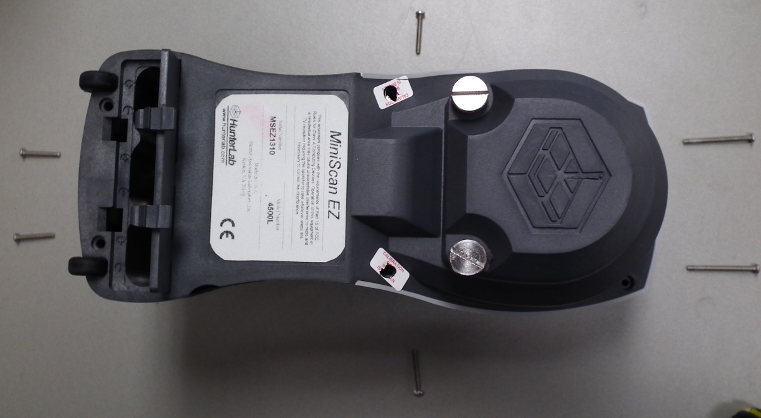
Figure 1. Remove Screws from MSEZ Cover.
- Locate the lamp on the side of the sphere.

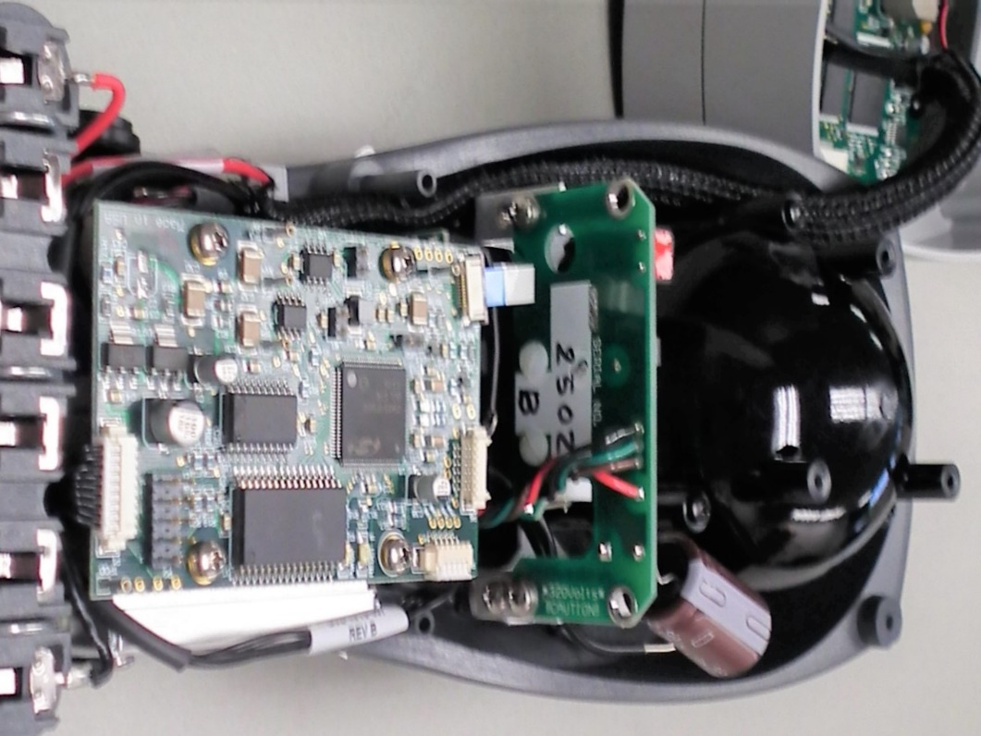
Mounting Screws
Figure 2. Locate Lamp Supply & Mounting Screws
- Unplug the old lamp from the lamp supply and remove the mounting screws.
- Examine the new lamp. Please note the new lamp has a label covering one of mounting screws. This screw replaces the old mounting screw due to the new shield’s standoff.

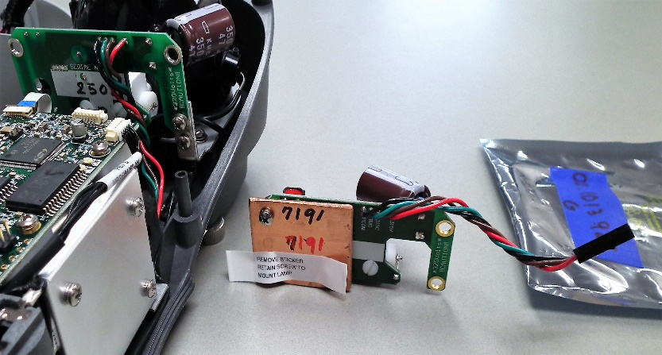
Figure 3. New Lamp with Label Covering Mounting Screw
- Peel off the label, remove the nut on the lower left screw, and mount the new lamp and shield. Replace the lower left mounting screw with the screw provided under the label.
- Plug in the new lamp and install the instrument’s cover.
- On MSEZ install the batteries.
- Turn on the instrument and Calibrate the instrument.
- Installation complete.

