1. The first thing you want to do scan is the protocol document. This lists all the commands and how they are implemented (stapcp)

2. The second thing you should try is the Test program that will show you what the commands and responses look like in raw form. (Test_Protocol)

3. The last is the VBS tool for creating the strings to a file that can be sent via Hyperterminal (msgchksum)
Once you have all that working, then you can implement it on whatever platform you want.
We can talk through these steps.

Here is an example of the msgchsum script usage. It will generate a file you can send through HyperTerminal with the <SOH> and checksum automatically generated.
Example:
1R1000003

Sequence number: 1
Start Run: R1
Product Setup 1: 0000
Default Unit of Measure: 0
Tristimulus Asynchronous: 3

Put the string in the script and generate the file to send
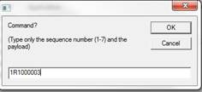
Give it a name
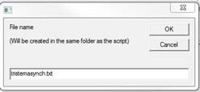

Open HyperTerminal and connect via TCPIP with sensor IP address and port 10001
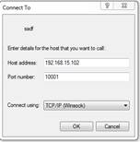
Send Text File
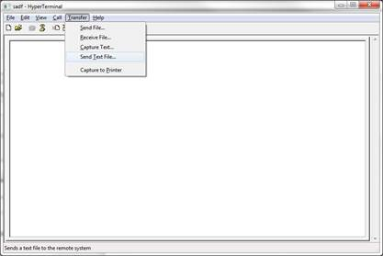

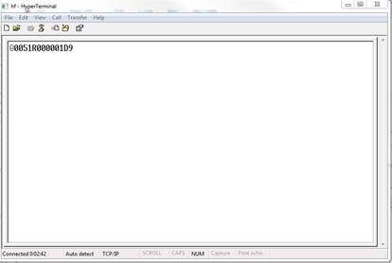

You will have to change the mode from 3 to 2 to actually receive data on the screen. Otherwise, you have to poll it. (H1)

