**How to utilize the “Index Bias Correction” feature on the Vista**

**Background:**

Color indices such as APHA, EP, Gardner, haze, and turbidity are based on physical standards that are often produced by third-party manufacturers and can vary from batch to batch. Additionally, variations in sample cells and sample cell types make absolute instrument readings often variable, even when the user standardizes the instrument with their specific sample cell type.

With these challenges in mind, end users often cannot achieve the absolute reading agreement with physical standards that they desire. However, for instruments that are shown to be in proper working order through applicable diagnostics software, it is acceptable to adjust instrumental reported values to better agree with traceable physical standards.

Example: A user cannot achieve results that match the APHA standards that they have purchased. In this example, the APHA 2 standard is measuring APHA 2.4 and the APHA 10 standard is measuring APHA 10.6. The instrument was validated to be in proper working order by performing the recommended diagnostic tests on the unit. Based on additional validation testing it appears that the measurement deviation is attributed to sample handling variations that cannot be directly controlled at the factory.

**Solution:**

HunterLab has introduced in its Vista product via EasyMatch Essentials software, a measurement correction algorithm that allows the user to adjust the instrument’s base performance via a Bias and Gain correction to precisely match reported results to assigned values for physical standards.

The Y(*adjusted Index value*)=m(*gain*)*uncorrected Index Value + offset (*bias*) equation allows the end user to correct reported values using standard sets numbering just one value to many.

**Implementation of Solution:**

Using EasyMatch Essentials software embedded operating system of the Vista:

1. An option *“Index Bias Correction”* is provided in *Read Options* dialog.
2. When the option *“Index Bias Correction”* is checked, the application provides an option to *Configure* and store the *Gain* and *Bias* values of the specified Indices as shown below.

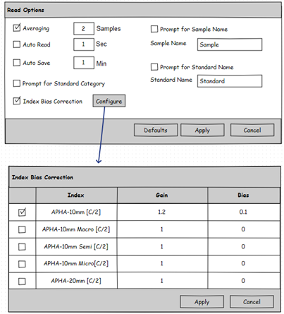

 The user can select any Index from the list of Indices and input the desired *Gain* and *Bias* values. After selecting (Checking) the required Indices, Click *Apply* button to save the selected Indices values and update the Views accordingly.

c)      All available Indices are available for Bias Correction list, this above methodology will provide an option to the user to apply the *Bias Correction* to each individual Index configured in Workspace, only according to the Indices selected in the *Index Bias Correction* List.

d)      The Bias Corrected Index value *(INDEX*)* will be calculated as

*INDEX*=(Gain * INDEX) + Bias*, where *INDEX* is the actual value of the Index under consideration. The Bias corrected Indices will be marked with * (eg*: APHA *10mm*) in the respective view display.

**Practical use example 1:**

User wishes to correct for the slight offset between, the assigned values for their standards and the values measured by the instrument.

The User has data points for two standards.

Using the data below, the user would need to complete the simple calculations to solve for the Gain and Bias, as found in the equation APHA* (corrected)=APHA (measured) * Gain + Bias.

Standard Values Measured Sample Values

APHA = 2 APHA = 2.4

APHA =10 AHPA = 10.6

Gain Correction= (Standard Value 1-Standard Value 2)/(Measured Value 1- Measured Value 2), such that

Gain=(10-2)/(10.6-2.4) = 0.975 and,

Bias Correction=Target Value 1-(Measured Value 1*Gain), such that

Bias= 10-(0.975*10.6) = -0.34

Index*=0.975*m+(-0.34)

To check equation, reintroduce the Measured values to be corrected,

Index*=0.975*2.4+(-0.34) = 2.0

**Practical use example 2:**

User has one standard data point.

Standard Values Measured Sample Values

APHA = 2 APHA = 2.4

With a single data point the Gain remains at 1.0 but the user can apply the Bias correction such that

Bias= Standard Value- Measured Value

Bias= 2-2.4 = -0.4

It can be seen from this example that a single point correction adjusts for the difference between any single standard and sample but does not correct for any difference in gain between additional samples.

**Practical use example 3:**

As evidenced in Example 2, the addition of measured data points within the working sample range will improve Bias and Gain correction. For data sets greater than 2 points, it is recommended that the user employ linear regression techniques available in most statistical and spreadsheet packages.

# The Addressed Tasks

## Read Option Dialog

The *Index Bias Correction* option is added as shown below. The user can check the option and click Configure the Gain and Bias correction for selected Indices.

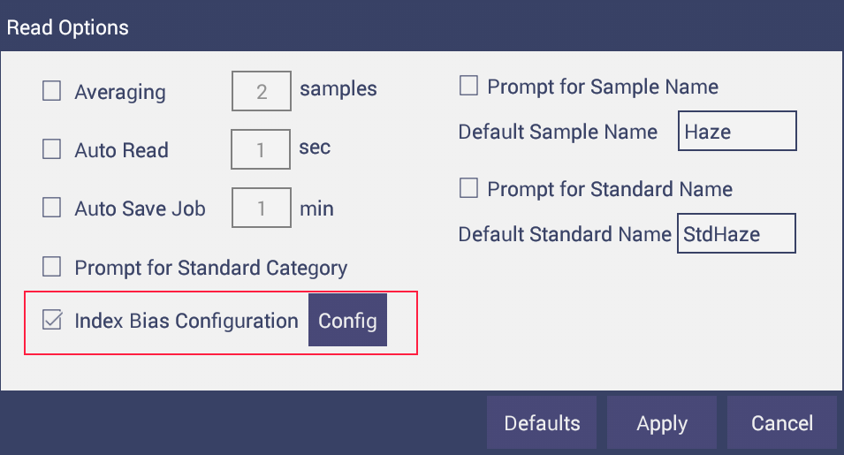

## Index Bias Configuration Dialog

A custom list view is implemented displaying a list of the all the Indices where the user can select any Index and configure the *Gain* and *Bias* values for the respective Index and click *Apply* button to save the selected Indices values and update the Views accordingly. Please note that the Indices configured in Workspace settings, which are in common with the selected (checked) Indices in the “Index Bias Correction” dialog” will only be considered for Bias correction.

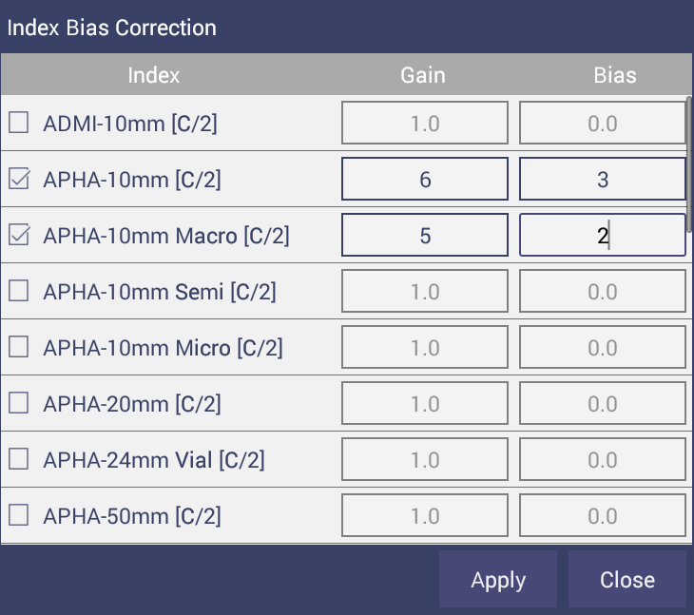

## Update Color Functions

The Color Functions Lookup table is updated to support the calculation of the Biased Indices.

## Serialization

The configured Index correction values are serialized into the workspace and Job file accordingly.

## Views

Based on the selection of Bias Corrected Indices, the CDTV, EZ View and Trend Plot will display the respective Indices Labeled with * notation as shown below.



