Auto Export Client using ‘PuTTY’ or ‘Tera Term’

The ‘PuTTY’ or ‘Tera Term’ application can be used for Auto-Exporting the measurement data through an Ethernet Connection. Please follow the below steps for ‘Auto Export’.

# In Essentials side

**Step 1:** Click ‘Preference’ in options menu.

**Step 2:** Check on ‘Auto Export Measurement’ option.

**Step 3:** Click ‘Config’ button.

**Step 4:** In ‘Network Data Export Configuration’, set the application as ‘Act as Server’.

**Step 5:** Provide the port number (say 2000 or any available port number) and the delimiter. Click ‘Apply’.

The screen shot is attached below.

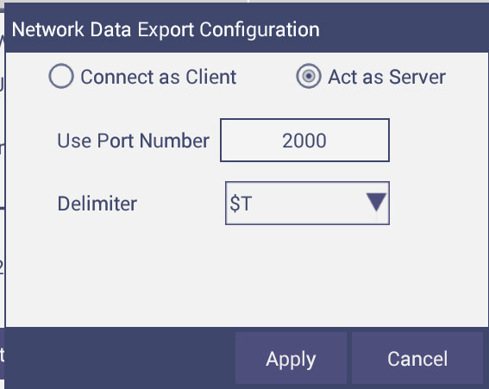

# In Windows PC Client side

Please download and install “PuTTY” or “Tera Term” clients.

**Note:** Before connecting to the server through PuTTY, Tera Term clients, please add the above configured AutoExport’s port number and IP Address to the Firewall’s Exception list.

## Steps to use PuTTY as Client

**step 1:** Open ‘puTTY’ application.

**Step 2:** provide the ‘Host Name (or IP address)’ and port number, which has been configured for ‘Auto Export’ in Essentials side.

**Step 3:** Select the connection type as ‘Raw’.

**Step 4:** Click on ‘Open’. The screen shot is attached below.

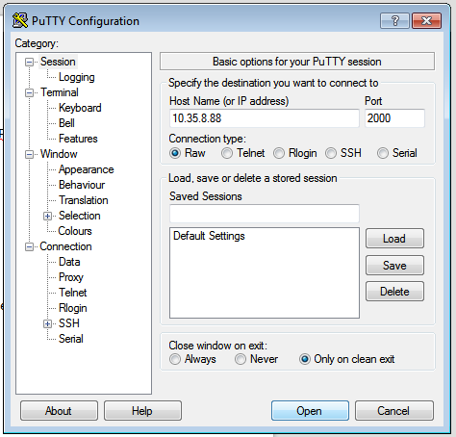

**Step 5:** After clicking ‘Open’ the below terminal window will be opened.

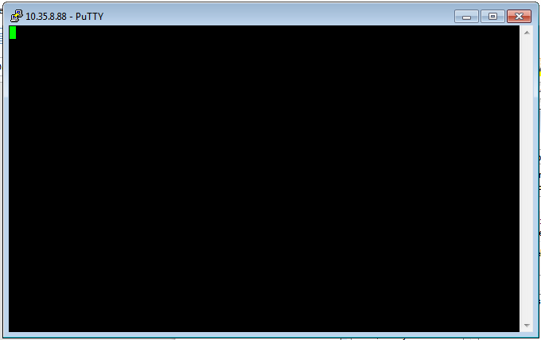

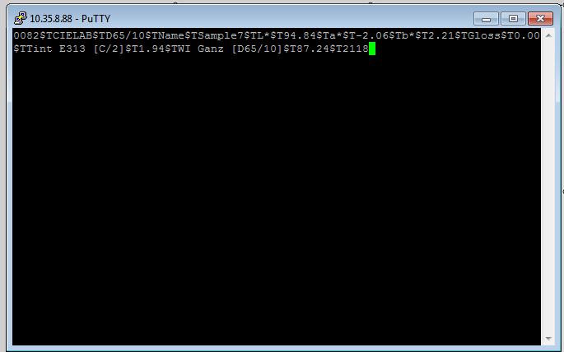**Step 6:** After successful establishment of connection, perform measurement in Essentials side and the measurement data will be received by the PuTTy client and are automatically displayed in the terminal. To see the data in any text editors, select the data from the terminal and press ‘Alt+c’ and paste the data into the text editor.

## Steps to use ‘Tera Term’ as client

**step 1:** Open ‘Tera Term’ client application. The below window will be displayed. You can also open this screen by clicking ‘File -> New Connection’ menu.

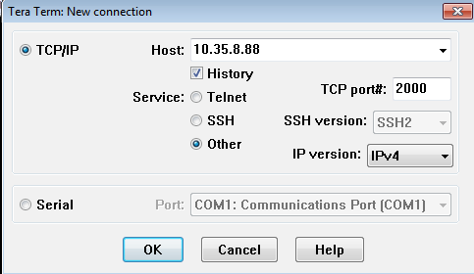

**Step 2:** Select ‘TCP/IP’ option.

**Step 3:** provide the ‘Host ’ (IP address) and the port number, which has been configured for ‘Auto Export’ in Essentials side.

**Step 4:** Select the Service type as ‘Other’.

**Step 5:** Select the IP version as “IPV4’

**Step 6:** Click on ‘OK’.

The Host list can be seen by clicking ‘Setup→ TCP/IP’ menu item.

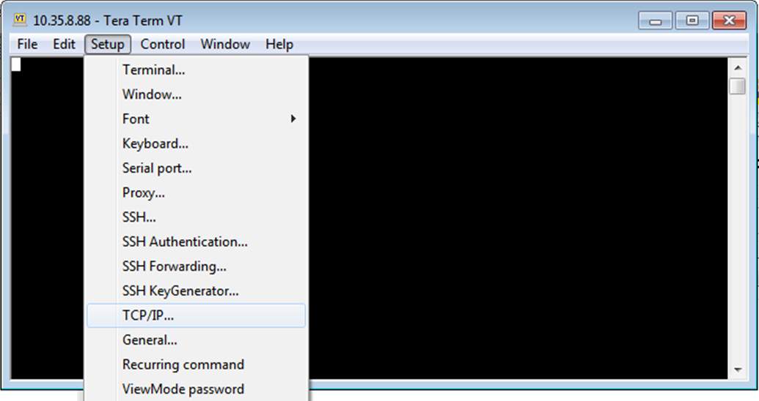

The below is screen shot showing the Host List. You can find the above configured IP and port numbers in the Host list.

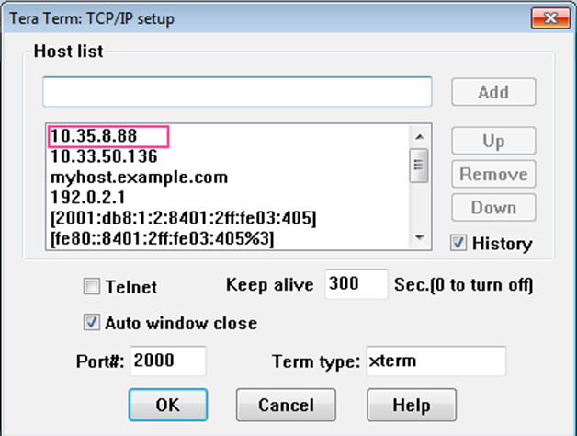

**Step 7:** After successful establishment of connection, perform measurement in Essentials side and the measurement data can be received by the client and are automatically displayed in the terminal. To see the data in any text editors, select the data from the terminal and press ‘Alt+c’ and paste the data into the text editor.



