How to Update Essentials in ColorFlex L2
Please find the latest version of the ColorFlex L2 Essentials software, along with a document outlining the major changes, in this support article .

- Download the HUNTERLAB-type file onto a flash drive (e.g., 2024.4.2.hunterlab, where 2024.4.2 is the release name).
Note: You can rename the file if needed. CFL2 Essentials will automatically recognize the file based on its type, not its name.
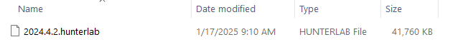
- Insert the flash drive into the ColorFlex L2.
  - Essentials will automatically detect the file on the drive.
  - If the file is a newer version than the currently installed one, Essentials will display a prompt to update.
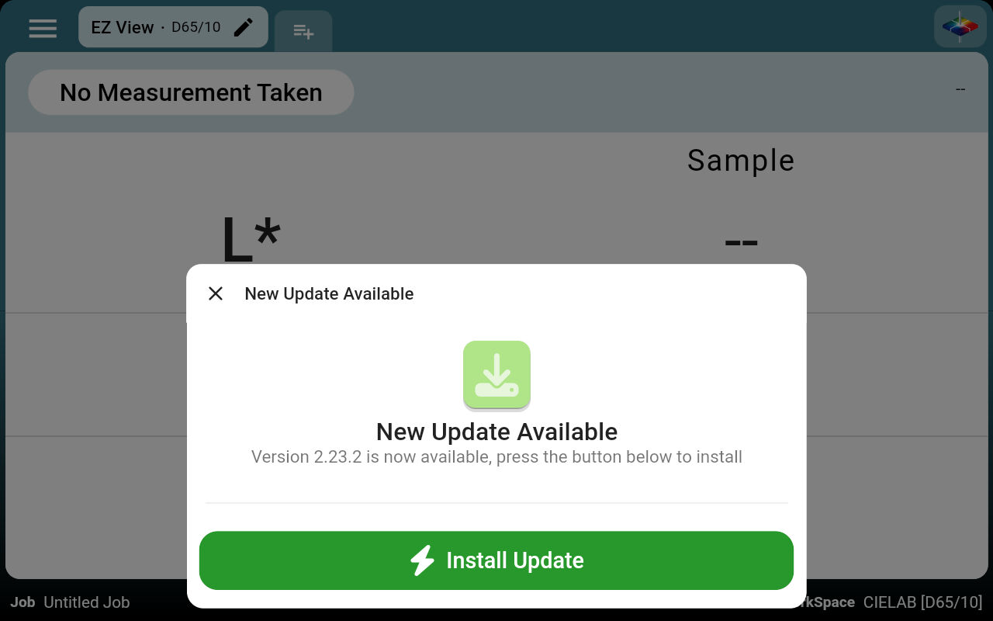
- Follow the on-screen instructions to complete the installation of the new Essentials software.

