APPENDIX B: Creating and Configuring a SQL Database
This appendix describes how to create and configure a SQL database for use with EasyMatch QC. A working knowledge of SQL server is recommended for performing these steps. A copy of SQL Server (Microsoft SQL Server is typical) should be installed first followed by EasyMatch QC, as described in the EasyMatch QC Installation Guide
- In SQL Server, select File > Open and choose to open the script file from the location
For 32 bit OS: “C:\Program Files\HunterLab\EasyMatchQC\SQL Database Script\EZMQC.sql”
(or)
For 64 bit OS: “C:\Program Files (x86)\HunterLab\EasyMatchQC\SQL Database Script\EZMQC.sql”
This is the location of the file if you installed EasyMatch QC to the default folder. If you installed elsewhere, you will find the SQL Database Script subfolder in your installation folder.
- Execute the ‘EZMQC.sql’ script file and the EZMQC SQL database will be created.
- You can use the SQL Server to view this database and see that tables have been created within it.
- In the Tree View, expand the Security Branch.
- Right-click on Security > Logins and choose New Login.
- Change Default Database to EZMQC and do User Mapping to set each User with data read and write roles for the EZMQC SQL database.
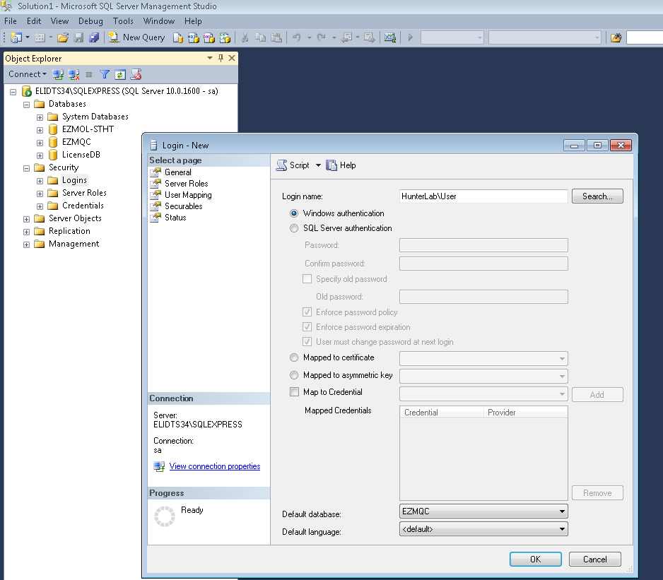Figure 227. Creating an SQL Database

- Close SQL Server.
- On the computer where EasyMatch QC will be run, open EasyMatch QC.
- Select System Configuration > Options, and then Data Storage. The Data Storage Screen appears.
- Select the SQL Server, enter the server and database name (EZMQC). Click OK.
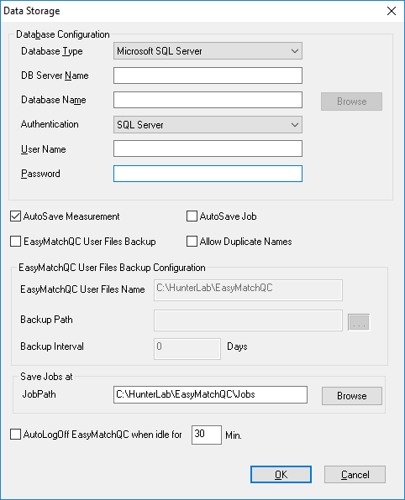
Figure 228. SQL Database Storage

When the SQL Database Server is selected, a new option is provided to select the Authentication type as ‘Windows’ or ‘SQL server’ in the Data Storage Dialog. If ‘Windows’ is selected, the current system login in user credentials will be used to login to the SQL server, then there is no need to specify the user name and password. When ‘SQL Server’ option is selected, the database server credentials need to be specified.
Note: When ‘Windows Authentication’ option is selected in SQL server (local server or network server in a domain), the login security permissions should be added for the configured EZMQC-ER Admin/User groups for EZMQC database in the SQL Server.
- Restart EasyMatch QC and then SQL Server Database is ready for use.
*********

