**Auto-Export Data from Vista Essentials via Direct Connection with a Computer or Through Network**

**Method #1: For Direct Connection between Vista and Computer with Ethernet Cable (No Network required)**

**Method #2: For Direct Connection between Vista and Computer with RS-232 Ethernet Adapter (No Network required)**

**Method #3: Through Network**

## **Method #1: For Direct Connection between Vista and Computer with Ethernet Cable**

1. Materials Needed
   1. Vista Firmware needed: 1.01.0014 and above
   2. Hardware needed: Ethernet cable, and USB Ethernet adapter if you want to have multiple Ethernet cables connecting to the computer.

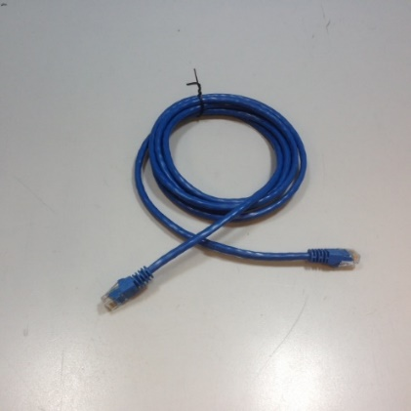

Figure 1- Ethernet Cable

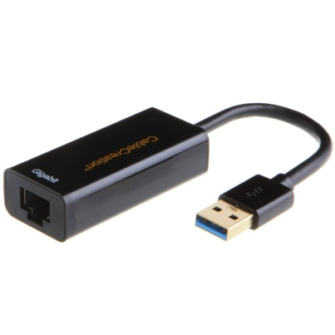

Figure 2- USB Ethernet Adapter

1. **Connect Vista to Computer:**
2. Plug Ethernet cable (Figure 1) into RJ-45 Ethernet connection at rear of Vista. Plug other end of cable into the computer directly or through USB Ethernet Adapter (Figure 2). 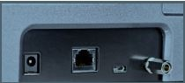

Ethernet Port

Figure 3- Rear View of Vista

1. **Configure IP address of the Vista:** (Note: Requires Essentials Rev 14 or higher)
2. **Check IP address in PC:** Open Command Prompt in the PC. Type in "ipconfig" and check the "autoconfiguration IPv4 Address" as well as the "Subnet Mask".

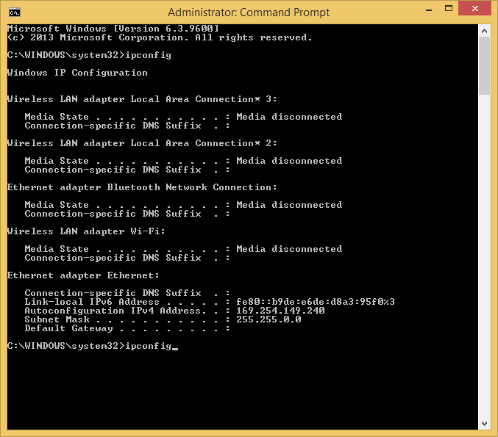

*Figure 4- Computer IP address*

1. **Configure IP address in Vista:** Open Vista Essentials, go to Preferences/Configure Network Settings. Uncheck "Use DHCP for Ethernet Config". Type in IP address and Subnet Mask manually, then apply. The IP address here should be exact same as the "autoconfiguration IPv4 Address" in the PC, except changing the last two digits. Restart Vista to get network setting applied.

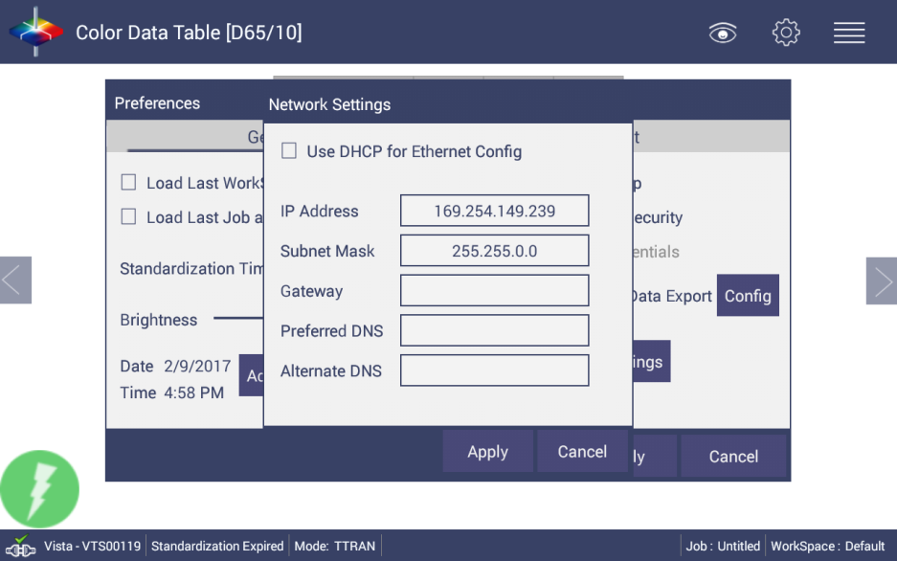

*Figure 5- Assign IP address to Vista*

1. Press Apply on the Ethernet Configuration
2. Check “Automatic Network Data Export” and click to configure.

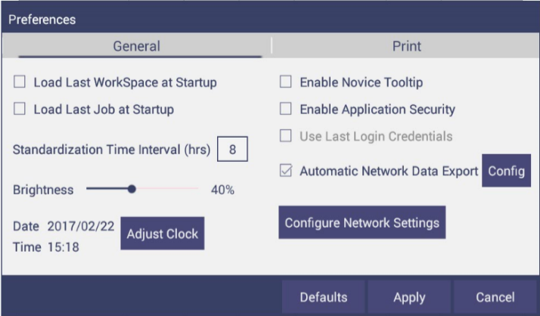

Figure 6- Preferences>Automatic Network Data Export

1. For a direct connection between Vista and computer with Ethernet cable, set up the Vista as a Client. Port Number is 10001.

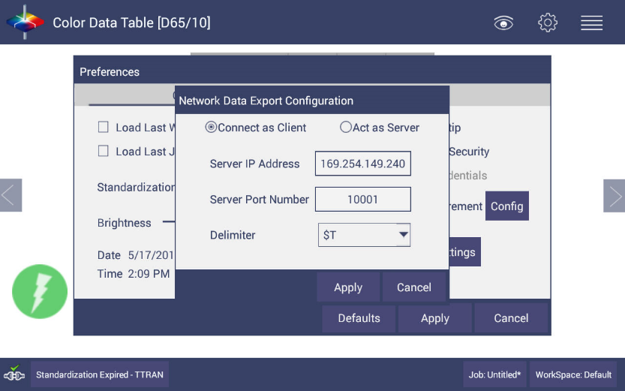

Figure 7 - Auto Export Measurement Configuration

1. **Configure the Computer Using HyperTerminal Software**
2. Go to the computer and open HyperTerminal.
3. Make a new connection:
   * 1. Enter a name for the connection
     2. Connect using TCP/IP(Winsock)
     3. The data collection computer will be set up as a Server. Enter Port Number as 10001
4. **Send Data from the Vista:**
5. Configure the Vista for the Color Data Screen:
   * 1. Select Color Scales, Indices & Illuminant/Obs (Workspace>Color Scales)
     2. Standardize the instrument. (Workspace>Standardize)
     3. Read sample and view the data on the computer.

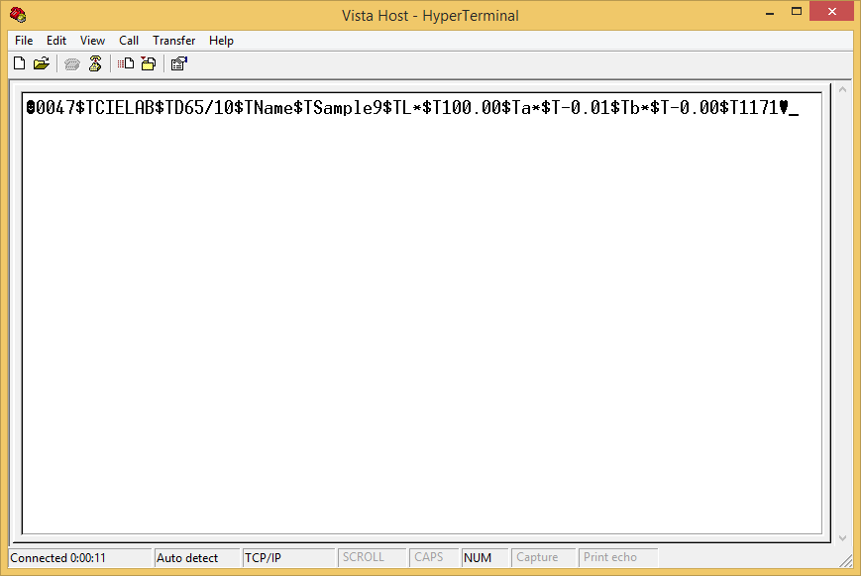

Figure8- Data from Vista through Ethernet Connection

The data string is shown as follows:

<STX><PACKET SIZE>$T<SCALE-LABEL>$T<ill/Obs>$T<LABEL NAME1><$T><VALUE1>$T<LABEL NAME2><$T><VALUE2><$T><LABEL NAME3>$T<VALUE3>$T ..... <LABEL NAME N><$T>

<VALUE N>$T<CHKSUM><ETX>

Where,

<STX> is the Start of Text (value =0x02)

<ETX> is the End of Text (value =0x03)

$T is the default delimiter.

<SCALE-LABEL> is the Scale Label (e.g. CIELAB)

<ill/Obs> is the ill/Obs name (e.g. D65/10)

<PACKET SIZE> is the Total size (HEX String) of the Packet excluding the <STX> and <ETX>

<LABEL NAME> is the label name (e.g. L*, a*, b*, dE* etc..)

<VALUE> is the value for the preceding Label Name

<CHKSUM> is the Checksum (HEX String) - the sum of all the ASCII values in the total packet play load starting from <PACKET-SIZE> and till <CHKSUM>

## **Method #2: For Direct Connection between Vista and Computer with RS232 Adapter**

1. Materials Needed
   1. Vista Firmware needed: 1.01.0014 and above
   2. Hardware needed: Ethernet cable, Crossover adapter, Ethernet to RS-232 Connector, RS-232 to USB (optional)



Figure 10- Ethernet Cable

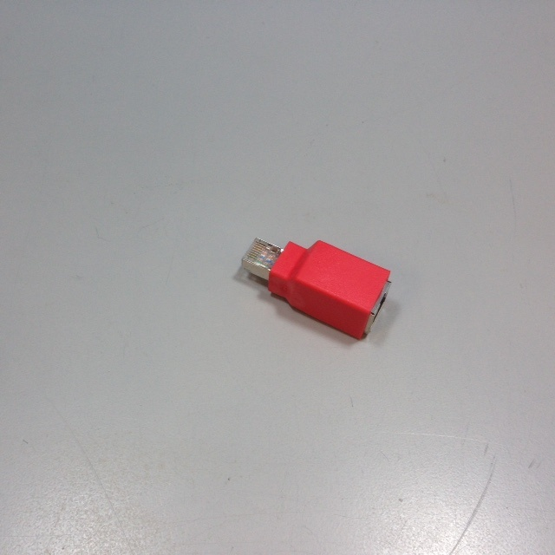

Figure 11 - Crossover Adapter

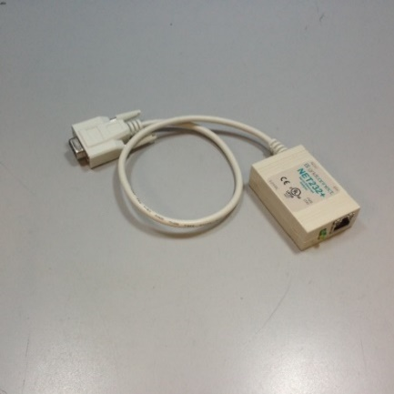

Figure 12- Ethernet to RS-232 converter for Connection via Serial port

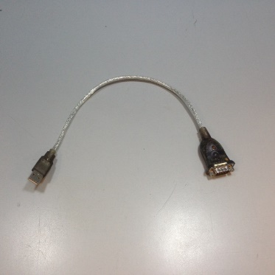

Figure 13- RS-232 to USB converter for connection via USB port

1. **Configure Ethernet to RS-232** 
   * + - 1. Set up Ethernet to RS-232 adaptor with static IP address and Port Number. In this example, adapter was configured with IP address of 192.168.0.100 and port 10001.
2. **Connect Vista to Computer:**
   * + - 1. Plug Ethernet cable (Figure 10) into RJ-45 Ethernet connection at rear of Vista. Plug other end of cable into Crossover Adapter (Figure 11).

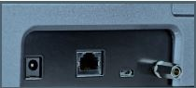

Ethernet Port

Figure 14- Rear View of Vista

* + - * 1. Plug other end of the Crossover Adapter into Ethernet port of Ethernet to RS-232 adaptor (Figure 12).
        2. Plug Ethernet to RS-232 adaptor into serial port of computer (if D-9 serial port is present) or into RS-232 to USB converter for connection to USB port. Plug power into Ethernet to RS-232 adaptor.

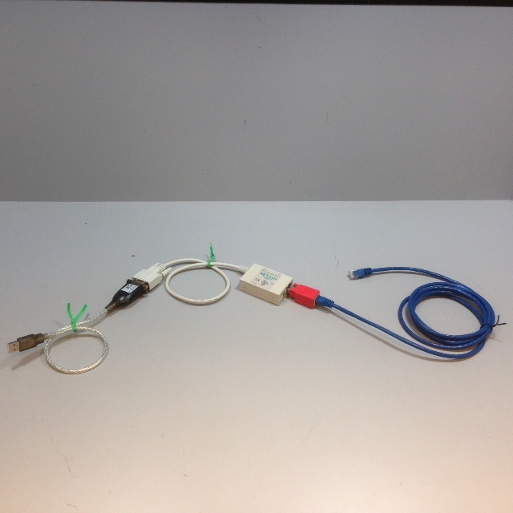

Figure 15- Cable Configuration for Direct Computer Connection

1. **Configure the Vista:** (Note: Requires Essentials Rev 14 or higher)
   * + - 1. **Configure the Ethernet port of Vista**. Select Jobs Menu> Preferences and Select ‘Configure Network Settings’. Uncheck “Use DHCP for Ethernet Config” and enter a valid IP address for the Ethernet port. In this example, the following parameters are selected.

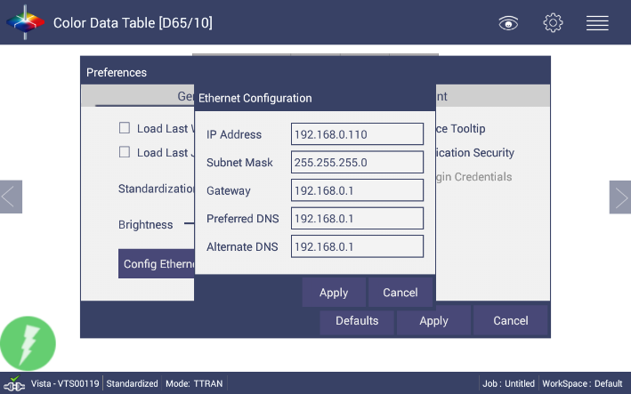

Figure 16- Configuration Parameters for Ethernet

* + - * 1. Press Apply on the Ethernet Configuration and then Apply on the Preferences Page to complete.
        2. Go to Jobs Menu> Preferences, check “Automatic Network Data Export” and click to configure.



Figure 17- Preferences>Automatic Network Data Export

* + - * 1. For a direct connection between Vista and data collection computer with RS-232 adapter, set up the Vista as a **Client**.
        2. Set the IP Address to match the settings of the Ethernet to RS-232 converter, in this case 192.168.0.100 and the Port as 10001. Press Apply and then press Apply on the Read Options screen to continue.

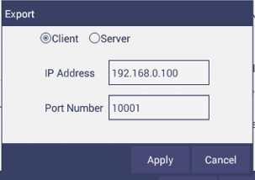

Figure 18- Read Options Export

1. **Configure the Computer:**
2. Connection configurations differ depending on data collection software. In this example, HyperTerminal is use to demonstrate connectivity.
3. The data collection computer will be set up as a Server.
4. Connect as follows:
   * 1. Select the Com port that represents the USB or Serial port connection.
     2. Define the Connection:

Bits per second: 9600

Data Bits: 8

Parity: None

Stop Bits: 1

Flow Control: None

1. **Send Data from the Vista:**
2. Configure the Color Data Table with the color scale and parameters to be transmitted.
   * 1. Standardize the instrument.
     2. Select Color Scales, Indices & Illuminant/Obs (Workspace>Color Scales)
     3. Hit Read Button, data will be transferred to the computer.

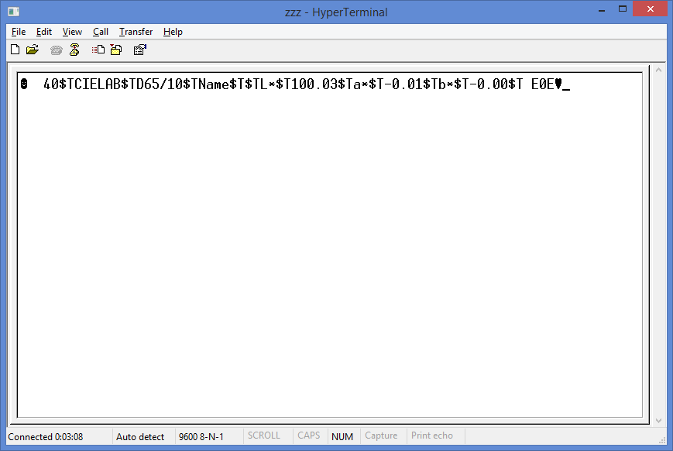

Figure 19- Data Output

The data string is shown as follows:

<STX><PACKET SIZE>$T<SCALE-LABEL>$T<ill/Obs>$T<LABEL NAME1><$T><VALUE1>$T<LABEL NAME2><$T><VALUE2><$T><LABEL NAME3>$T<VALUE3>$T ..... <LABEL NAME N><$T>

<VALUE N>$T<CHKSUM><ETX>

Where,

<STX> is the Start of Text (value =0x02)

<ETX> is the End of Text (value =0x03)

$T is the default delimiter.

<SCALE-LABEL> is the Scale Label (e.g. CIELAB)

<ill/Obs> is the ill/Obs name (e.g. D65/10)

<PACKET SIZE> is the Total size (HEX String) of the Packet excluding the <STX> and <ETX>

<LABEL NAME> is the label name (e.g. L*, a*, b*, dE* etc..)

<VALUE> is the value for the preceding Label Name

<CHKSUM> is the Checksum (HEX String) - the sum of all the ASCII values in the total packet play load starting from <PACKET-SIZE> and till <CHKSUM>

Method #3 – To export data through network

Connect Vista to a Network. You can connect Vista to a network hub using the Ethernet cable or connect Vista to a network hotspot through a WiFi connection. The computer must be connected to the same network as the Vista.

***Option A: Connect Vista to the network with Ethernet cable.***

Vista Firmware needed: 1.01.0014 and above for Ethernet Network

1. To connect Vista to network, go to Workspaces> Preferences and Select ‘Config Network Settings’. Select Ethernet configuration and check “Use DHCP for Ethernet Config”. Please write down the IP address showing in the Ethernet Setting dialog. You can also check the IP address of Vista in Jobs/About/Info.
2. Go back to Workspaces/Preferences and select ***Auto Network Data Export*** Measurement using a check and select “Config” button. Choose Vista as ***Server*** and ***Port number as 11111***. You can also choose a delimiter to mark your data.
3. Configure the terminal program such as Hyperterminal in the computer with the following settings:

* Set computer as client
* Enter the IP address of Vista which is recorded in step 1 above
* Put the port number as “11111”

After all the setting, you should be ready to get the data exported from Vista to the computer.

***Optional B: Connect to a hotspot through the WiFi connection***

Note: This option only works for VTS00388 and above. All Vista below this serial number does not have WiFi ability built-in. Also, WiFi network option is only available for Vista Essentials Rev 1.05 and above.

1. To connect Vista to network, go to ***Workspaces> Preferences*** and select ***Config Network Settings***.Select ***Configure WiFi Settings*** and the WiFi configuration dialog will be prompted. Please search and connect to the available WiFi and write down the IP address showing in this dialog. After the WiFi configuration, please click the floating ***Back Button*** to go back to Essentials app.
2. Go back to Workspaces/Preferences and select ***Auto Network Data Export*** Measurement using a check and select “Config” button. Choose Vista as ***Server*** and ***Port number as 11111***. You can also choose a delimiter to mark your data.
3. Configure the terminal program such as Hyperterminal in the computer with the following settings:

* Set computer as client
* Enter the IP address of Vista which is recorded in step 1 above
* Put the port number as “11111”

After all the setting, you should be ready to get the data exported from Vista to the computer.