As per the given below details, the event source details were not completely registered. Here is the list in Registry editor from your site before I made any change. Some files are missing here.

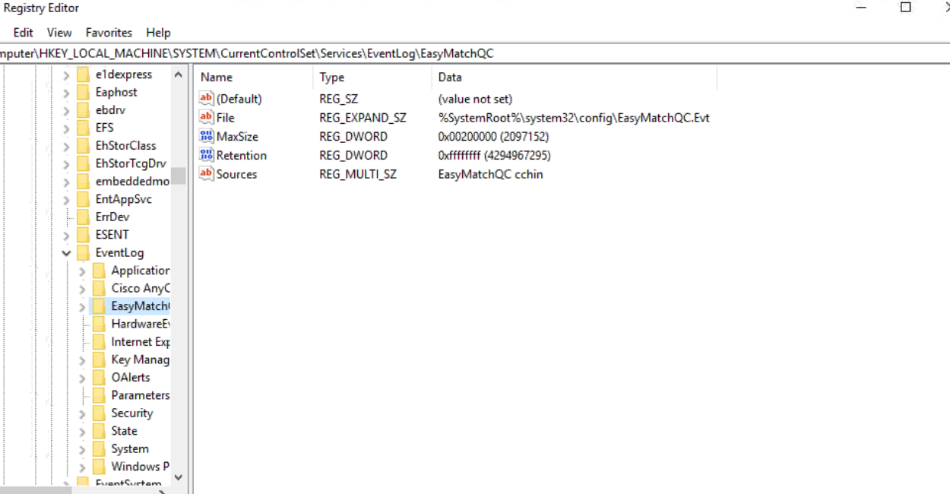

Usually, it should look like this,

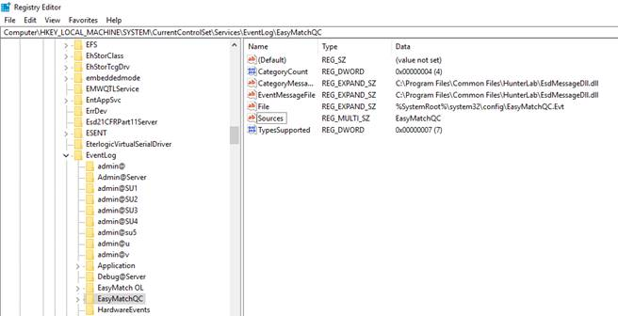

The event source details are created by the EZMQC-ER CFR server(Esd21CFRPart11Server) service which runs with system privileges.

If, this CFR service is not registered as service due to some unknown reasons, the server runs with logged in user privileges which may not be having sufficient privileges to create the event source details in the registry.

In such case where event source registration is incomplete, the event logs will be recorded in the “Window Logs” section in the system.

To resolve this, the CFR Server needs to be registered as service using the below procedure:

Step 1: Close the EZMQC-ER application if running, then open the Task Manager and verify “Esd21CFRPart11ServerModule” is running. If it is running then end this task by clicking on EndTask button.

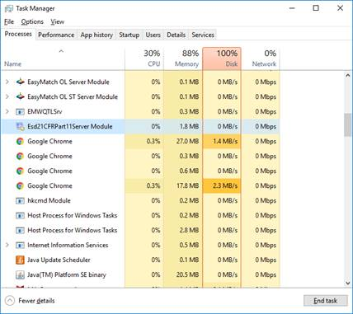

Step 2: Open command prompt with administrative privileges and type “cd C:\Program Files\Common Files\HunterLab”(for 32 bit system) or “cd C:\Program Files (x86)\Common Files\HunterLab”(for 64bit System) and press enter.

Step 3: Type “Esd21CFRPart11Server.exe /service” and press enter. (This will register the service.)

Step 4: Type “net start Esd21CFRPart11Server” and press enter. (This will start the service.)

Please refer the below screen.

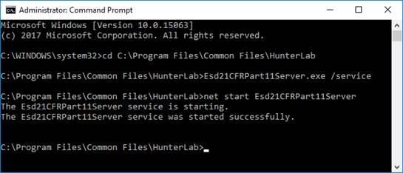

After we did the above steps, the event log can be created correctly for both EZMQC-ER admin and user accounts. This is a windows registry issue and does not influence other EZMQC-ER features. After registering Esd21CFRPart11Server.exe successfully, you do not need to re-install EZMQC-ER. You can keep working on EZMQC-ER OQ and PQ procedure.