**Connect Aeros with EZMQC**

Here are three methods that we can use to connect Aeros with EZMQC. Please select the right method and follow the corresponding instruction to connect.  Please note, only EZMQC/QC-ER 4.93 and above support Aeros sensor.

Method 1: Connect Aeros with EZMQC to the same network hub using Ethernet cables.

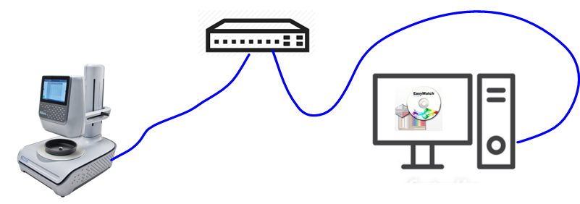

Method 2: Connect Aeros with EZMQC to the same network through WiFi connection

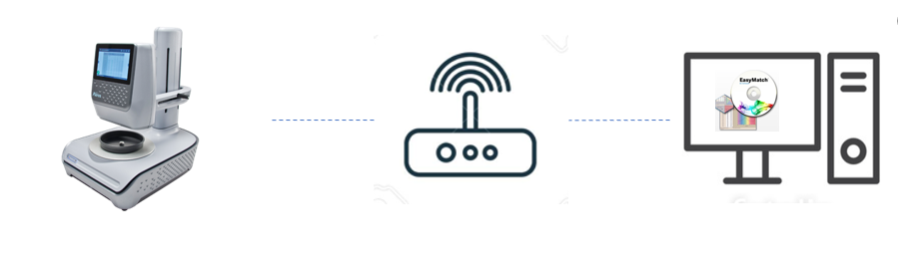

Method 3: Direct Connection between Aeros and a Computer using an Ethernet cable

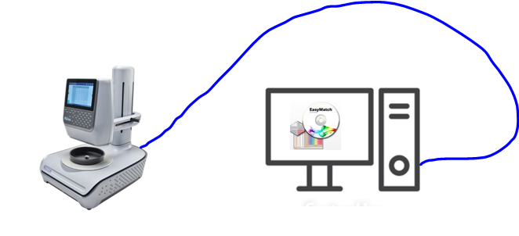

## Method 1: Connect Aeros with EZMQC to the same network using Ethernet cables



You can connect Aeros and PC to the same network hub using the Ethernet cable. Except the company network, customer can also use a stand-alone DHCP tool here to connect Aeros and PC.

1. Plug Ethernet cable into the back of the Aeros and the other end to a network hub. Plug the PC to this network hub as well.

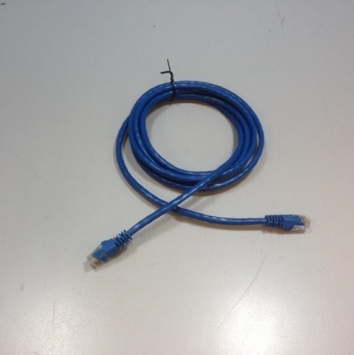

2. Connect Aeros to network, go to Workspaces > Preferences and Select Config Network Settings. Select Configure Ethernet Settings. Check Use DHCP for Ethernet Config and click Apply. If you used the other network setting before, please restart Aeros to apply the new network setting.

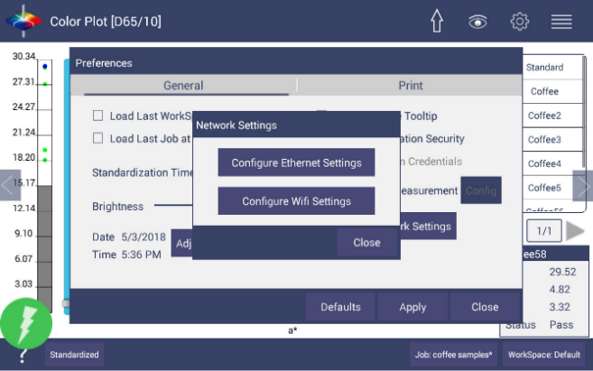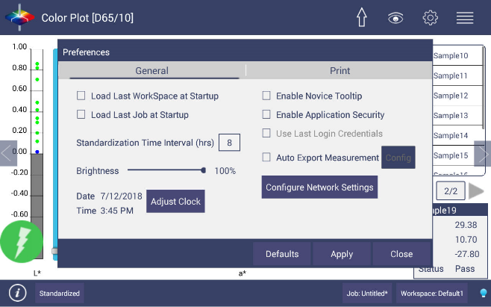

3. Aeros is now ready to connect to EZMQC. Open EZMQC in the PC. In Sensor, click "Add Sensor" and select "Aeros". Select “Ethernet” and check the box "Discover and Select a Sensor in the Network" and then click "Search" to do an automatically searching. There will be a drop-down list of all available Aerossensors. If the sensor in the list including IP address as well as sensor name, then it is connectable. If the sensor i the listwith “??????” instead of sensor name, it means that EZMQC can find the Aeros, while Aeros is not free to connect to EZMQC. If you meet this problem, you can restart Aeros and click search again. Also, you can go to Aeros Essentials/Workspace menu/Diagnostics/Advanced, click "Restart Comm" to have Aeros communication available, and then go back to EZMQC and click search again.

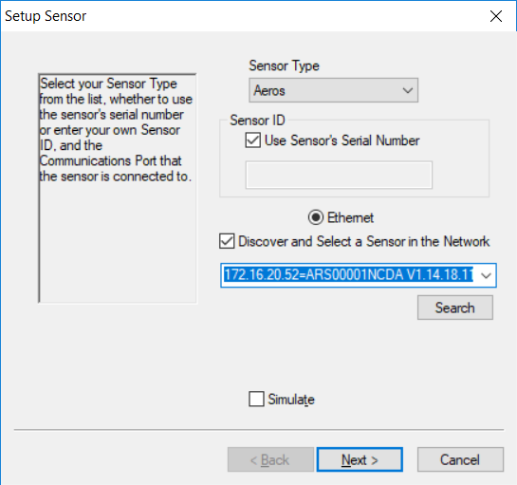

## Method 2: Connect Aeros with EZMQC to the same network through WiFi connection



1. Connect Aeros to network, go to Workspaces> Preferences and select Config Network Settings. Select Configure WiFi Settings and the WiFi configuration dialog will be prompted.

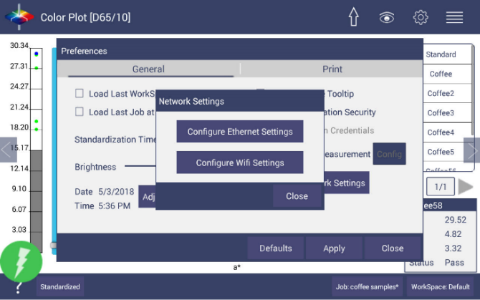

  2. Please search and connect to the available WiFi and write down the IP address showing in this dialog. After the WiFi configuration, please click the floating Back Button to go back to Essentials app. If you used the other network setting before, please restart Aeros to apply the new network setting.

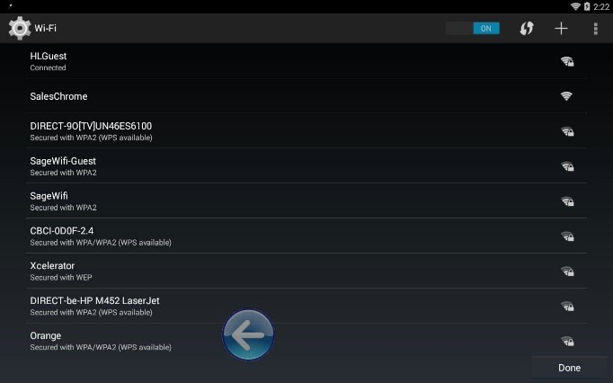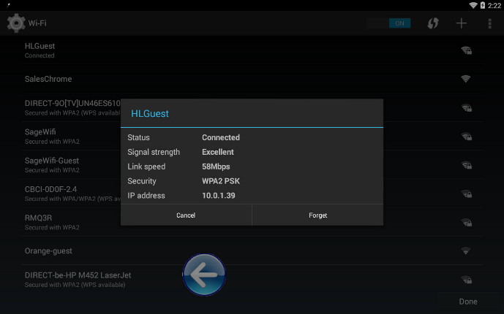

3. Connect PC to the same network as well.

4. Aeros is now ready to connect to EZMQC. Open EZMQC in the PC. In Sensor, click "Add Sensor" and select "Aeros". Select “Ethernet” and check the box "Discover and Select a Sensor in the Network" and then click "Search" to do an automatically searching. There will be a drop-down list of all available Aerossensors. If the sensor in the list including IP address as well as sensor name, then it is connectable. If the sensor in the listwith “??????” instead of sensor name, it means that EZMQC can find the Aeros, while Aeros is not free to connect t EZMQC. If you meet this problem, you can restart Aeros and click search again. Also, you can go to Aeros Essentials/Workspace menu/Diagnostics/Advanced, click "Restart Comm" to have Aeros communication available, and then go back to EZMQC and click search again.

## Method 3: Direct Connection between Aeros and a Computer using an Ethernet cable



1. Plug Ethernet cable into RJ-45 Ethernet connection at rear of Aeros. Plug the other end to the PC. If PC does not have any available ethernet port, USB-Ethernet adapter can be applied.

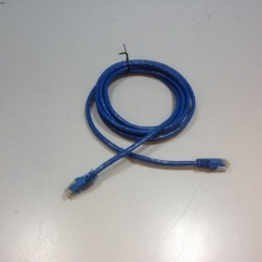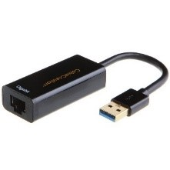

2. Check PC IP settings. Open Command Prompt in the PC. Type in ipconfig, find the right ethernet (in this case, it is Ethernet adapter Ethernet) and write down autoconfiguration IPv4 Address as well as the Subnet Mask.

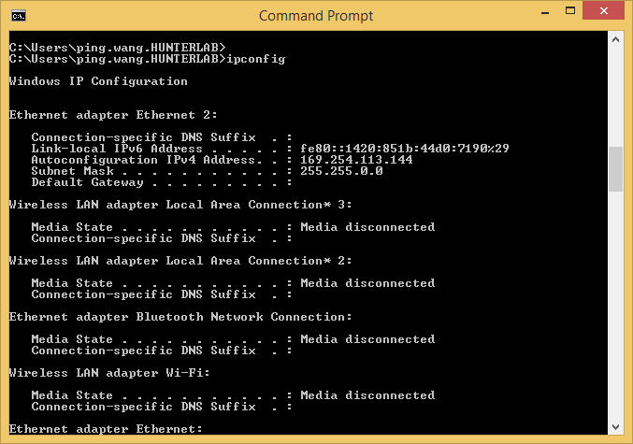

3. Configure the Aeros IP settings

Open Aeros Essentials, go to Workspaces > Preferences > Configure Network Settings. First, select the Ethernet configuration. Uncheck Use DHCP for Ethernet Config. Type in IP address and Subnet Mask manually. The Subnet Mask is the exact same as the one showing in PC. The last factor in the IP address should be changed such that is different from the computer IP address by one digit. Press Apply on the Ethernet Configuration and then Apply on the Preferences Page to complete.

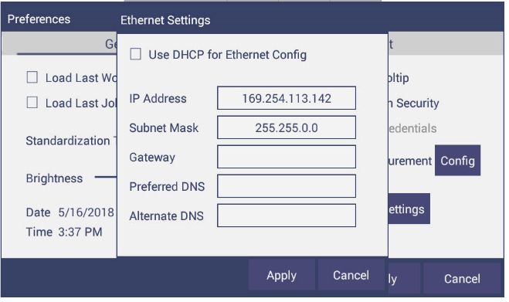

4. Turn the instrument off and then back on.

5. Aeros is now ready to connect to EZMQC. Open EZMQC in the PC. In Sensor, click "Add Sensor" and select "Aeros". Select “Ethernet” and check the box "Discover and Select a Sensor in the Network" and then click "Search" to do an automatically searching. There will be adrop-down list of all available Aerossensors. If the sensor in the list including IP address as well as sensor name, then it is connectable. If the sensor in the listwith “??????” instead of sensor name, it means that EZMQC can find the Aeros, while Aeros is not free to connect to EZMQC. If you meet this problem, you can restart Aeros and click search again. Also, you can go to Aeros Essentials/Workspace menu/Diagnostics/Advanced, click "Restart Comm" to have Aeros communication available, and then go back to EZMQC and click search again.