Connect Agera with EZMQC

Here are three methods that we can use to connect Agera with EZMQC. Please select the right method and follow the instruction to connect. Please note, only EZMQC 4.95 and above support Agera sensor.
Method 1: Connect Agera with EZMQC to the same network hub using Ethernet cables.
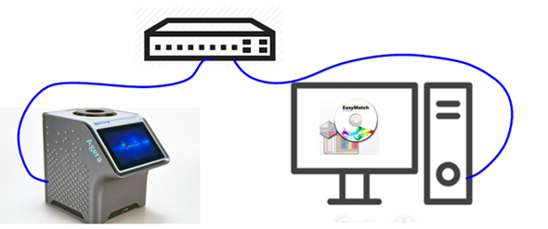
Method 2: Connect Agera with EZMQC to the same network through WiFi connection
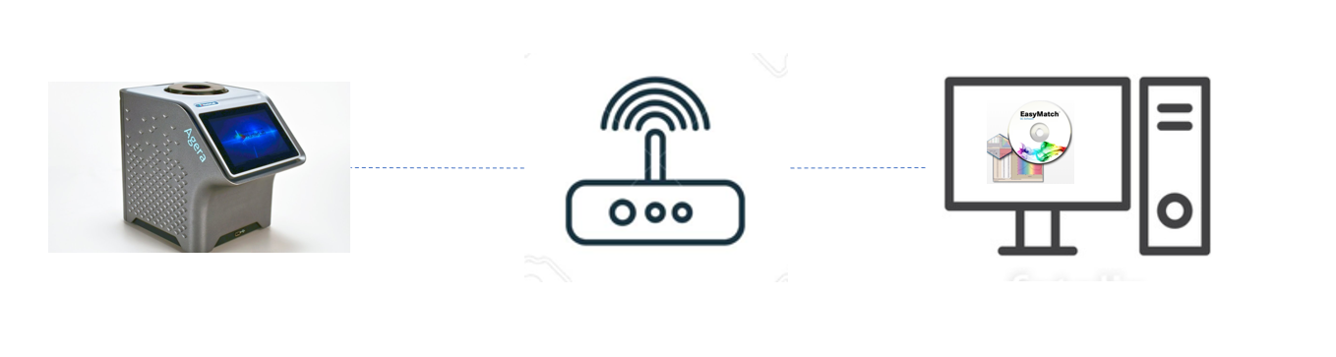
Method 3: Direct Connection between Agera and a Computer using an Ethernet cable
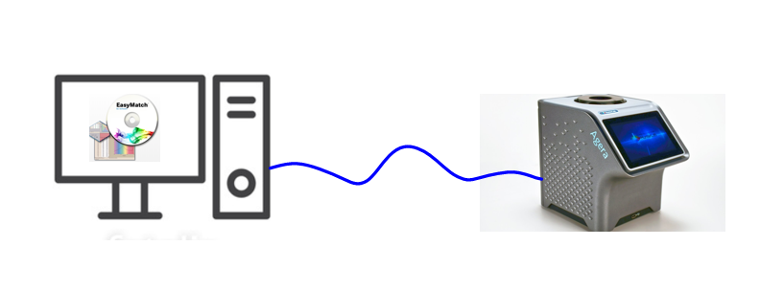

Method 1: Connect Agera with EZMQC to the same network using Ethernet cables
You can connect Agera and PC to the same network hub using the Ethernet cable. Except the company network, customer can also use a stand-alone DHCP tool here to connect Agera and PC.
- Plug Ethernet cable into the back of the Agera and the other end to a network hub. Plug the PC to this network hub as well.
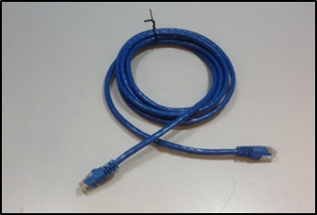
Ethernet Cable
- Connect Agera to network, go to Workspaces > Preferences and Select Config Network Settings. Select Configure Ethernet Settings. Check Use DHCP for Ethernet Config and click Apply. If you used the other network setting before, please restart Agera to apply the new network setting.

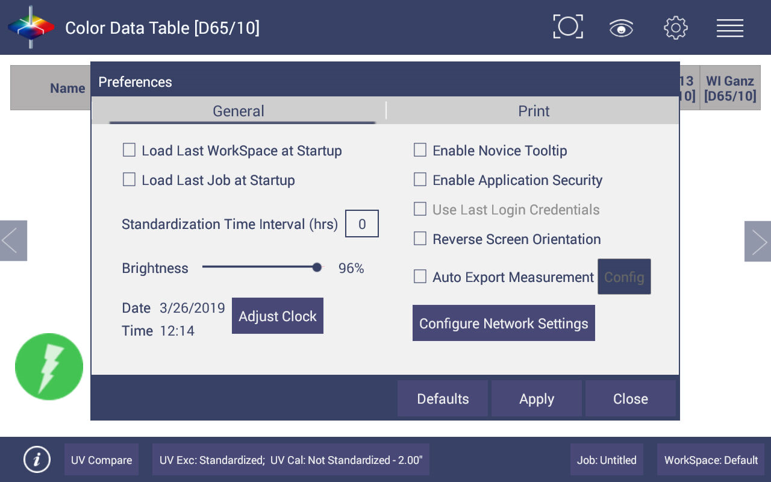
Preferences (General) > Network Settings
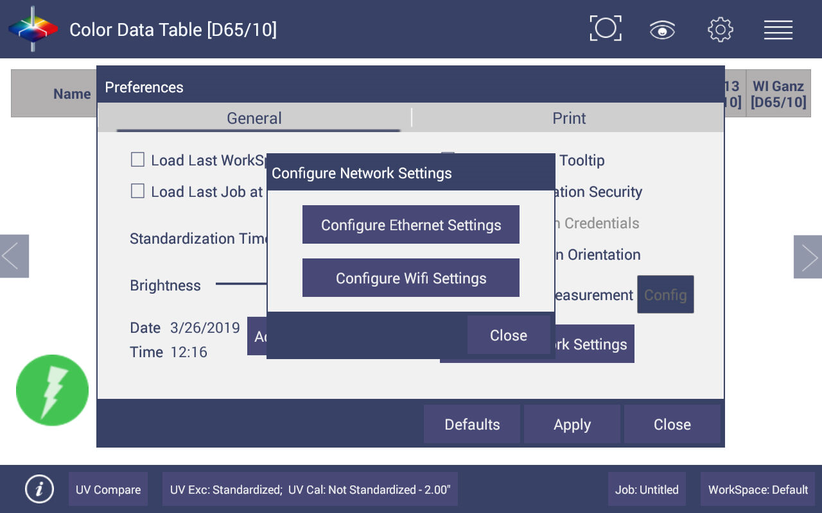
Configure Ethernet
- Agera is now ready to connect to EZMQC. Open EZMQC in the PC. In Sensor, click "Add Sensor" and select "Agera". Select “Ethernet” and check the box "Discover and Select a Sensor in the Network" and then click "Search" to do an automatically searching. There will be a drop-down list of all available Agera sensors. If the sensor in the list including IP address as well as sensor name, then it is connectable. If the sensor in the list with “??????” instead of sensor name, it means that EZMQC can find the AGERA, while AGERA is not free to connect to EZMQC. If you meet this problem, you can restart AGERA and click search again. Also, you can go to Agera Essentials/Workspace menu/Diagnostics/Advanced, click "Restart Comm" to have Agera communication available, and then go back to EZMQC and click search again.
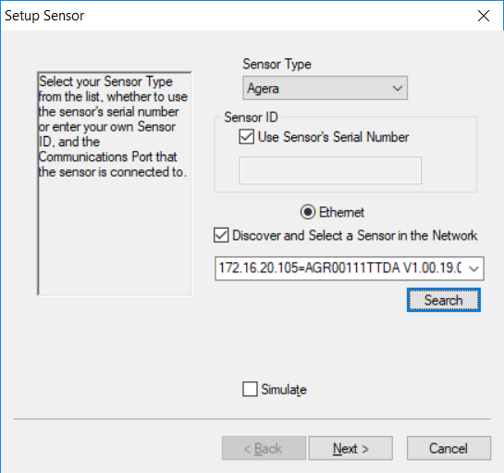
Add Agera sensor to EZMQC

Method 2: Connect Agera with EZMQC to the same network through WiFi connection
- Connect Agera to network, go to Workspaces> Preferences and select Config Network Settings. Select Configure WiFi Settings and the WiFi configuration dialog will be prompted.

Configure Network Settings
Configure WIFI settings
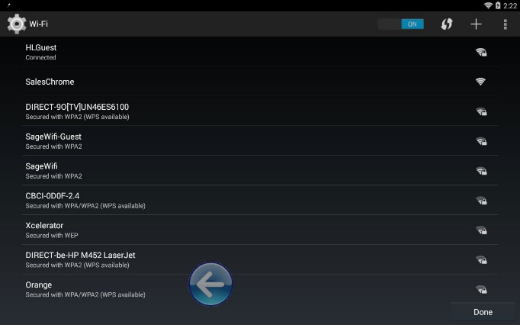
- Please search and connect to the available WiFi and write down the IP address showing in this dialog. After the WiFi configuration, please click the floating Back Button to go back to Essentials app. If you used the other network setting before, please restart Agera to apply the new network setting.
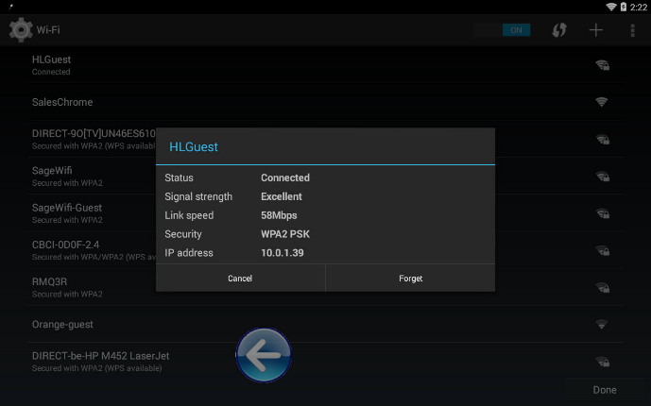
Find IP Address
Find IP Address (Part2)
- Connect PC to the same network as well.
- Agera is now ready to connect to EZMQC. Open EZMQC in the PC. In Sensor, click "Add Sensor" and select "Agera". Select “Ethernet” and check the box "Discover and Select a Sensor in the Network" and then click "Search" to do an automatically searching. There will be a drop-down list of all available Agera sensors. If the sensor in the list including IP address as well as sensor name, then it is connectable. If the sensor in the list with “??????” instead of sensor name, it means that EZMQC can find the AGERA, while AGERA is not free to connect to EZMQC. If you meet this problem, you can restart AGERA and click search again. Also, you can go to Agera Essentials/Workspace menu/Diagnostics/Advanced, click "Restart Comm" to have Agera communication available, and then go back to EZMQC and click search again.

Method 3: Direct Connection between Agera and a Computer using an Ethernet cable
Ethernet cable is plugged into the back of the Agera and the other end is connected to the computer. Ethernet adapter USB can be applied here if the computer does not have any spare Ethernet port.
- Plug Ethernet cable into RJ-45 Ethernet connection at rear of Agera. Plug the other end to the PC. If PC does not have any available ethernet port, USB-Ethernet adapater can be applied.
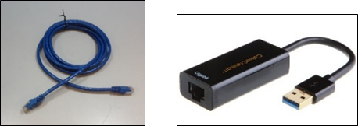
Ethernet Cable and Ethernet to USB Adapter
- Check PC IP settings. Open Command Prompt in the PC. Type in ipconfig, find the right ethernet (in this case, it is Ethernet adapter Ethernet) and write down autoconfiguration IPv4 Address as well as the Subnet Mask.
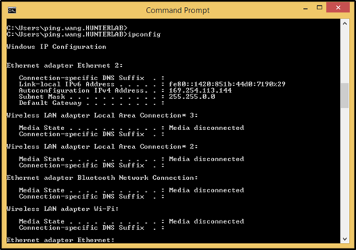
Command Prompt ipconfig
- Configure the Agera IP settings
Open Agera Essentials, go to Workspaces > Preferences > Configure Network Settings. First, select the Ethernet configuration. Uncheck Use DHCP for Ethernet Config. Type in IP address and Subnet Mask manually. The Subnet Mask is the exact same as the one showing in PC. The last factor in the IP address should be changed such that is different from the computer IP address by one digit. Press Apply on the Ethernet Configuration and then Apply on the Preferences Page to complete.

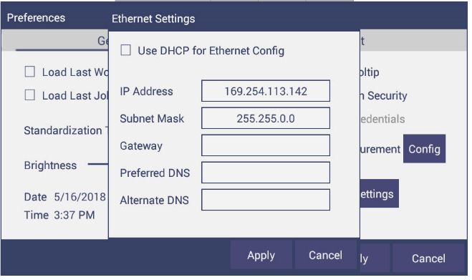
Configuration Parameters for Ethernet
- Turn the instrument off and then back on.
- Agera is now ready to connect to EZMQC. Open EZMQC in the PC. In Sensor, click "Add Sensor" and select "Agera". Select “Ethernet” and check the box "Discover and Select a Sensor in the Network" and then click "Search" to do an automatically searching. There will be a drop-down list of all available Agera sensors. If the sensor in the list including IP address as well as sensor name, then it is connectable. If the sensor in the list with “??????” instead of sensor name, it means that EZMQC can find the AGERA, while AGERA is not free to connect to EZMQC. If you meet this problem, you can restart AGERA and click search again. Also, you can go to Agera Essentials/Workspace menu/Diagnostics/Advanced, click "Restart Comm" to have Agera communication available, and then go back to EZMQC and click search again.

