Vista Essentials Rev 1.06.0088 and EZMQC Rev4.96.06 has the external triggering feature available for user to remote control Vista to run standardization and measurements.
Vista Essentials or EZMQC should connect to the same network of the External Triggering tool.
Vista Essentials/External Trigger:
*Go to Workspace menu/Read Options, check External Triggering. When it is checked on, a new dialog box will be opened to configure the port number. The IP address showed in Vista Essentials is Vista’s own IP address. On ‘Apply’, the enable status and port number will be saved and the application will be in listening mode as a server.
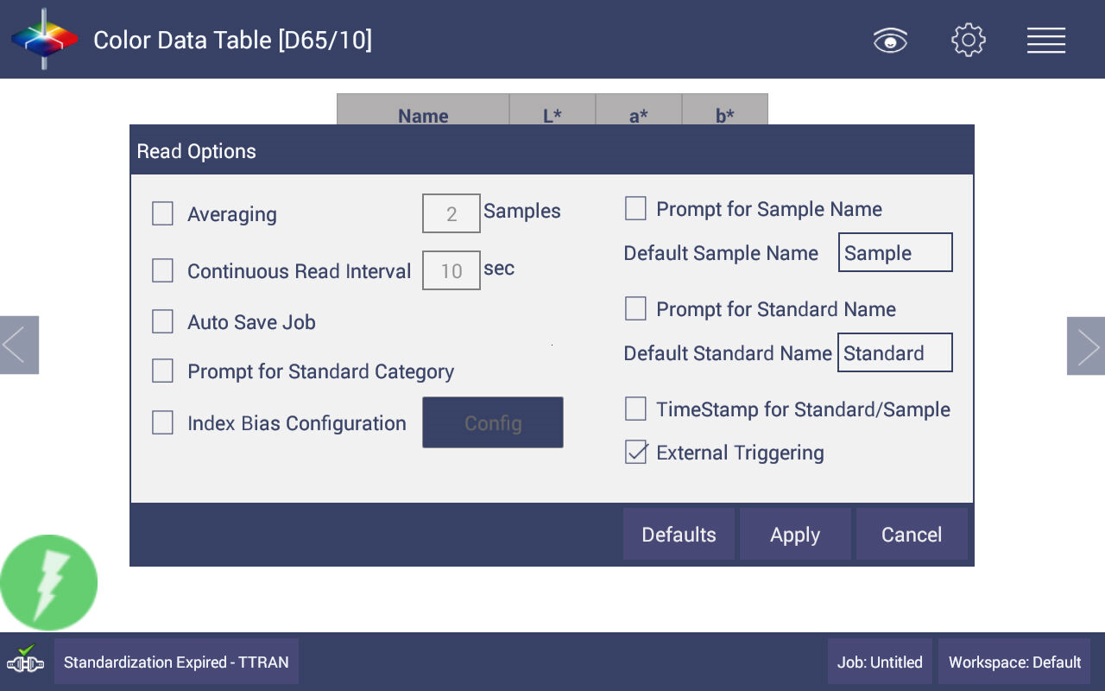
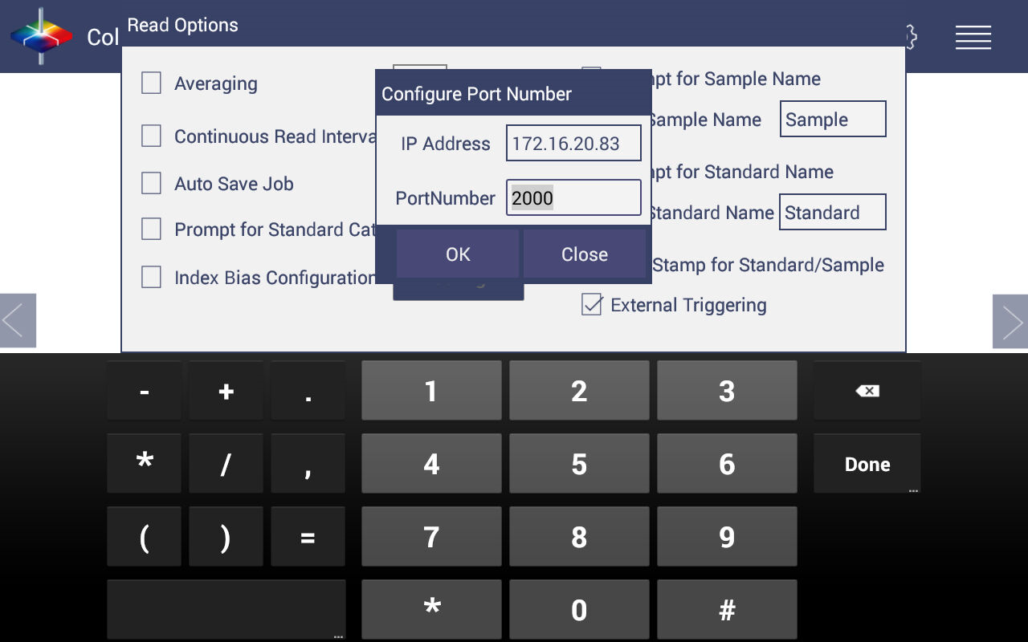

*We used this External Triggering tool as an example here. When the Vista instrument IP and configured port number are specified in the tool and click ‘Connect’, the client tool will be connected to the External Trigger server in Vista Essentials.
After successful connection, ‘Standardize’ and ‘Read Sample’ commands can be operated using this tool.
For other tools, user need to configure to connect with Vista IP and port number. And then send the standardization and Read sample commands to Vista. After each command, Vista will send the response back to the tool. E.g, if Vista pass the standardization or successfully take a measurement, it will response with “Succeed” message.
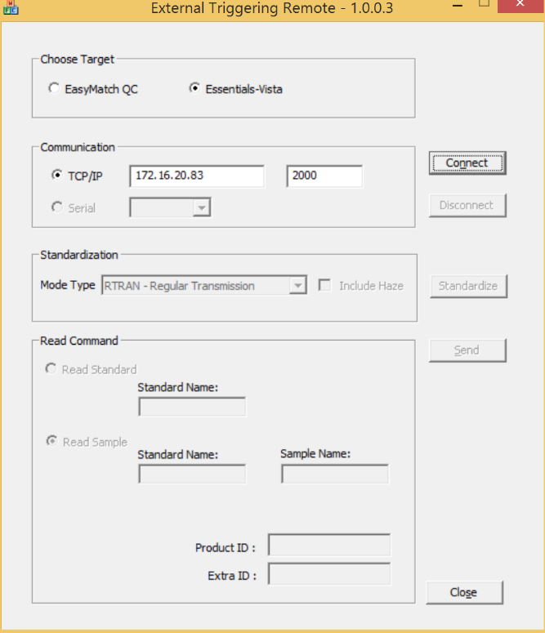
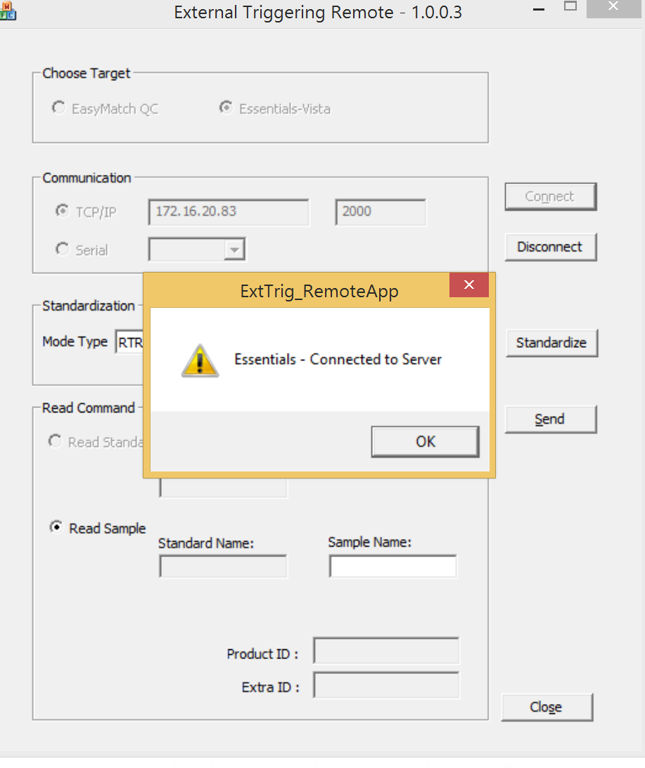

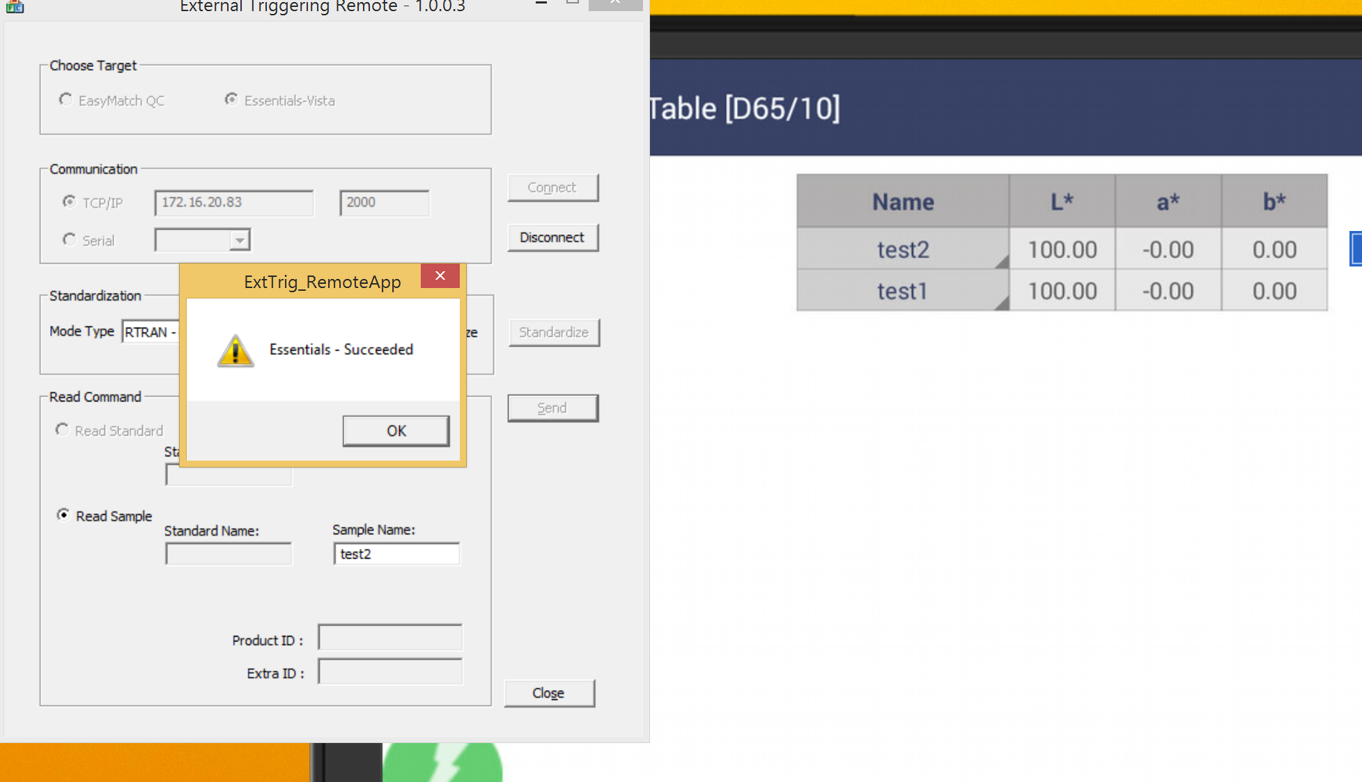
EZMQC/External Trigger:
*Add Vista sensor into EZMQC
*Click EZMQC/Options/External Triggering Configuration and setup the port number
*Setup a External triggering tool with the EZMQC PC IP and port number. Here we used our External triggering tool.
Compared to Vista Essetials external triggering, EZMQC’s one can additionally support to do standard measurements and enter product ID/Extra ID name.
Each standardization, measure sample/standard will get the reponse. E.g.”Standardization Successful” “Standard Measurement Successful” and “Sample Measurement Successful”.
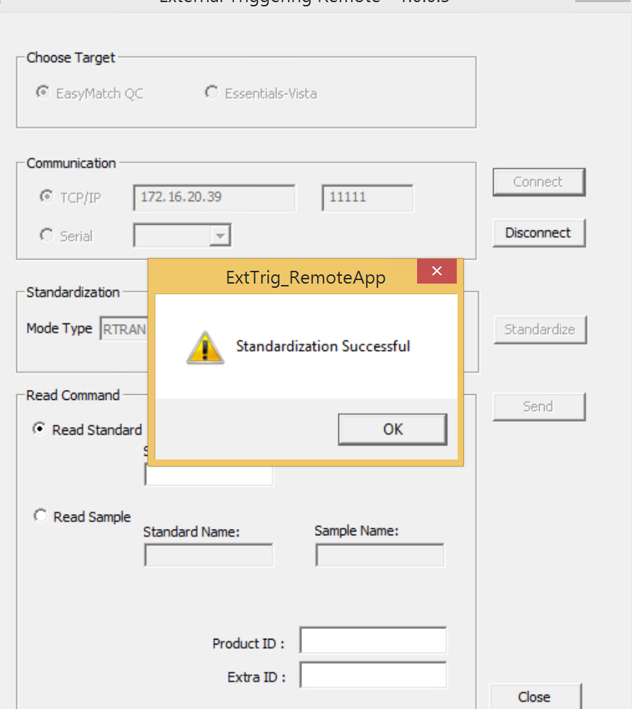

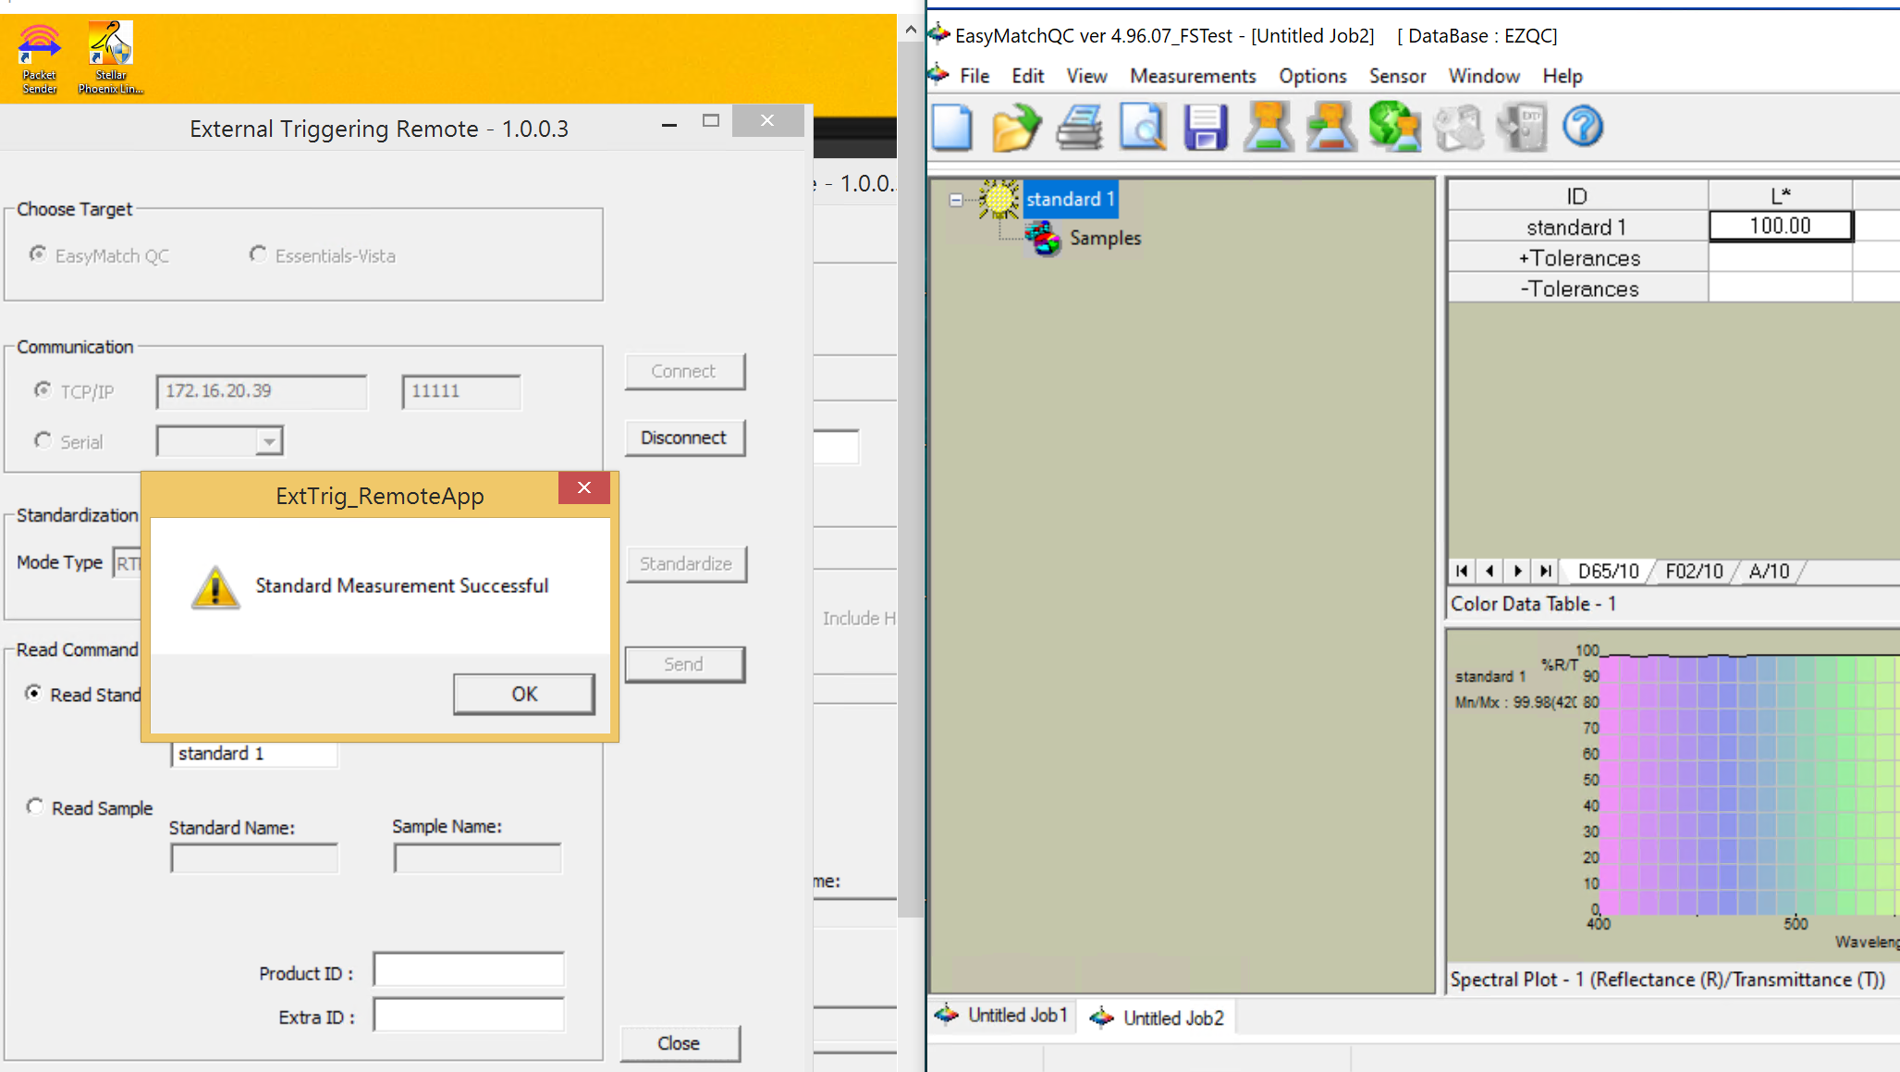
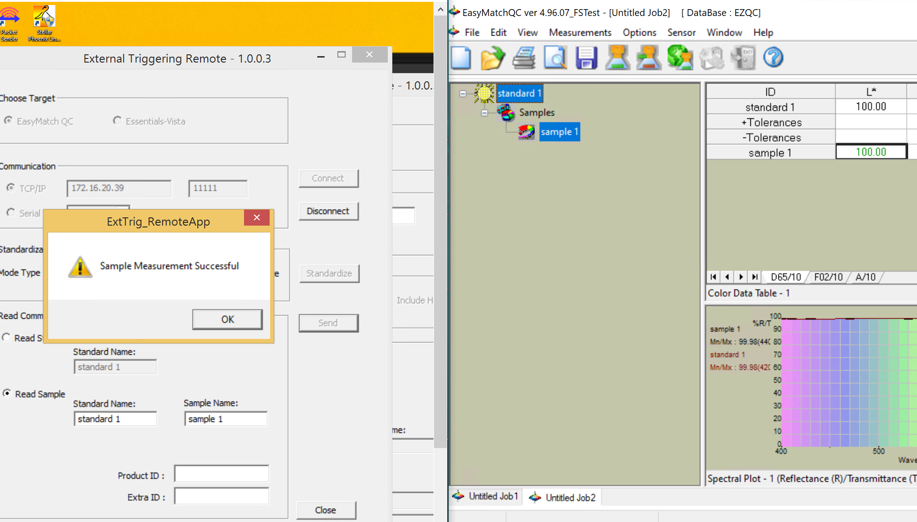

Following are External Triggering command and response structures

The below is the typical command frame sent from External Triggering tool.

$,<CMD>,<COMMAND INFO>,#

Where

<CMD> is the Command String

<COMMAND INFO> The associated Command Parameters

$ and # are the Begin and End Markers of the Command frame.

Command Response Structure

For every command received from the Triggering Tool, the Essentials-Vista response will be in the below format:

“$ Essentials - <ACKINFO> #”

Where

<ACKINFO> can be “Connected to Server”, “Succeeded”, “Failed”, “Standardization Expired! Please Standardize to continue”, the name of the connected sensor, etc..

‘Get Current Sensor’ Command Structure:

When “Standardize” button in External Triggering tool is clicked, the below command is sent to Essentials.

$,GETCURRENTSENSOR,#

If th connected sensor type is received as “Vista”, then only the standardization command is sent to Essentials.

‘Standardize’ command structure:

The following is the Command Structure for standardization

$, <CMD>, <MODE TYPE>, <mode type>, <HAZESTATUS>,<haze status>, #

Where,

<CMD>: STANDARDIZE

<Mode Type>: ‘RTRAN – Regular Transmission’ (or) ‘TTRAN – Total transmission’.

For EZMQC: This field is not applicable. The Standardization is performed as per the current selected mode in Modes configuration dialog.

<Haze Status>: 0 for ‘without Haze’ and 1 for ‘with Haze’

Example:

ex1: $,STANDARDIZE,HAZESTATUS,0,# --->For EZMQC application

ex2: $,STANDARDIZE,MODETYPE,RTRAN – Regular Transmission,HAZESTATUS,0,# --->For Essentials-Vista

‘Measure’ command structure:

The following is the typical Command Structure for Measurement

$, <CMD>, <MEASUREMENT TYPE>, <STD>, <std name>, <SMP>, <sample name>, <PID>, <Product ID>, <EID>, <Extra ID>, #

Where,

<CMD>: MEASURE

<MEASUREMENT TYPE>: 1 for ‘Read Standard’ and 2 for ‘Read Sample’

The <Product ID> & <Extra ID> represent to associated with the respective measured Standard or Sample.

Example:

a) Read Standard (Only for EZMQC):
ex1:$,MEASURE,1,STD,Standard1,PID,prodID1,EID,extraID1,#

ex2: $,MEASURE,1,STD,Standard1,# -- with no optional PID &EID.

b) Read Sample (For EZMQC):
ex1:$,MEASURE,2,STD,Standard1,SMP,sample1,PID,pid1,EID,eid1,#

ex2: $,MEASURE,2,STD,Standard1,SMP,sample1,# -- with no optional PID & EID

c) Read Sample (For EZMQC and Essentials):
ex1: $,MEASURE,2,SMP,sample1,# -- with no Standard and optional PID & EID

