# **Using the 6mm Aperture/Receiver Ring to take Total Transmittance Measurements on a Sample**

D02-1019-350

**Instrument**: USVIS, USPRO

**Requires**: D02-1019-305 Receiver Ring Assembly, installed

**Description:** D02-1019-350 is installed on the sphere to reduce the aperture size for Total Transmittance measurements. It requires the installation of the Receiver Ring Assembly which holds the 6mm aperture magnetically.

## STANDARDIZATION

1. In EasyMatch QC, go to ***SENSOR > ADD SENSOR*** to select your sensor.
2. Go to ***SENSOR > STANDARDIZE*** and select **TOTAL TRANSMITTANCE MODE** (TTRAN) for USVIS or USPRO.
3. To standardize for Total Transmittance measurements and set the bottom-of-scale, place the light blocker card in the transmittance compartment at the sphere side.

The transmittance compartment door may be closed or left open. Follow the software prompts.

1. To set the top-of-scale, place the white tile at the reflectance port with the Transmittance compartment closed. When taking transmittance measurements, the calibrated white tile used during standardization must be kept at the reflectance port.
2. The instrument is now ready to take measurements in TTRAN.

## MEASURING SAMPLES

1. 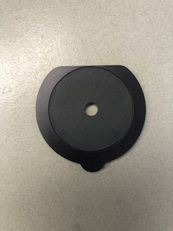Insert the magnetic 6mm aperture (D02-1019-350) into the holder and place on the sphere receiver ring.

***Note: This aperture has an opening that is smaller than the usual transmittance port opening. Performance specifications (i.e. Factory-supplied color values, stability, accuracy, etc.) are based on the standard transmission port opening. These specifications will not be met with the aperture in place.***

1. In EasyMatch QC, set up the measurement screen to read the desired color scale, illuminant and observer.
2. Place the sample to be measured in the transmittance compartment making sure that the area of the sample to be measured faces the aperture.
3. Take a reading using the sample button or ***MEASUREMENTS > SAMPLE***.
4. Rotate the sample and read it at least one more time. Average the multiple color readings for a single measurement representing its color (***MEASUREMENTS > AVERAGE***). Averaging multiple readings with rotation between readings minimizes measurement variation associated with non-uniformity or texture.
5. Record the average color values.
6. With small samples, it is recommended to look at color difference using a Sample vs a Standard instead of absolute readings. Difference measurements show excellent repeatability.

***Note: if this is the first time using EZMQC software, please refer to EasyMatch QC user Manual.***