Vista - Software download - How to Update Vista Essentials software

For Vista Essentials Non-ER customer: Attached, please check the latest Vista Essentials non-ER(.apk file), Version 1.08.0100. The major changes from last version 1.07 to 1.08 are listed in the attachment.

To check for version number on your instrument, go to *JOBS MENU > ABOUT***.**

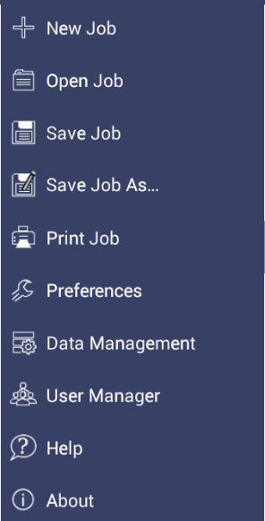

Jobs Menu

***Figure. Jobs > About***

The version number is listed on the bottom of the ***ABOUT*** page.

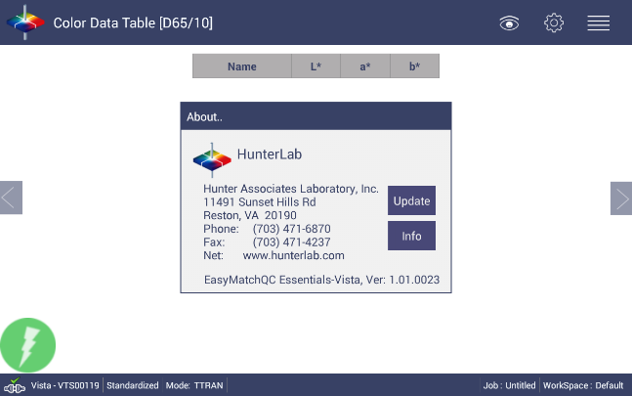

***Figure. ABOUT > Software Version***

Please download the .apk file onto a flash drive. To update Essentials, attach the flash drive with the new update to the front USB port of the Vista.

***Figure. Insert Flash Drive***

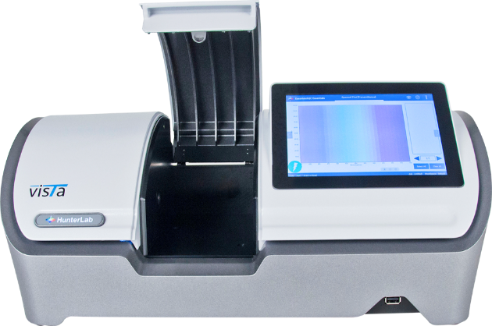

Go to *JOBS > ABOUT* and click *UPDATE* to the latest version. The Instrument will detect the corresponding Essentials apk file on the flash drive. If the latest Essentials is already installed in the instrument, the following message will be displayed: *The application package is up to date.*



**Figure. Update**

* About the file service to backup/restore between Vista and the networked PC, please check this article, [*https://support.hunterlab.com/hc/en-us/articles/360033114192*](https://support.hunterlab.com/hc/en-us/articles/360033114192)

*\* For Vista Essentials 1.03.0045 and above, we provide two different Vista Essentials packages, Vista Essentials non-ER and Vista Essentials ER. Vista Essentials ER has additional features to be compliance with FDA 21 CFR Part 11. If you'd like to update Vista Essentials from non-ER to a ER, or if you currently has a Vista Essentials ER in your Vista and would like to check the latest ER, please contact* [*support@hunterlab.com*](mailto:support@hunterlab.com)

If the current Essentials version in Vista is before 1.01.0019, please follow the steps below to update Essentials. Please check this [video](https://www.youtube.com/watch?v=hJbHpAnxEJs&feature=youtu.be) on how to get to Vista home screen from Essentials.

1. Go to ***JOBS>ABOUT*** and tap the screen 6 times inside the box.

Tap 6 times



1. Once the Home Screen is displayed, go to ***ESSENTIALS UPDATE***. Follow the process to update the software.

Select Essentials Update

1. To return to Vista Essentials for measurement, select ***ESSENTIALS***.



Select Essentials

1. Return to ***JOBS > ABOUT*** to verify the software version.

Do you still need more information? Submit a ticket and our support team member will reach out to you soon!