Revision history from Vista Essentials 2 2025.1 to 2025.2
Notable changes in Vista 2025.2
- Essentials For Vista Standard Import
Vista Essentials 1 standard exports can now be imported into Essentials 2. Export your standards as a .std file, then go into instrument settings to import them. A new WorkSpace will be created for each imported standard.
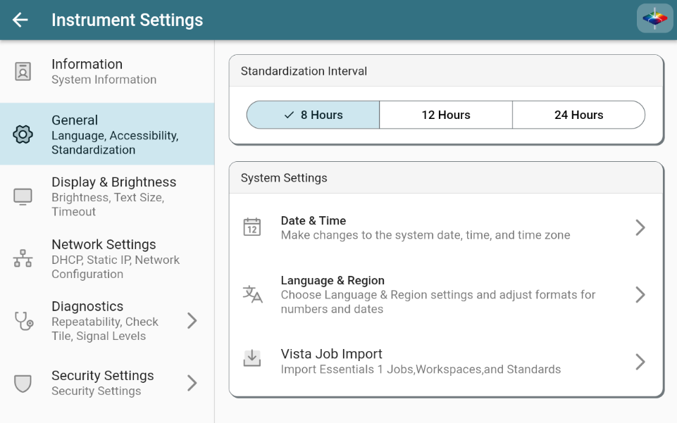
- Instrument Global Search
A new global search tool has been added to Essentials! Using this tool, you can quickly find jobs or workspaces just by typing their name. You can find the new global search in the help menu in the upper right, or by swiping up with 3 fingers on any page.
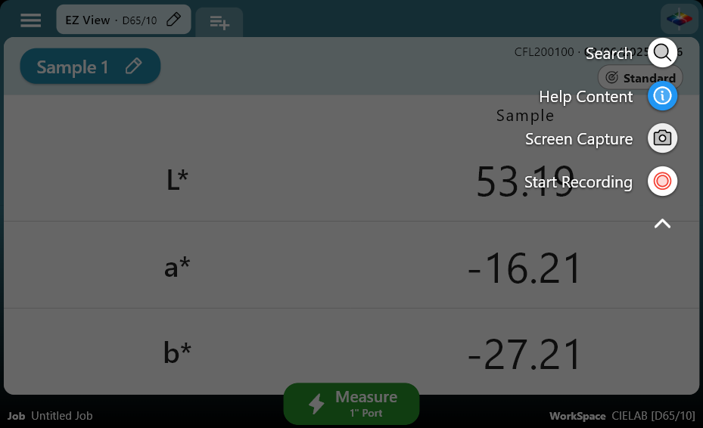
All jobs and workspaces on your instrument can be searched for and open, as well as many of the instrument settings pages.
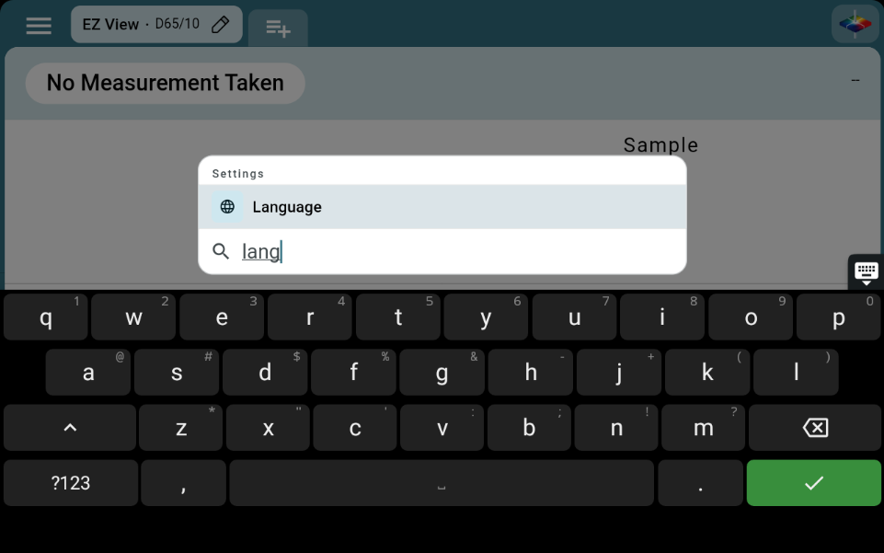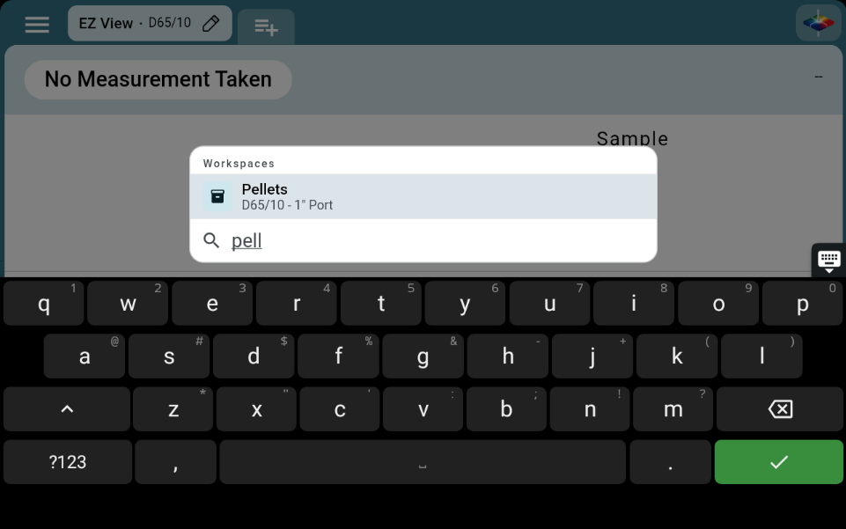
- Measurement Label Printing
Individual samples can now be printed on supported labels directly from the instrument. Press the "Print Label" button in the measurement detail dialog to print. Additional options are available in your workspace settings to control the barcode and other format options of the label. Essentials Supports the Brother QL800 series printers. We recommend the following label sizes:
- 29x90 mm (Address Label)
- 62x100 mm (Shipping Label)
- 62 mm width Roll (Shipping Label continuous)
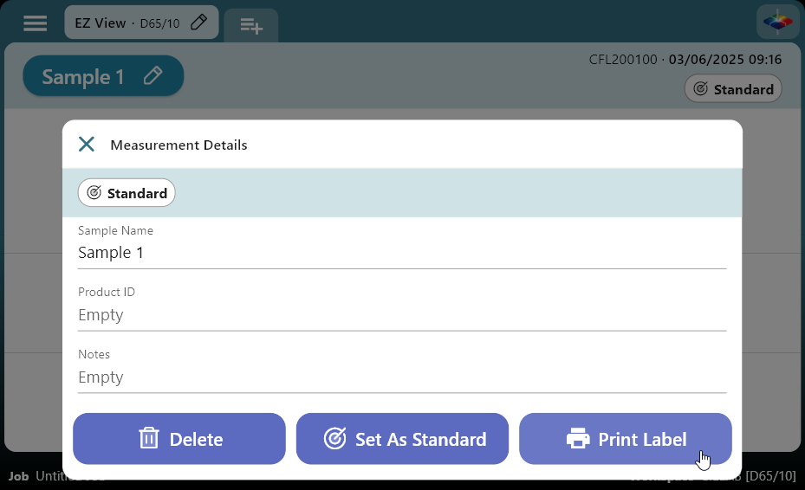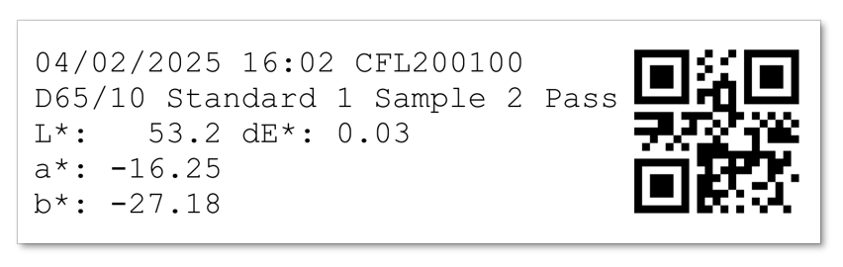
- Workspace Barcode Automation
A new workflow has been added to Essentials that makes it even easier to switch workspaces. You can now print a unique barcode for any WorkSpace and scan it to immediately switch to that workspace. Now instead of using the UI on the instrument, you can print out a book of your WorkSpaces and just scan them to switch.
If you have a label printer connected to your instrument, you can even print the WorkSpace barcode directly from Essentials.
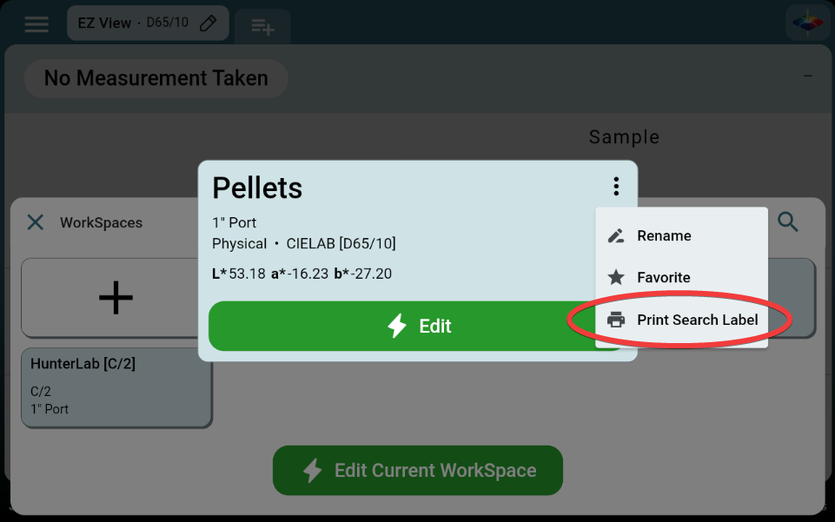
- Full Page Job Printing
In addition to PDF Exports, you can now print a Job to a networked printer directly from your Vista. All measurements in the job will be printed out, matching how you've configured your color data or spectral data tables.
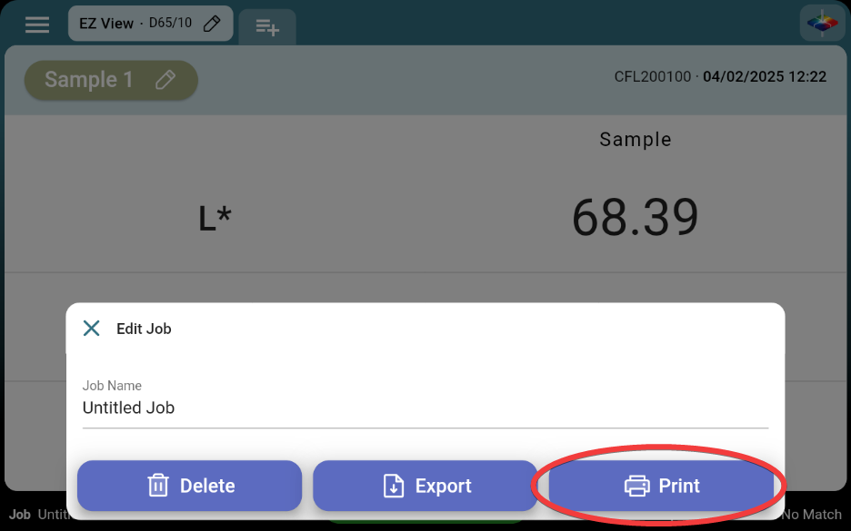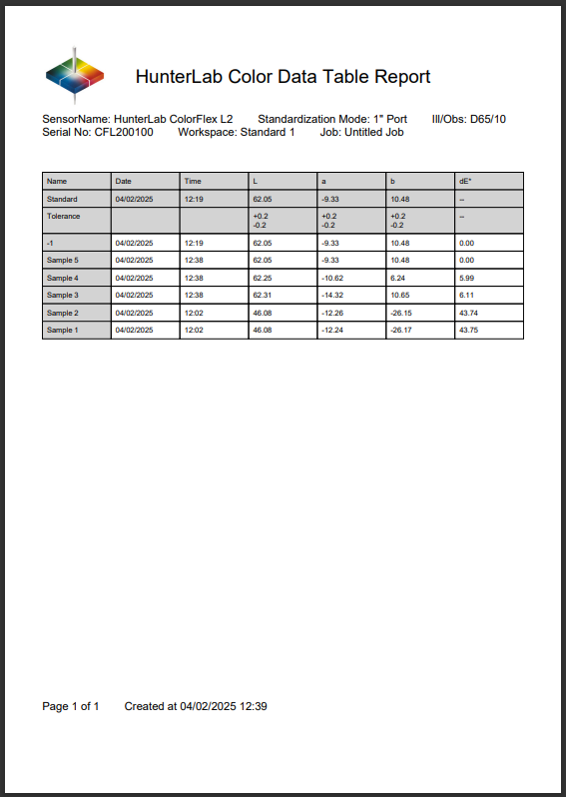
- PDF and XLS Job Exports
Jobs can now be exported in more than just CSV format. PDF and XLS formats are now available and make it easy to open jobs in Excel or to print reports in a preset format. If you're opening a Job in Excel, we strongly recommend using the XLS export as it will better format numbers and dates. The CSV export remains and is recommended if you're providing the Job to any sort of automation system.
When exporting a PDF, you can select either the color data table or spectral data tables to export.
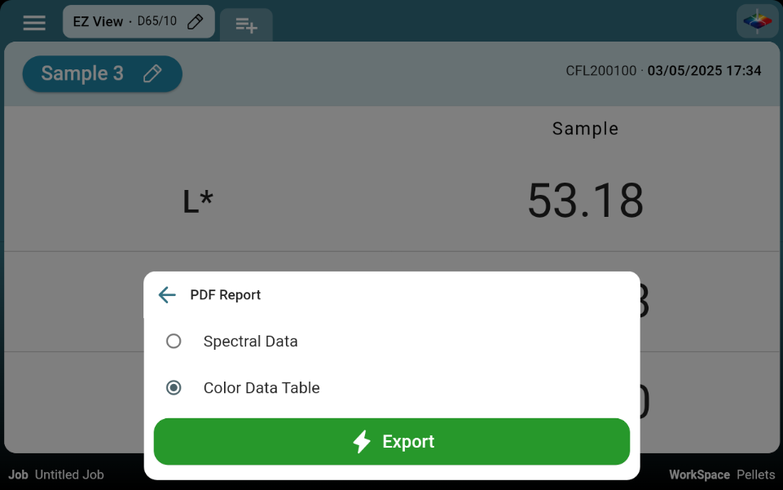
- AutoSearch Standards
AutoSearch For Standard has been added as a system level option, allowing your sample to be matched to any WorkSpace based on its tolerances.
Once enabled, AutoSearch will show any WorkSpace where all the tolerances pass for that sample. If multiple WorkSpaces match, you'll be allowed to pick which one your sample is saved to.
If no WorkSpaces pass for this sample, you'll still be able to save the sample to the new "No Match" WorkSpace for later review.
Only WorkSpaces with Physical, Numeric, or Hitch standards will be included in AutoSearch. Your WorkSpace must also have at least one tolerance applied. If you want to exclude a WorkSpace from AutoSearch, you can always exclude it in the WorkSpace settings page for that WorkSpace.
- Standardization and Diagnostics Illustrations
To keep things clear and simple, new illustrations have been added to the standardization and diagnostics prompts. These illustrations make it easy to know exactly how the instrument should be configured, no matter your language.
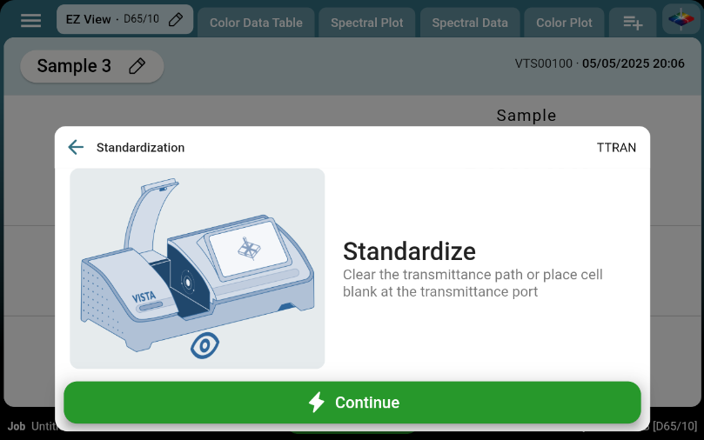
- Pass/Fail Logic Changes
The pass/fail indicators on EZ View and the Color Data Table are now hidden if no tolerances are set. Previously, we would show "pass" if no tolerances were set.
- Other notable changes:
- Updated the Lovibond lookup table to the April 2025 Version
- The "Setup Hitch" text now has a higher priority than the "Standardize" text on the main action button. Pressing "Setup Hitch" will still trigger standardization before the hitch wizard launches.
- The floating back button is now turned on when entering system pages like print settings or file pickers
- Historical diagnostic targets are now preserved. If the targets are reset or changed, the new values will not affect prior diagnostic results
- Updated Hitch wizard text, "Hitch To Tile" is now "Hitch to Standard" to better include hitch standards
- The jewel button in the top right now shows the drop-down that used to be triggered by a long press. This menu now contains a link to the help overlay, screenshot, screen record, and global search functions
- Files are now fully written to the connected flash drive before the finish message is shown on screen. This means it should always be safe to unplug the flash drive when the instrument says an export is complete.
- Notes and Product ID should now be available on the CSV and XLS exports
- CSV and XLS export file names now include the WorkSpace name to avoid file name collisions
- An option to create a backup has been added to the "Install Update" dialog. We encourage all customers to create a backup to a flash drive before installing an update.
- When exporting diagnostic Jobs as PDFs, the color data table export layout will always be used
- The inactivity detector has been updated to work on dialogs and the internal tools pages. This should mean that the screen wont get stuck being dim while a dialog is open.
- The Button Procedure system has been fully overhauled. This system is responsible for any measure/standardize/average/diagnostic button you see in Essentials, and had some fundamental issues causing it to not always show or do the right thing. This refactor should resolve all the cases where a button is stuck saying "Standardize" or otherwise behaves in an unexpected way.
- When exporting a job from the job list, you'll now be returned to the data views instead of staying in the export dialog
- Dramatically improved the start up time of Essentials after the instrument has booted. This means there's less time sitting at the homescreen after boot up, instead the app launches immediately.
- If all prompts are disabled in the WorkSpace Settings (Sample Name, Product ID, etc) then the measurement will immediately be taken when pressing the measure button
- Shade Sorting Number has been added as an index
- Favorited WorkSpaces are now indicated on the WorkSpace list with a star. The are also sorted to the top of the list, after the currently launched WorkSpace
- Merged the latest translations from Localizely as of 2025-05-05, the current list of supported languages is as follows:
  - English (US)
  - German
  - Chinese Simplified
  - Chinese Traditional
  - English (GB)
  - Thai
  - Spanish
  - Japanese
  - Italian (IT)
  - Czech (CZ)
  - Hungarian (HU)
  - Polish (PL)
  - Portuguese
  - Turkish
  - Russian (RU)
  - Korean
  - Indonesian
  - Dutch
Bug Fixes in Vista 2025.2
- Changed CSV export to quote any fields when they contain the field delimiter character, preventing parsing errors (1564)
  - This means if you're using a comma delimiter and comma decimal separator, the values will all be inside double quotes
- Fixed a bug where a hitch standard could get set in one of the default workspace without a way to remove it (1563)
- Fixed diagnostic job names being in UTC instead of local time (1582)
- Fixed the main procedure button and diagnostic warning banners not updating their text when changing language (1568)
- Updated Vista repeatability tolerances to 0.02
- Updated Vista diagnostics to not say "Didymium Filter Repeatability"
- Fixed a number of bugs with auto-export fields not populating correctly (#1406)
- XLS exports now work correctly for numeric standards (#1400, #1399)
- Fixed an issue where hitch settings weren't being applied correctly when set with the main action button (#1395)
- Fixed a bug where the average measurement dialog would always scroll to the bottom, even when it had finished taking measurements (#1354)
- Fixed an error when Hitching in XYZ
- Fixed a bug where the averaging dialog was reordering rows as measurements were taken
- Enabled global search by default
- Fixed tolerances being rounded to values lower than what the user entered on the CDT
- Fixed a bug where hitch as-read measurements were prompting for sample name (#1267)
- Fixed a bug where setting a hitch in a workspace with continuous measurement enabled would result in the as-read hitch measurement being taken continuously with no escape
- The export button in the internal tools signal level page will now activate correctly when plugging in a flash drive and taking a measurement (or reading any signal levels) (#1246)
- Workspace favorites are now correctly sorted to the top of the list of workspaces (#1296)
- Exporting both a job PDF and sample images will no longer get stuck with a permanent loading spinner (#1302)
- Fixed a bug where you could get stuck in the help overlay, unable to interact with Essentials until power cycling the instrument. (#1081)
- Fixed a bug where the average read count was being used for automatic mode, even if automatic mode did not have a limit set. (#1161)
- Fixed Static IP addresses not being show in the Instrument Information page
- Fixed not being able to switch back to DHCP when setting a static IP

