**New Features in Vista Essentials Rev 1.11.0123**

* Predictive Diagnostics is updated.
* Added Warning and Error prompts for Monitor channel, TOS, BOS, Diagnostics Test, Service activity, standardization vector data etc.
* Added Standardization Vector Log feature.
* Added Initial Data feature. Provided a button as ‘Initial Data’ in Advanced Diagnostics page. Please scroll down the first column in the “Advanced Diagnostics” page to find the ‘Initial Data’ button.
* Added Warning and error alert notifications at the “Info” button with red or yellow dot.
* Updated standardization command flow to allow collecting the above predictive diagnostics data.
* Provided “Export” button in Predictive Diagnostics Page. Diagnostics log, standardization vector log and Initial data can be exported by clicking ‘Export’ button.
* All the Predictive alerts (Warning and Error) can be disabled by selecting the ‘Disable Warning/Error Alerts’ option provided in Predictive page.
* Convergence CMR is available.
* EasyCal in Essentials is implemented.
* Indices: Updated EPOP index (If Haze%D65/10 is above 14, Essentials shows “Out of range” for EPOP index); Added ‘OffHue [C/2]’ color index; The ASBC Turbidity index is updated to display 'free of turbidity' or 'turbid'.
* Updated the Recall standard dialog. All standards are listed with rendering color, color data and some other details.
* Updated German and Simplified Chinese strings.
* Removed Wifi access in Vista Essentials.

**New Features in Vista Essentials Rev 1.09.0105**

* Integrated “Standard and Tolerances” features. The standard tolerances are saved with each standard (previously, standard tolerances are saved into workspace). Added “Recall Standard” button in tool bar.
* Add Extra ID and Product ID properties for measurements.
* EasyCert: Sort the standard list with respect to Standard ID. Updated the EasyCert export report to add spectral data for each standard measurement.
* Incorporated new index, Excitation Purity.
* Implemented Convergence feature, to save data automatically into SQL database and to show the measurement in Essentials and EZMQC simultaneously if both software is open.

**New Features in Vista Essentials Rev 1.08.0100**

* Updated “Validation” feature in Vista Essentials for EasyCert and EasyCal test.
* Updated Help content

**New Features in Vista Essentials Rev 1.07.0094**

* + - * Implement EasyCert in Workspace menu/Diagnostics
* Incorporated CP Indices (CP, CP GY, CP YG, CP Y, CP OY, CP ORR, CP BR). Enabled to add these indices in ‘Custom Indices’
* Updated to support Footswitch feature.
* Updated the following dialogs to support for all Chinese/Japanese/German languages: Color Scales, Read Options, Tolerances, View Options, Preferences, User Manager, About, Configure Ethernet, Configure Auto Export, Diagnostics, Perform Auto Diagnostics and File Browser for Open, Save, Import / Export the objects
* Implement Saybolt and ASTM D1500 factors adjustment in Custom Indices dialog
* Added ‘Auto Backup Interval’ feature
* Implemented External Triggering feature in Workspace menu/Read Options.
* Option to add ‘Sensor Number’, ‘standardization mode” and ‘User Name’ in CDTV View Options.
* Added the option to remove Current Email Account
* File Browser is updated to show the list in sorting by date; Replaced the EditText control with AutoCompleteTextView (ACTV) control. On typing the first few characters of the name, the relevant list of names of files & folders will be shown in the ACTV.

**New Features in Vista Essentials Rev 1.06.0079**

* . CSV feature: Create and auto update .csv file in HunterLab folder after job is saved. User can export/email these .csv files through data management.
* Lovibond RYBN calculations in Vista Essentials. Provide an option in the Lovibond dialog to choose RY or RYBN and save the option.
* Added file service package to backup hunterlab folder in android system to network or local PC.
* Implemented the Chart view for Measure, Read Signal/Dark/Zero in Advanced Diagnostics
* Search for Standards: Auto Complete Text View is added in the “Recall Measurements” dialog. Added ‘Log off’ feature for Vista Non-ER application, when application security is enabled.
* Custom indices: Transmittance index is updated for Difference and Biased Index Difference. Absorbance index is added. Biased Index, Difference and Biased Index Difference calculations are also implemented for this index.
* Updated the Iodine Calculations. EPOP index is added (Calculation is same as EPOP in EZMQC). Updated APHA calculation (If L>99.96, c*<0.035, then APHA=0).
* UI Modification: Updated the UI modification (Spinner, Radio Button, CheckBox, All Dialogs).

**New Features in Vista Essentials Rev 1.05.0064**

* The WiFi feature is enabled in network settings dialog.
* Essentials in Multi-Languages: Added a button “Language Settings” in “Preferences -> General” page to select the language and configure the keyboard. When the button ‘Config Keyboard” is clicked, the system’s “Choose Input Method (IM)” screen is displayed which is used for choosing one of the installed IMs. Updated the strings for all the given language (Japanese, Simple Chinese & Traditional Chinese).
* Added the Signal test into the ‘Run Auto Diagnostics’ test.
* Added the ‘export’ button in the data review to export the data of Signal/Dark/Zero in ‘csv’ format.

**New Features in Vista Essentials Rev 1.04.0056**

**Custom Indices in Color Scales/Indices is the major implementation for this new build:**

1. Users can create modified-pathlength indices as well as add transmittance data into indices list. Indices available for pathlength modification are APHA, ASBC, ASTM D1500, Chinese Acid Wash Color, EBC, EP, FAC, Gardner, Iodine, JP, Saybolt, USP.  Any transmittance data from 400nm to 700nm can be added into indices list. All the created custom indices except %T indices will be showed in Bias Configuration list so that user can do bias and gains on these new indices.

Please note:

1. The configured pathlength can be any number between 0-100 with maximum one decimal.
2. Due to the implementation of custom indices feature, most indices names have been changed compared to the names in Vista Essentials 1.03.0045. If any old index name is found in different format to the new, index will not be calculated. In such case, please go to Color Scales/Indices and ‘Apply’ to update the list of indices.
3. The custom indices can only be the ones that not listed in the default indices list. E.g. if user try to create APHA 10mm in custom indices dialog, Essentials won’t allow this since this index already exist in the default indices list.

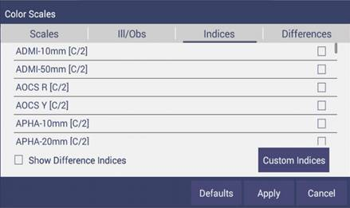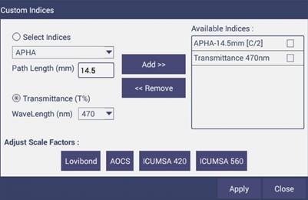

1. Scale factors of LOVIBOND®/AOCS/ICUMSA 420/ICUMSA 560 can be adjusted in custom indices dialog. LOVIBOND®/AOCS cell pathlength, instead of only 5 pathlength options in dropdown list, can be entered with any number between 0-100 with maximum one decimal.

For ICUMSA 420 and ICUMSA 560, the density (g/ml) and weight%(g/g) need to be configured for accurate ICUMSA calculation. Density (g/ml) should be from 0.5-2. Weight% (g/g) should be from 1-100.

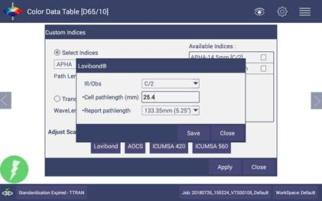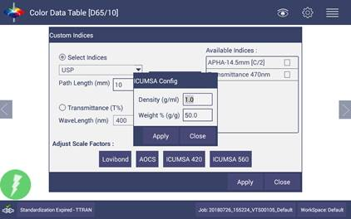

**Except the above custom indices implementation, here are the other new changes that we addressed in 1.04.0056:**

* Updated the status bar. The Standardization status, job name and workspace name are showed as buttons in status bar. Clicking on each of these buttons can open the corresponding dialogs:

        -Open standardization dialog when click standardization status;

        -Open “Open Job” dialog when click job name;

        -Open “Load Workspace” when click workspace name.

When click the ‘Sensor Status picture’ in the left corner, the connected sensor name, serial number and logged in user name (if applicable) will be showed.

* New: Show standardization Error message along with Error code.
* New: screen saver feature. The screen will change the light to 3% when idle 15 mins and the default brightness in Essentials is 100%.
* New: Provided an option to browse “Download” folder to export/Email/Delete the pdf files in Download file folder. E.g. user can click “Print” and select “Save as PDF” to save the pdf document into “Download” folder. Then user can email/export/delete this pdf file in “Download” folder through Data Management.
* Added log feature in Advanced diagnostics. Once it is enabled, all the sensor commands/response will be recorded in the log file. User can export this log file by clicking the “Export” button.

*“LOVIBOND”  is a registered trademark of The Tintometer Ltd, UK.*