SpectraTrend Simulator Mode

After downloading please install as follows.

- Double click EasyMatch OL ST Client.exe
- Choose REPAIR and click FINISH when completed
- Double click EasyMatch OL ST Server.exe
- Choose REPAIR and click FINISH when completed.
- Open EasyMatch OL Client by double clicking on the desktop icon. The first time you will need to enter the computer name under System Setup/Data Storage and then select TEST to check the name.

You may run the EasyMatch OL simulator while waiting on the sensor to arrive.
To run in Simulation mode follow these instructions.

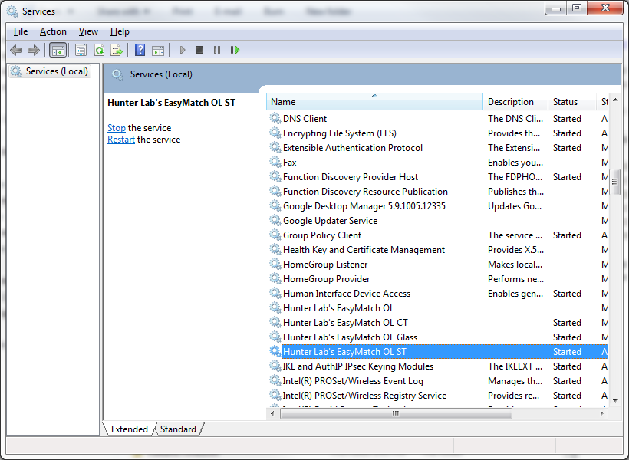
- Open the Services and select HunterLab EasyMatch OL ST

- If the service is STARTED then you must stop.
- Under the Properties add the string 0 SIM to the start parameters. The 0 is the number zero.
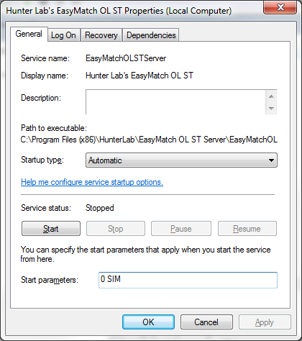

- You must press the START button to begin simulation. If you click OK before Start, the simulator will not operate.
- Once the service has started, you may run EasyMatch OL normally and check to see if it is generating data. The Simulator mode will stop if the Server is stopped or the computer is restarted.

