Color Perception

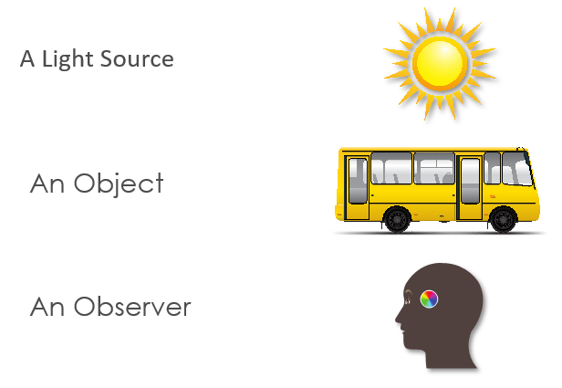
Things Required to See Color

Visual Observing Situation
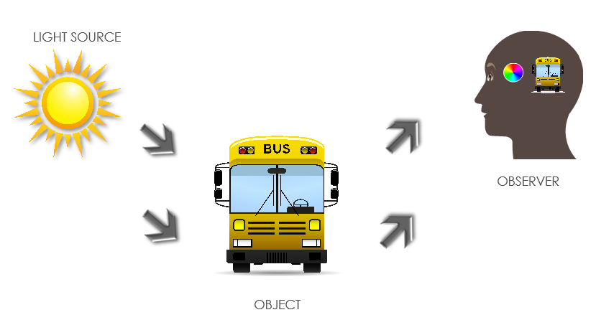

- The visual observing model shows the three items necessary to perceive color.
- To build an instrument that can quantify human color perception, each item in the visual observing situation must be represented as a table of numbers.


Light Source
- A light source emits white light.
- When light is dispersed by a prism, all visible wavelengths can be seen.
- Visible light is a small part of the electromagnetic spectrum.
- The wavelength of light is measured in nanometers (nm).
- The CIE wavelength range of the visible spectrum is from 360 to 780nm.
- A plot of the relative energy of light at each wavelength creates a spectral power distribution curve quantifying the characteristics of the light source.

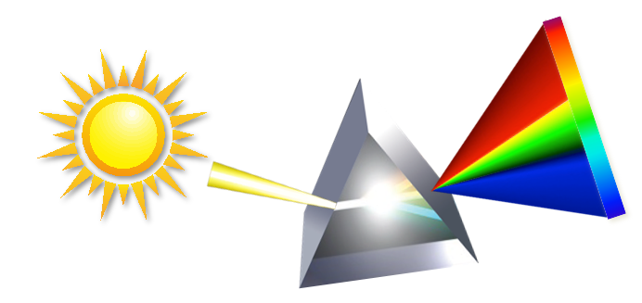
Sunlight Spectrum

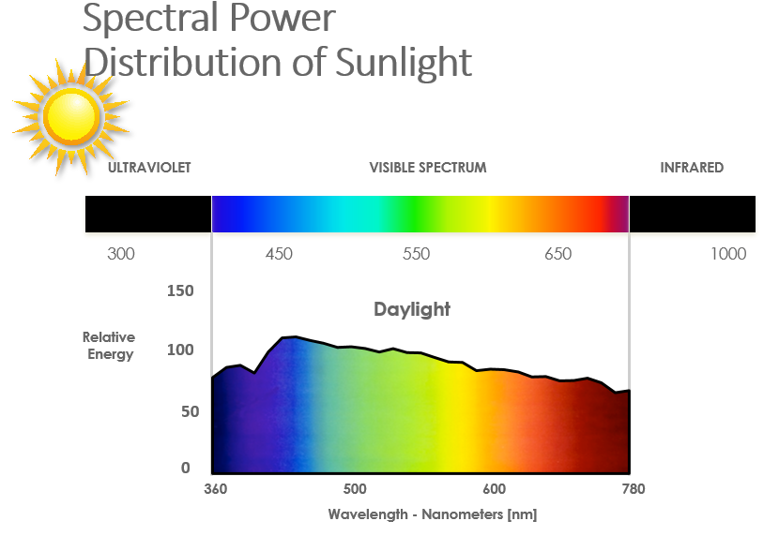

Light Source vs. Illuminant
- A light source is a physical source of light.
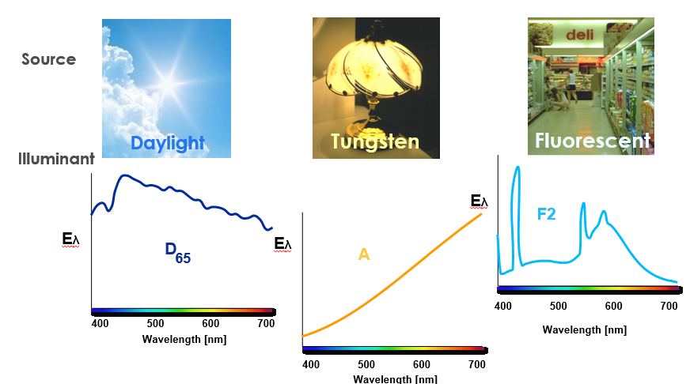
- A CIE Illuminant is a standard table of numbers representing relative energy versus wavelength for the spectral characteristics of light sources.

Some Common Illuminants
- A Incandescent
- C Average Daylight
- D65 Noon Daylight
- F2 Cool White Fluorescent

CIE Illuminant
- By representing a light source as an illuminant, the spectral characteristics of the first element of the Visual Observing Situation have been quantified and standardized.
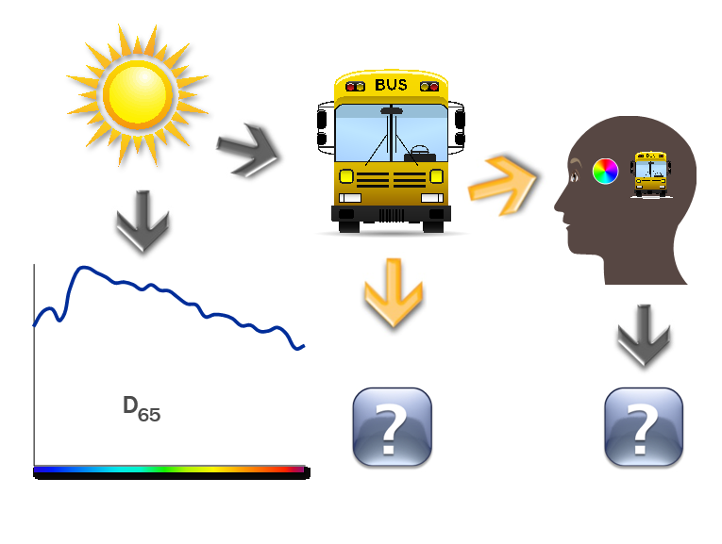

Object
- Objects modify light. Colorants such as pigments or dyes, in the object, selectively absorb some wavelengths of the incident light while reflecting or transmitting others.

- The amount of light, reflected or transmitted by the object at each wavelength can be quantified. This can be represented as a spectral curve.
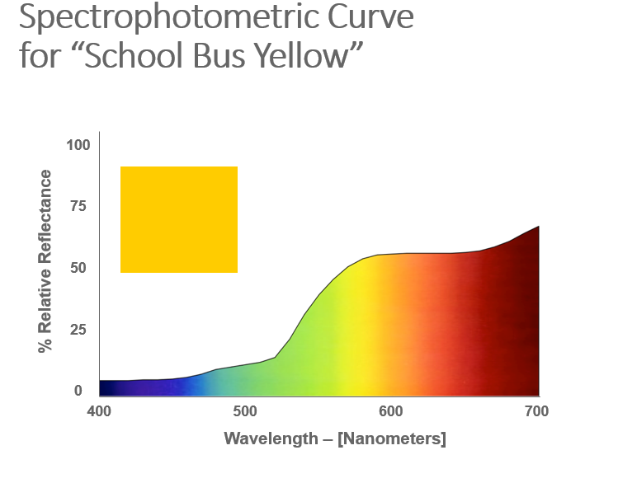
- By measuring the relative reflectance or transmittance characteristics of an object, the second element of the Visual Observing Situation has been quantified.

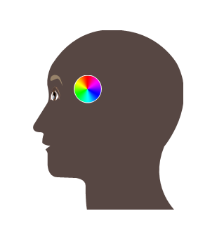
Observer

Human Observer
- Rods in the eye are responsible for low light vision.
- Cones in the eye are responsible for color vision and function at higher light levels.
- The three types of cone sensitivities are red, green and blue.
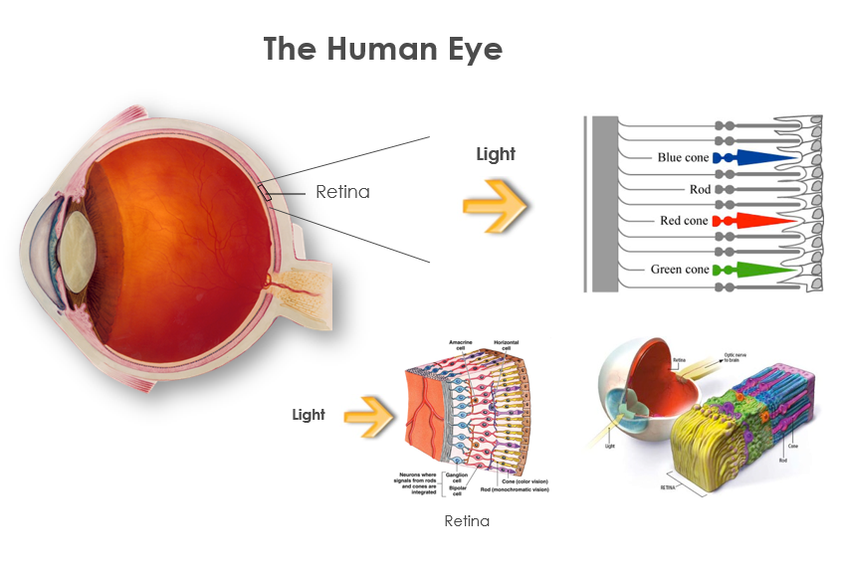

CIE Standard Observer
Experiments were conducted to quantify the ability of the human eye to perceive color.
A human observer looked at a white screen through an aperture having a 2-degree field of view. Half of a screen was illuminated by a test light.
The observer adjusted the amount of three primary colored lights on the other half of the screen until they matched the test light color.
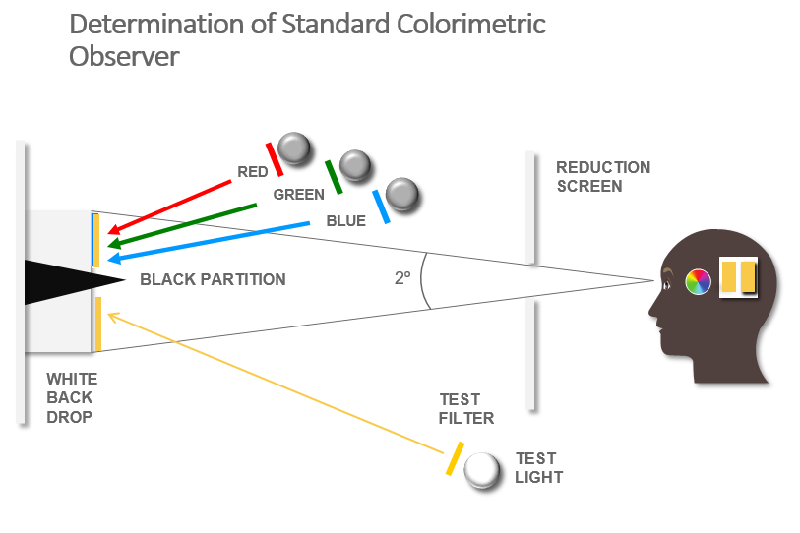
This process was repeated for colors across the visible spectrum.

- The experimentally derived x, y and z functions became the CIE 1931 2-degree Standard Observer.
- These functions quantify the red, green and blue cone sensitivity of the average human observer.

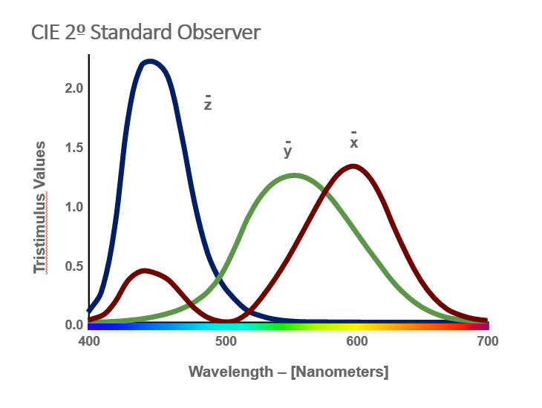
- When the 1931 2-dgree Standard Observer experiments were conducted, it was thought that the cone concentration was only in the fovea region.
- Later, it was determined that the cones were spread beyond the fovea.
- The experiments were re-done in 1964, resulting in the 1964 10-degree Standard Observer.
- Of the two observers, the CIE recommends the 10-degree Standard Observer. It best correlates with average visual assessments made with large fields of view. This is typical of most commercial applications.

Summary
- The three elements of the Visual Observing Situation have now been quantified as tables of numbers.
- The Light Source is a user-selected CIE Illuminant.
- The Object is quantified by measuring reflectance or transmittance.
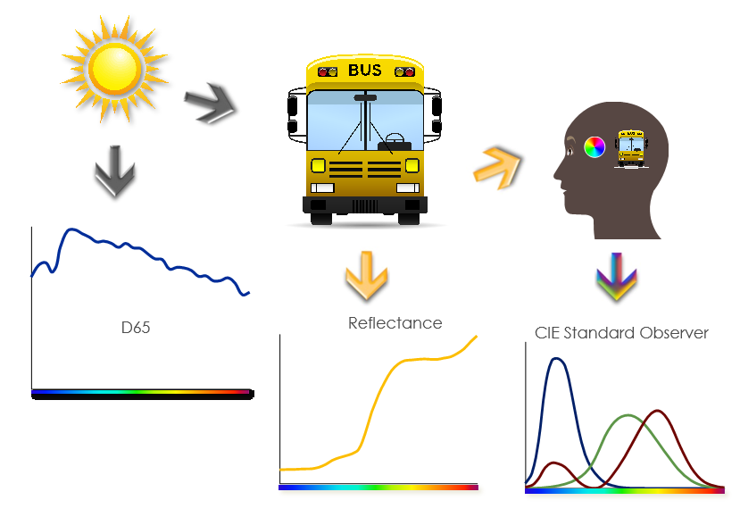
- The Observer is represented by a CIE standard Observer.

