Sample Preparation and Presentation

Ideal Sample for Color Measurement
- Opaque or transparent
- Solid
- Flat
- Smooth
- Uniform

Sample Preparation
- Choose samples that are representative of the product.
- Prepare the sample in a way to best approximate ideal sample characteristics.
- Prepare the samples in the same way each time.
- Present the samples to the instrument in a repeatable manner.
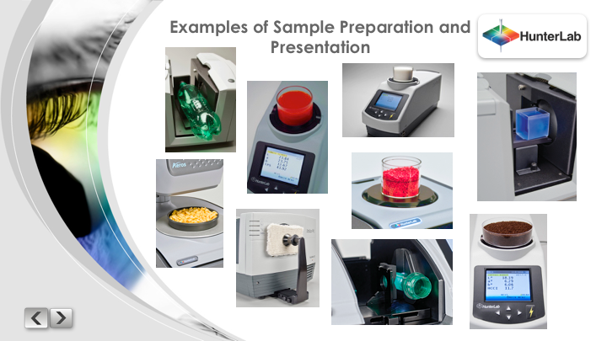
- Take multiple readings of the sample for an average measurement.

