Color Scales

Visual Organization of Color
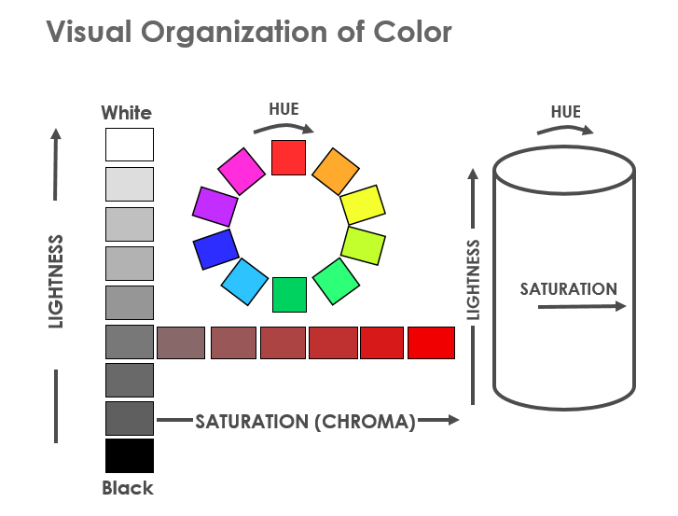
- All colors are organized into three dimensions: Lightness, Chroma or Saturation and Hue.

Measured Color Values
- Visual evaluation of color is subjective and approximate.
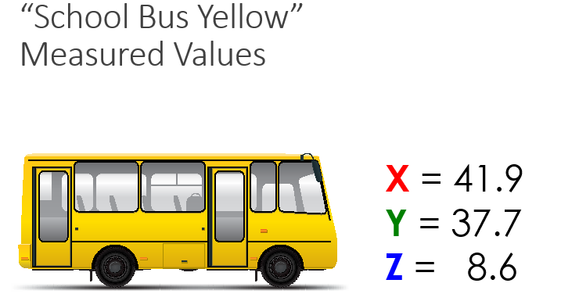
- Measuring color using an instrument provides objective and precise results that correlate to human perception.

Color Scales
X,Y,Z values are not easily understood. Other color scales have been developed to:
- Better relate how we perceive color.
- Simplify understanding.
- Improve communication of color.
- Better represent uniform color differences.

Opponent Color Theory
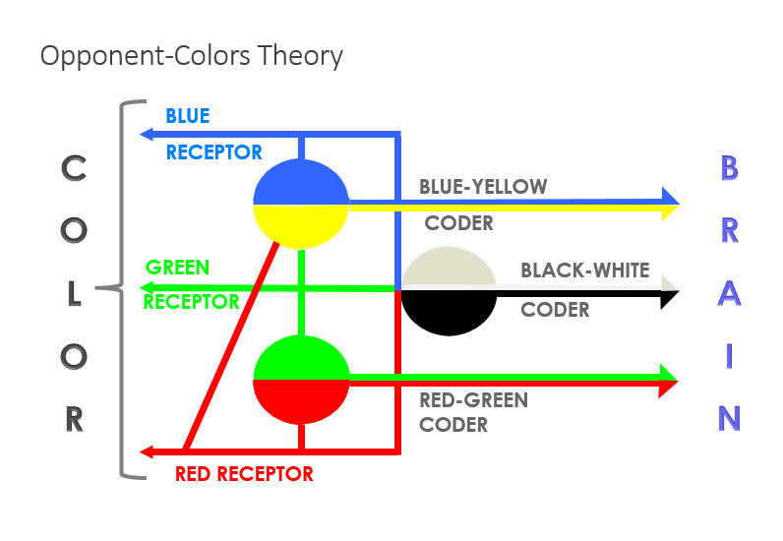
States that red, green and blue cone responses are remixed into opponent coders as they move up the optic nerve to the brain.

To understand opponent color theory, focus on the black cross in the center of the stripes and then look to a plain white piece of paper.

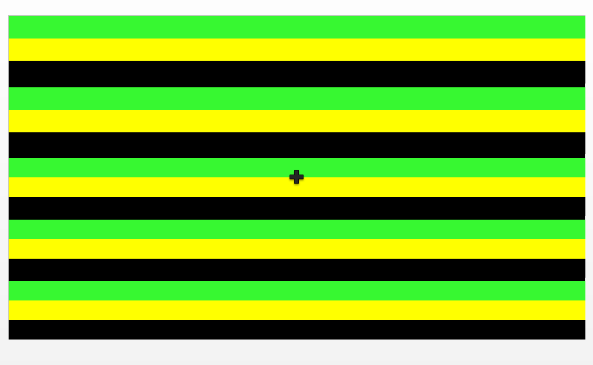
- Do you se the stripes as red, white, and blue? This occurs because the green, black and yellow stripes saturate the cone response of the eye. When you look at the black paper, your vision tried to return to balance and you see a red, white, and blue after image. This demonstration support the opponent color theory.

Hunter L,a,b Color Space
Hunter L,a,b color space is a 3-dimentional rectangular color space based on opponent color theory.
- L (Lightness) axis – 0 is black, 100 is white and 50 is a medium gray.
- a (red-green) axis – positive values are red, negative values are green and 0 is neutral.
- b (blue-yellow) axis – positive values are yellow, negative values are blue and 0 is neutral.
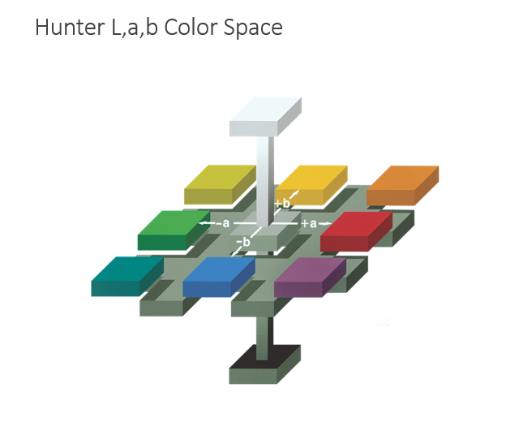
- All colors can be represented in L,a,b rectangular color space.

- The next image shows the school bus in Hunter L,a,b color space.
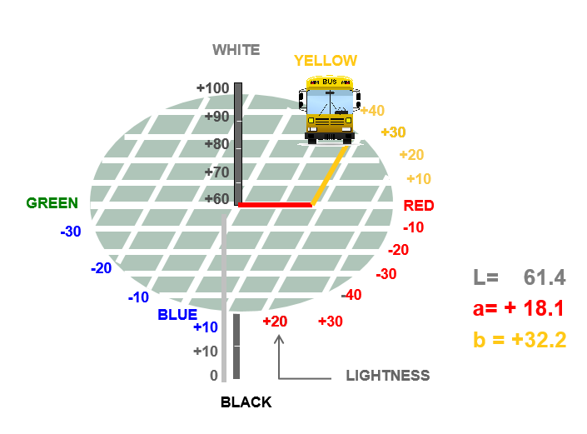
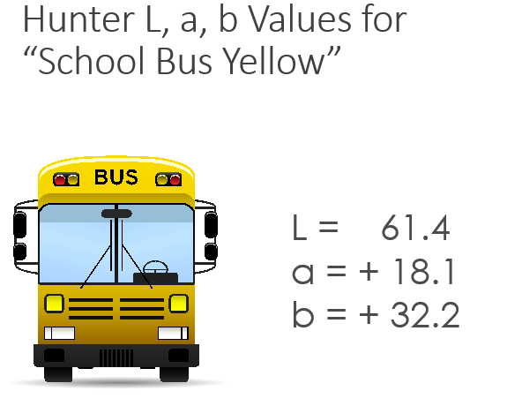

Hunter L,a,b versus CIE L*,a*,b*
- There are two popular L,a,b color scales in use today: Hunter L,a,b and CIE L*,a*,b*
- While similar in organization, a color will have different numerical values in these two color spaces.
- Hunter L,a,b, and CIE L*,a*,b* scales are both mathematically derived from CIE X,Y,Z values.
- Neither scale is visually uniform. Hunter L,a,b is over expanded in the blue region of color space and CIE L*,a*,b* is over expanded in the yellow region.
- The current CIE recommendation Is to use L*,a*,b*

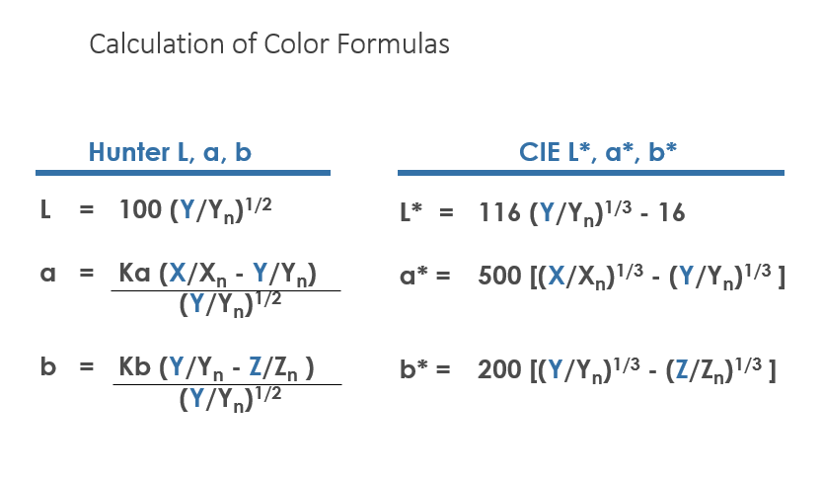
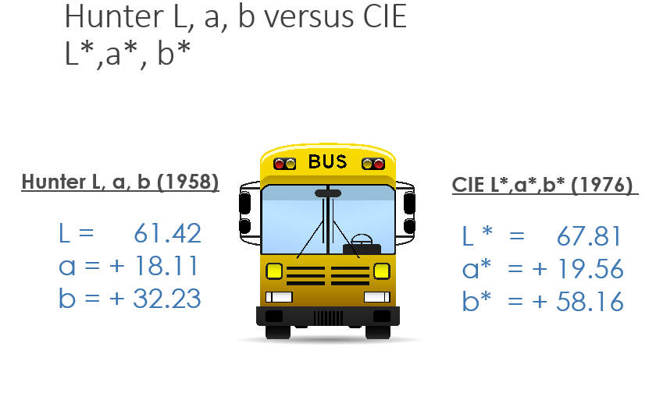

Color Difference
- Acceptable color difference varies with the application.
  - What is acceptable for color matching of automotive paint is close to being a minimum perceptible limit.
  - What is acceptable for snack foods is greater and the maximum acceptable limit defines the tolerance for the product.
- Color difference is always calculated as sample minus standard.
  - If delta L* is positive, the sample is lighter than the standard. If negative, it would be darked than the standard.
  - If delta a* is positive, the sample is more red (less green) than the standard. If negative, it would be more green (or less red).
  - If delta b* is positive, the sample is more yellow (less blue) than the standard. If negative, it would be more blue (less yellow).

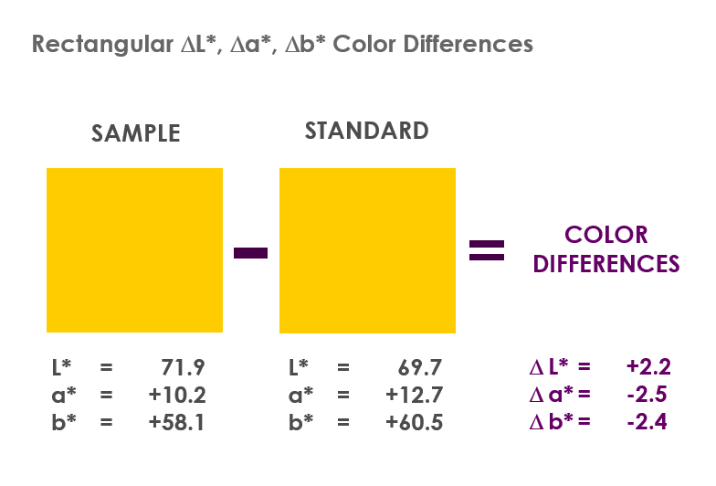
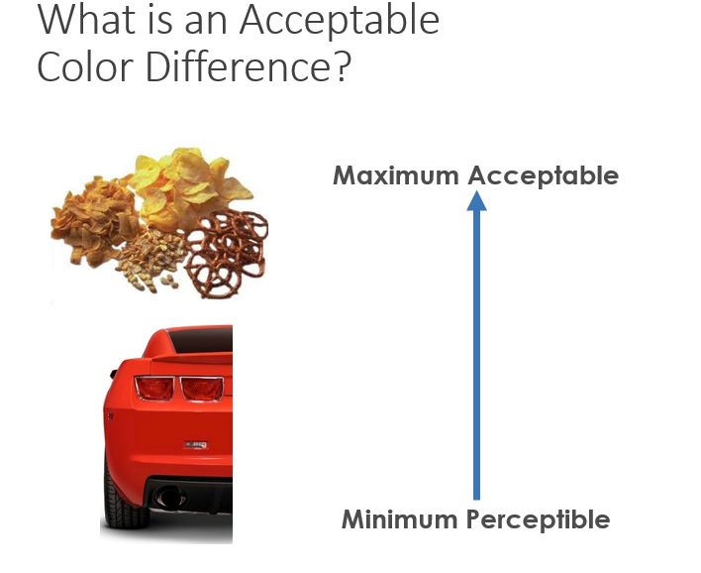

- Delta E* is based on L*,a*,b* color differences and was intended to be a single number metric for PASS/FAIL decisions.



