Surface Characteristics and Geometry

Reflectance of Light
- For opaque materials most of the incident light is reflected.
- Color is seen in diffuse reflection and gloss is seen in specular reflection.
- The reflection at the specular angle is generally the greatest amount of light reflected at any single angle.
- Specular reflection represents less than 4% of total reflected light.
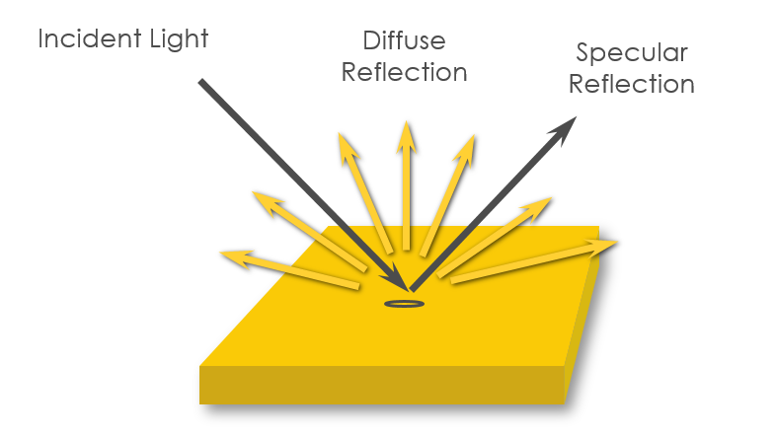
- The remaining reflection is diffuse.

Effect of surface Texture on Perceived Color

Samples of the same color with different surface textures, will appear to be different colors.
- Glossy surfaces appear darker and more saturated.
- Matte and textured surfaces appear lighter and less saturated.
- Increased surface roughness affects perceived color such that it appears lighter and less saturated. This is caused by mixing diffuse reflectance with increased scatter from specular reflectance (white). The rougher the surface, the greater the scatter of specular reflectance.

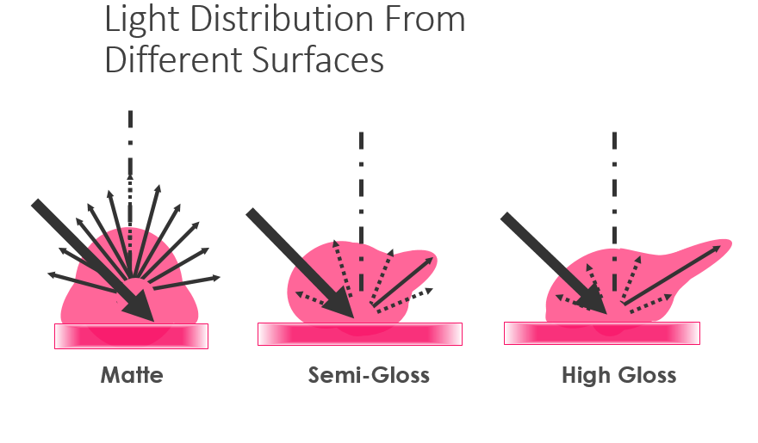
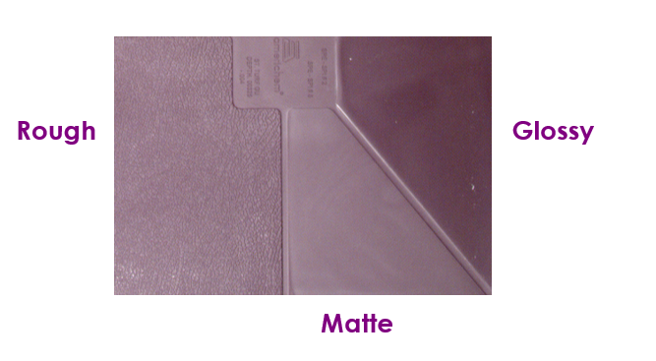
Instrument Geometry
- Instrument geometry defines the arrangement of light source, sample plane and detector.
- There are two general categories of instrument geometry: Directional (45°/0° and 0°/45°) and diffuse (d/8° sphere).

Directional Geometry
- Directional 45°/0° geometry has illumination at a 45° angle and measurement at 0°. The inverse 0°/45° geometry has illumination at 0° and measurement at 45°.
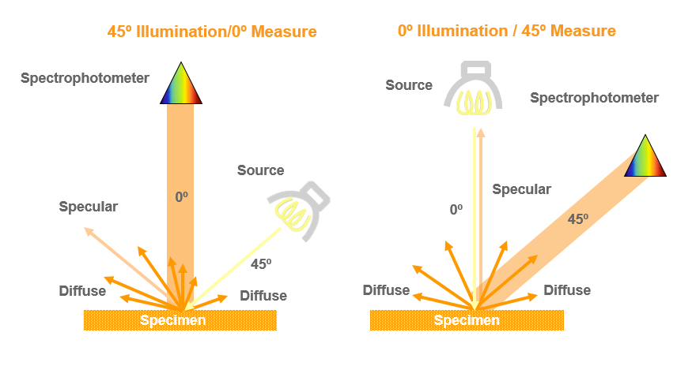
- Both exclude the specular reflection in the measurement (specular excluded). This provides changes in sample appearance due to either changes in pigment color or surface texture.

Gloss Effect on Color Difference Measurement
- In the next image, the paint on the card is the same color across the entire card. The right side has a matte surface finish and the left side has a high gloss finish.
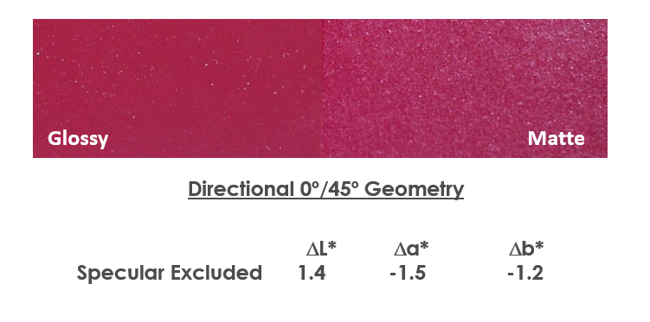
- The color difference measurement made using a directional instrument, indicates a color difference that agrees with visual evaluation (the matte side is lighter and less red).
- Directional instruments measure both the effect of the pigment and the effect of the surface finish. They are appropriate for quality control applications where agreement with what you see is important.

Diffuse Geometry
- Diffuse (sphere) geometry instruments use a white coated sphere to diffusely illuminate the sample with 8° (d/8°) viewing.
- Measurements on a diffuse sphere instrument can be taken with the specular-included or excluded.
- Specular-included measurements negate surface differences and provide values which correspond to change in color.
- Specular-excluded measurements negate specular reflectance on very smooth surfaces, measuring only diffuse reflectance.
- Most measurements are taken in the specular-included mode.

Gloss Effects on Color Difference Measurement
- The next image shows measurements taken with a diffuse d/8° sphere instrument.
- The specular-included measurement indicates o color difference. It quantifies only colorant differences and negates differences in surface finishes.
- In the specular-excluded mode, the readings quantify appearance differences similar to those from the 0°/45° instrument.
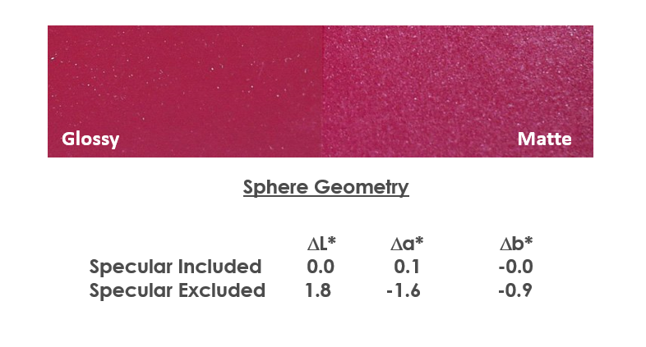

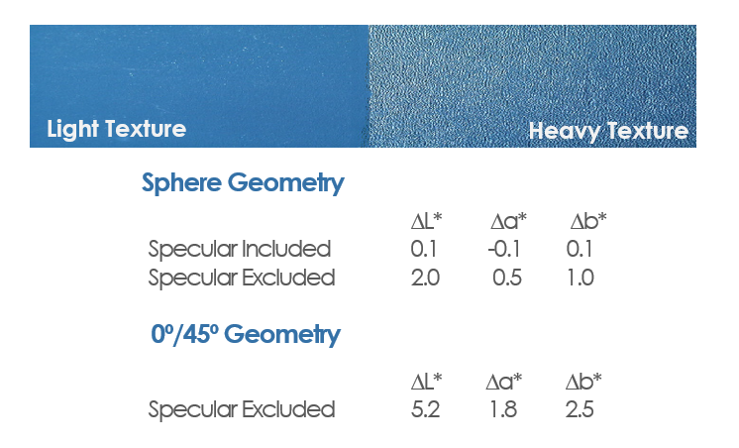
Texture Effect on Color Difference Measurement

Sphere Geometry for Transmittance
- Sphere geometry instruments also have the ability to measure the color of transmitted light.
- Color is seen primarily in regular transmittance for transparent solids ad liquids.
- Surface texture or internal scattering within the material can cause the light to scatter or diffuse.
- Diffuse Transmittance also contains color of the material.
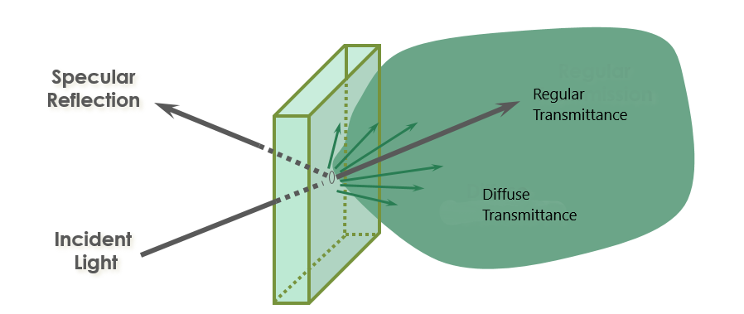
- Total Transmittance is a combination of regular plus diffuse transmittance.

