Color Measurement

Things required:
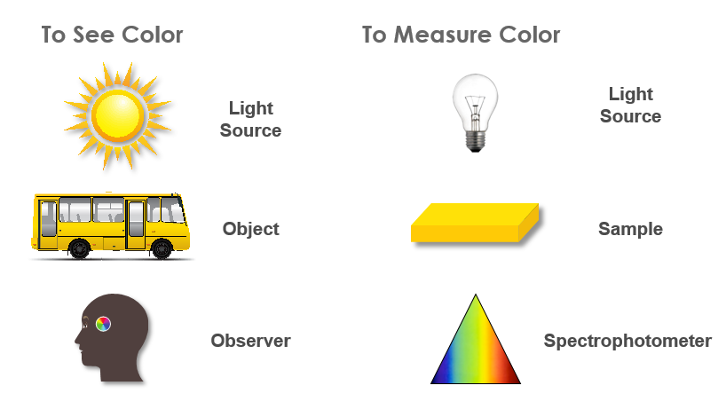

Color Measurement

- The CIE X, Y, Z tristimulus color values are obtained by multiplying the illuminant, the reflectance or transmittance of the object and the standard observer functions.
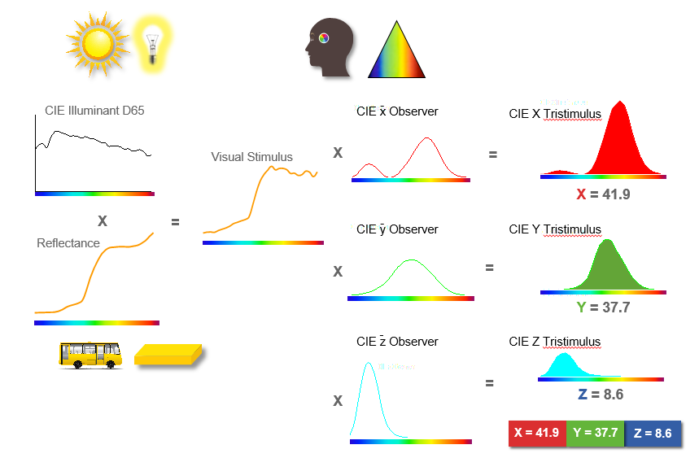
- The product is then summed for all wavelengths in the visible spectrum to give the resulting X, Y, Z tristimulus values.

- A colorimetric spectrophotometer uses a light source to illuminate the sample being measured.
- The light reflected by the object passes to a grating which breaks it into its spectral components.
- This sample signal falls onto a diode array, measuring the amount of light at each wavelength.

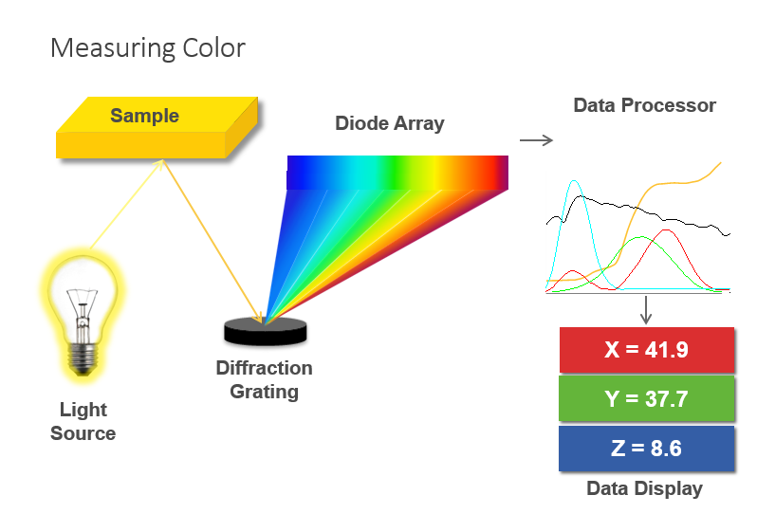
- The spectral data is sent to the processor where it is multiplied with user-selected illuminant and observer tables to obtain CIE X, Y, Z color values.

