Addressing the Challenges of Color Quality Control in Textured Food Samples
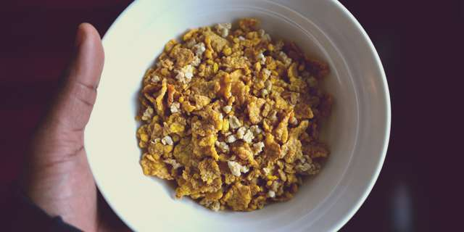
Measuring textured food samples can prove to be a challenge for food manufacturers. Image source: Yvens Banatte on Unsplash
In the food industry, texture is a common concern. Combined with color, texture is an essential component of how consumers will perceive your products, guiding purchasing decisions and sensory experiences. Unfortunately, textured foods can present unique challenges for the color quality control process, as their lack of uniformity means don’t have the large flat surfaces necessitated by many color measurement technologies.
Today’s state-of-the-art spectrophotometers can resolve these challenges. By choosing a spectrophotometer specifically designed to measure the color of textured samples, you can easily and accurately analyze your products to ensure only the highest quality goods enter the marketplace.
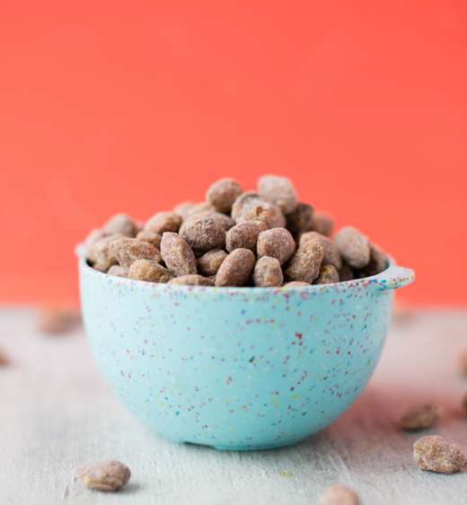
The color uniformity of certain snack foods will impact consumer perception of quality. Image source: Whitney Wright on Unsplash

How Texture Impacts Food Color and Measurement
It is often said that we eat with our eyes first. Indeed, research has continuously shown that texture plays a significant role in consumer food choices and eating experiences. According to one study, food texture has a direct impact on everything from what we chose to eat, to how much we eat, and how many calories we perceive foods to have.¹. Due to the consumers’ focus on texture, food manufacturers must thoughtfully perfect the texture of the foods they create.
However, the texture doesn’t just impact consumer perception of a product. It also affects the color of a product, as texture impacts how light is absorbed or reflected and can make color appear darker or lighter than it actually is.² Unfortunately, this perceived color variation can make color measurement difficult, as not all color measurement instruments are capable of analyzing textured products and may return erroneous color readings, potentially leading to the release of substandard product, increasing the need for rework, and damaging company reputation. To prevent this, some spectrophotometers require samples to be prepared into a flat surface in order to capture accurate color data, a laborious and time-consuming process that impedes efficiency and leaves you vulnerable to operator error.

The HunterLab Aeros is designed specifically to address the challenges of analyzing textured foods. Image source: Sharon McCutcheon on Unsplash

The Aeros: Toward More Accurate Analysis of Textured Foods
When working with textured foods, it’s important to choose a spectrophotometer with the ability to capture meaningful color data in irregularly shaped samples without the need for extensive sample prep. The HunterLab Aeros is designed to do exactly that. The Aeros is a modern non-contact spectrophotometer specifically engineered to measure the color of textured samples, making accurate analysis of nonuniform food products possible and allowing for extraordinary insight into color behavior.
In order to capture color data, this state-of-the-art instrument relies on Auto Height Positioning technology to determine the distance between the sensor and the sample, then makes automatic adjustments for optimal measurement; the sample never touches the instrument and the impact of texture is accounted for in color analysis. The non-contact nature of the Aeros means that it does not require extensive sample preparation, but can analyze samples in their whole state, minimizing waste, labor, the potential for contamination, and risk of operator variation. Its sample platform automatically rotates to provide the largest sample area measurement in the world, taking 35 measurements in 5 seconds and covering 27.5 square inches of sample. It then averages readings to provide comprehensive color analysis. This improves the rapidity and accuracy of your color measurement and gives you greater confidence that your sample is representative of the batch as a whole. The on-board EasyMatch Essentials color measurement software includes a complete range of color scales, indices, and metrics to allow for easy color categorization.
In order to facilitate accuracy further, the Aeros comes with a touchscreen interface that provides easy-to-read color data and graphics and an intuitive workflow, simplifying color capture and analysis and further minimizing the risk of operator error. Smart communications abilities allow color data to be easily shared via email, printed, or streamed to LMS and SPC systems. Taken together, these features give you the ability to optimize reliability of color measurement and expand analytical possibilities through both advanced technology and user-friendly design. This allows you to not only guarantee the quality of each batch but gain the insight you need to fine tune production over time, leading to improved efficiency in both the short and long term.

HunterLab Innovation
Food manufacturers often have trouble with color control due to the impact of texture on color. As color and texture play a significant role in consumers’ perception of quality, it’s critical that you quickly and accurately analyze the appearance of your products using the most advanced technologies available. The Aeros spectrophotometer offers an elegant solution for manufacturers who want to take their quality control protocols to the next level. Want to learn more? Contact us to learn more about how our innovative instruments can streamline quality control in your food production process

