Agera - Software download - How to Update Agera Essentials SoftwareFollow


Ping Wang
- 19 days ago

Note: If you have Agera instruments with serial number <130, please contact us first before upgrading Agera Essentials. The green tile has assigned with color value by UV excluded mode in some Agera instruments (Serial No. <130). We need to re-assign green tile by UV nominal mode then you can do Essentials upgrade.
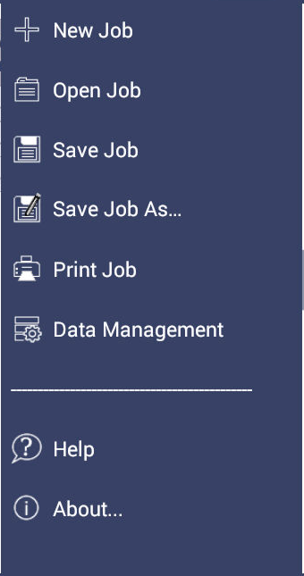
Please check the instrument for the latest Agera Essentials software. The current version of software can be found using JOBS > ABOUT. The ABOUT menu provides information about HunterLab and the current software version. If your version is less than the update, then continue.



Figure. Jobs > About
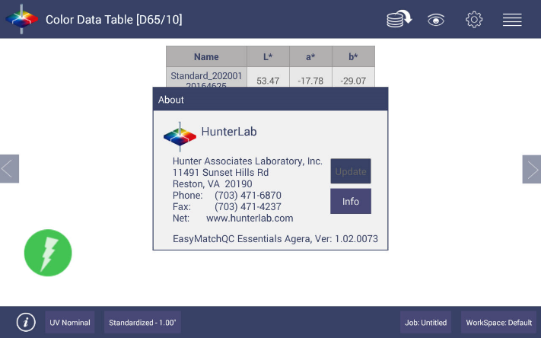
Figure. Software Version
To update the software version download the new version onto a USB flash drive. This software upgrade is found on support.hunterlab.com site.
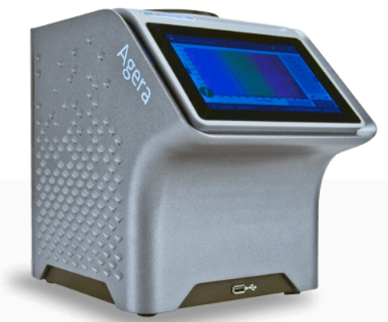
Insert the USB flash drive with the upgrade into the port on the front of the instrument.

Open the JOBS > ABOUT menu and press UPDATE to continue. The Instrument will detect the corresponding Essentials apk file on the flash drive. If the latest Essentials is already installed in the instrument, the following message will be displayed: The application package is up to date.
Figure. Update

