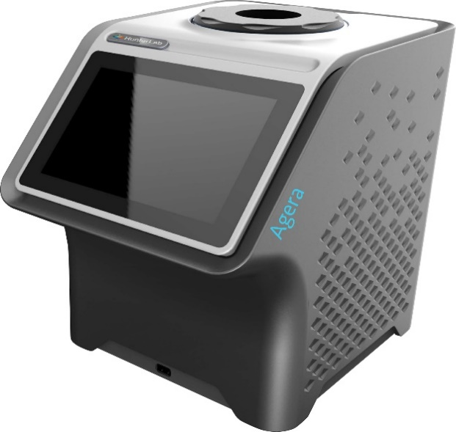
Measuring Tomato Scores Using Agera
Part No. A60-1019-459

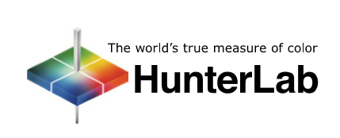
Hunter Associates Laboratory
11491 Sunset Hills Road
Reston, Virginia 20190 USA
www.hunterlab.com

For EasyMatch Essentials 100.0051 and Above with Agera-Tomato Option

Measuring Tomato Scores Using Agera
This option features the measurement of Tomato Scores: Fresh Tomato Color Index (C/2), Tomato Paste (C/2), Catsup (C/2), Tomato Sauce (C/2), Tomato Juice (C/2), Tomato a/b Ratio (C/2). This option includes: HunterLab Tomato Tile (L02-1014-594), (2) 64 mm (2.5 in) OD Glass Sample Cups (04-7209-00), Port for Sample Cup (D02-1018-615) and Sample Cup Cover (04-4000-00).

SETTING UP THE INSTRUMENT

Standardization
From the WORKSPACE menu, select STANDARDIZATION. You can also press the Standardization button in the Status bar as a shortcut.
Each Agera has a specific set of Black Glass and White Tiles unique to the instrument. These are not interchangeable with other instruments. Install the port plate for the sample cup. Position the standard tiles on the instrument with the white line matching the white line on the port plate.
- READ BLACK GLASS: Place the Agera black glass at the sensor port and press READ. Make sure that the line on the tile matches the port plate white line.

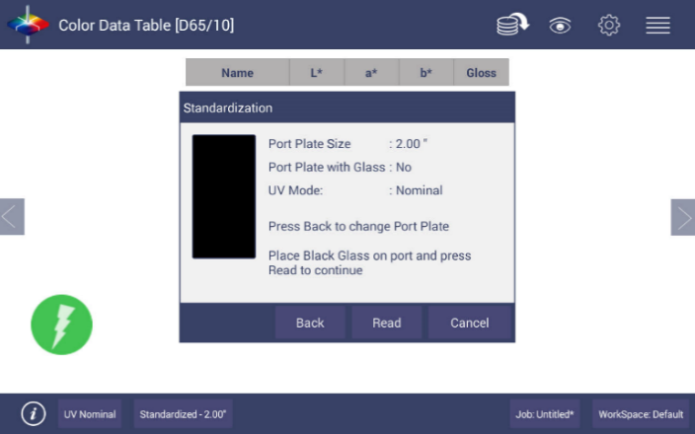
Figure 1. Read the Black Glass for Bottom-of-Scale
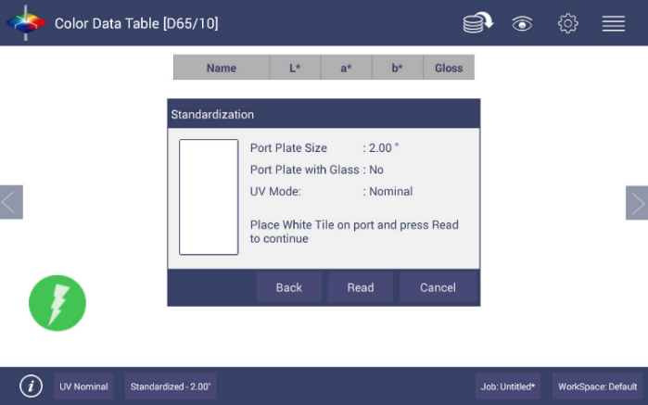
- READ WHITE TILE: Remove the black glass and place the Agera white tile at the port. Press READ to continue.
Figure 2. Read the White Tile for Top-of-Scale
- Remove the calibrated white tile when standardization is completed. Click OK.
- Standardization is updated and reported as STANDARDIZED in the bottom status bar along with UV Mode and Port Plate Size.

Select Views
Go to WORKSPACE > VIEWS to select the screen views to be used. Simply check on the box of the screen needed. Press APPLY to save one or all of the screens. Tomato Scores are displayed on the COLOR DATA TABLE and EZ VIEW. To navigate between screens once the selections have been applied, use the VIEW FLIPPERS on the left and right of the screen. EZ View allows you to eliminate the color scale and display results – one sample at a time.
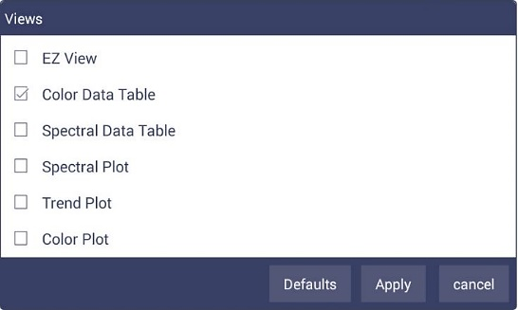
Figure 3. Workspace Views
    - VIEW OPTIONS for EZ View includes the selection of NO COLOR SCALE, PASS/FAIL, IMAGE VIEW, PRECISION and FONT SIZE.
  - VIEW OPTIONS for Color Data include UV MODE, IMAGE STATUS, PORT PLATE SIZE, TOLERANCES, DATA ORDER, DATE, IMAGE VIEW, TIME and PASS/FAIL.

Setup Tomato Indices
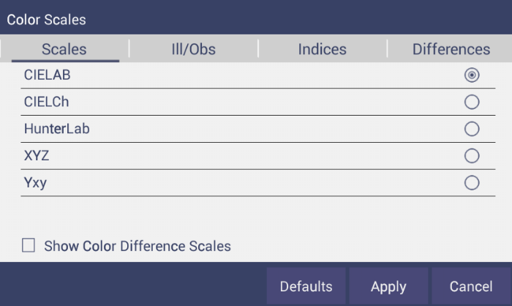
Go to WORKSPACE > COLOR SCALES provide four tabs in which the SCALES, INDICES, DIFFERENCES AND ILLUMINANT/OBSERVER (ILL/OBS) can be configured.
Figure 4. Color Measurement Scales
  - The SCALES Tab shows the five scales available for measurement. Select the absolute scale or color difference scales (if a standard is selected). Press APPLY and begin to read your samples.
  - The ILLUMINANT/OBSERVER tab displays combination selections for these parameters. The Tomato Scores use C/2.
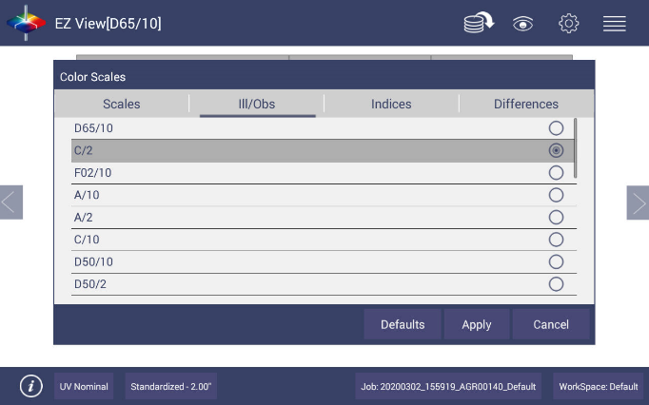
Figure 5. Illuminant/Observer Configuration
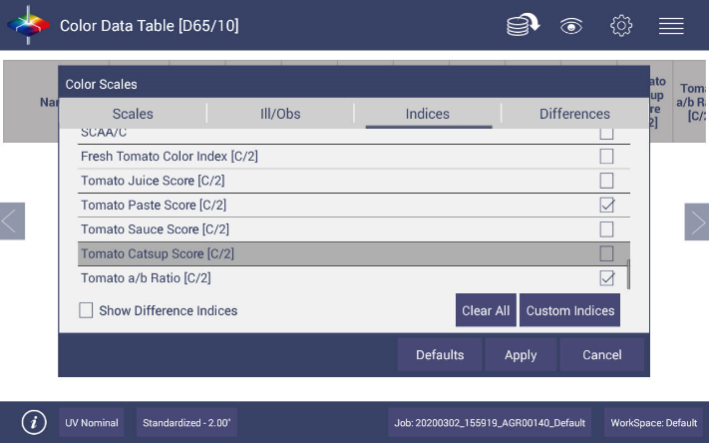
  - To select indices, go to the INDICES tab and check the corresponding box on the right side. Multiple selections are available for Tomato Scores. To remove all selections, press CLEAR ALL. To see more choices, the screen can be scrolled. Press APPLY to continue.
Figure 6. Index Configuration

Setting Tolerances
Tolerances can be manually entered for Scales, Indices and Differences. Tolerances will be displayed on the measurement screen if enabled under VIEW OPTIONS for the Color Data and EZ View Screens. Pass/Fail based on these tolerances can also be viewed on these screens.
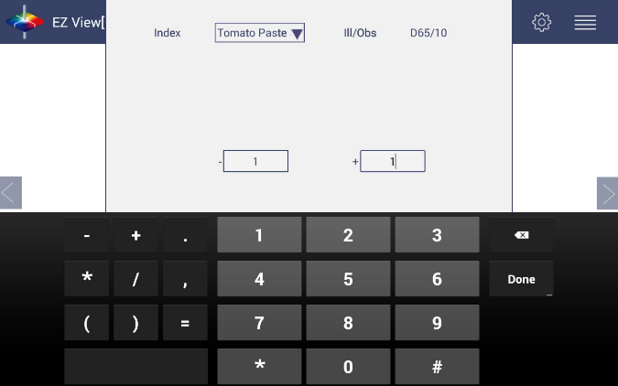
Figure 7. Indices Tolerance Configuration

Using A Hitch To The Tomato Red Tile
The purpose of the Tomato Red Tile is to improve inter-instrument agreement in Tomato Score values at multiple sites, or between a buyer and seller of processed tomato products. The hitch standard is particularly important for the Agera Tomato because in the first setup hitches the instrument to the assigned values of the Tomato Red tile.
At the factory, the values for the Tomato Red tile (C/2°) have been entered along with the product views. If it is necessary to re-set the hitch, here is the procedure.
- Go to WORKSPACE > STANDARD AND TOLERANCES.
- Place Tomato tile on the port plate and select READ.
- After reading, select HITCH. The Standard is displayed under AS READ. Enter the TARGET VALUES from the back of the tile.
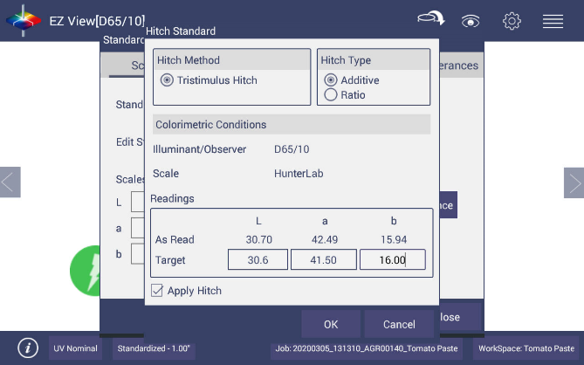
- Check the APPLY HITCH box and press OK.
Figure 8. Hitch Standardization
- On the next page press APPLY if you want to use the Tomato Tile as your standard for this job. Or you can select to save the hitched standard into database without applying it to the current measurement.

READING TOMATO SAMPLES
Complete the following steps to take individual readings using the Agera:
- When beginning measurements of tomato products, it is recommended to read the hitched tomato Red tile as a Performance Qualification check. If the instrument is still hitched correctly, it should read the assigned Hunter Lab C/2 values closely. If not, reset the hitch to the Tomato Red tile as described under USING A HITCH TO THE TOMATO RED TILE.
- To measure a sample, pour or spoon the sample into a 64 mm (2.5 in) glass sample cup until the cup is almost full.
- Place the sample cup in the recessed area of the sample cup port plate
- Cover the sample cup with the sample cup opaque cover.
- Measure the sample by pressing the READ key.
- The result is displayed.
- To create a standard for difference calculations, a long press on the Sample name will provide the option to SET AS STANDARD.
- Remove the sample cup from the sample port and place the next sample at the port.
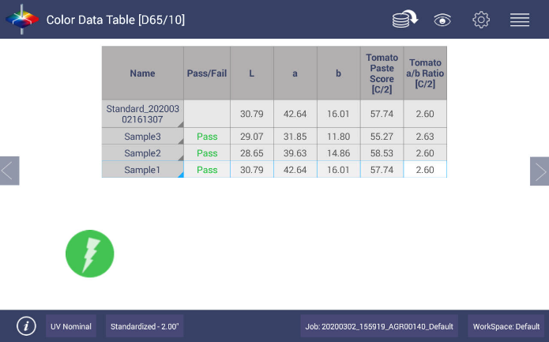
- Press READ to take another reading using this product setup.
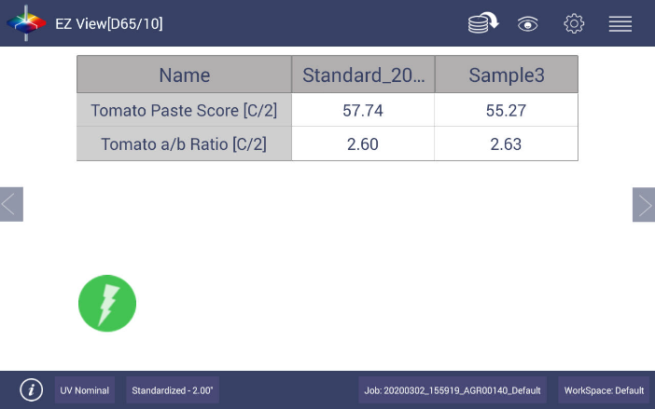
Figure 9. Tomato Score Readings in CDT
Figure 10. Tomato Scores in EZ View

